Preface

This User Guide explains how to use the system to process issued undertakings. It assumes that you are familiar with the basic principles of trade finance relating to guarantees, standbys and dependent undertakings together with web browsers.

# Introduction

This chapter provides an overview of how the system handles Undertakings. The term ‘Undertaking’ in this document is used as a generic term to refer to the following different forms of undertaking: either

* Guarantee or
* Standby Letter of Credit (LC) or
* Dependent Undertaking such as *surety*

Undertakings are used where parties are concerned with the obligations between them, rather than specific goods or services.

Undertakings provide security to beneficiaries in the form of a promise by the issuing bank on behalf of the applicant to reimburse the beneficiary for the amount of the standby/guarantee if the applicant defaults. Undertakings are normally subject to the laws and customs of the country of issue. A bank may therefore request a counter undertaking when dealing with a bank in another country. In this case, the issuing bank provides a counter indemnity to the overseas bank to cover the liability incurred by them.

## Undertakings in Trade Innovation

Trade Innovation includes two products to handle Undertakings

* Issued undertaking
* Received undertaking

Issued undertaking - which reflects the transaction from the perspective of the issuing bank. *Issued undertakings* cover the

* issuing of the bank’s own undertaking
* issuing of the bank’s own counter and local undertaking
* processing of received counter undertakings from another bank, where they have been requested to issue their own local undertaking or issue a further counter undertaking/local undertaking against a received counter

Received undertaking – which reflects the transaction from the perspective of the advising bank typically in the beneficiary’s country. *Received undertakings* cover the

* advising the undertaking to the beneficiary
* advising the undertaking to the beneficiary via an *advising bank* or *advise through* bank
* advising of confirmed Standbys where a *Requested confirmation party* can also be specified.

## Renewals, Non-extensions, Increases and Reductions

Undertakings in Trade Innovation can be renewed, reduced or increased automatically, or manually after review, according to schedules defined when the transaction was first entered on your system.

For renewals, these schedules allow you to define when and how often the transaction is to be renewed, and for how much, whether the original amount of the transaction, or its value at the time of renewal. You can also define whether the customer is to be advised of the renewal, and if so, how soon before the renewal occurs. A non-extension notification can be sent to the customer where the undertaking is not going to be renewed beyond the current expiry date.

For reductions and increases, these schedules define when the transaction is to be increased or reduced, and the amount of the increase or reduction, expressed as a fixed amount or as a percentage of the transaction's value. Again, you can define whether the customer is to be advised of the change of amount, and, if so, how soon before the reduction or increase takes place.

## Payment Terms

The system includes facilities for the handling of **Demand** payments.

There are a number payments options available to the bank allowing them to either ‘pay’, ‘reject’, ‘request to pay or extend’ or ‘extend’ an undertaking.

Where a Demand is:

* Paid – the payment is settled
* Rejected - it is not paid
* Requested to be paid or extended – the applicant has the option to either pay or extend the term of the undertaking
* Extended – the applicant approves the extension to the undertaking and the expiry date is amended to a new requested date

## Financing and Discounting

The system permits you to enter details of a loan to the applicant for each part payment. You can subsequently record repayment of the loan in part or in full manually. Alternatively, you can set up a loan so that it is repaid automatically as the maturity date is reached. The system also allows acceptance and deferred payments to be discounted and paid early for issued undertakings.

If you have the financing module implemented, you can enter loans from within the payment events for issued undertaking. Loans can have interest charged in advance or in arrears, or they can be discounted.

The financing module also allows you to create financing transactions independent of any existing trade finance transaction. The trade finance transaction can then be associated with the financing transaction as it is created.

For a full description of the financing module's functionality see the Financing User Guide – Trade Innovation.

## Licenses

The system includes facilities for the use of licenses with transactions of the type described in this Guide. Your bank can also make returns to the central licensing authority on a regular basis to show the utilisation of the licenses issued to customers.

One or more licenses can be linked to a transaction and a reservation made for the amount of the transaction. When a claim is received, a drawdown can be made against the license. Full validation between the transaction and license is provided to ensure that licenses do not become overdrawn.

If the amount of the transaction is increased or decreased during an amendment event, then additional reservations can be made for an increase or the balance reinstated for a decrease. Any unutilised balance on expiry or cancellation can be (optionally) reinstated on the license.

See the Licenses User Guide – Trade Innovation for details of licenses.

## Participating a Transaction

If you have the participations module implemented, you can participate a transaction using an existing participation deal, or create a new participation deal for use with that transaction.

You can participate a transaction from within the Issue event, or later from within a Maintain Liability event. At either of these stages, you can either select an existing agreed participation deal, or create a new deal.

If the amount of a transaction is changed by an Amend event, or by the transaction being paid, expired, or cancelled, a Drawdown/Revolve Commit Amt event may be created as a subsidiary event to update the commitment amount available on the participation deal. This will occur under the following circumstances:

* If the amount is increased, a drawdown will take place to reduce the amount available on the participation deal
* If the amount is decreased, including being reduced to zero when the transaction is paid, expired, or cancelled, a revolve will be used to increase the amount available on the participation deal only if the participation deal is defined as revolving

A Drawdown/Revolve Commit Amt event may be created by the following events:

* Amend
* Cancel
* Expire
* Maintain Liability
* Claim Received
* Outstanding Claim
* Renew
* Reduction/Increase

If the participation deal itself is amended in such a way as to alter a participant's share, a Maintain Liability subsidiary event is automatically generated for each transaction affected by the amendment. This updates the transaction and the charges associated with it to take account of changes to the participation deal.

For a full description of using participation deals, see the Participated Deals User Guide – Trade Innovation.

## Credit Risk Management

If your bank has implemented a credit risk management application, your system will perform on-line credit limit checking as necessary as part of the life-cycle of a transaction. Depending on how your system has been configured, account manager approval for a credit line utilisation may be required always, or only when overline conditions are detected.

See the Common Facilities User Guide – Trade Innovation for more information on credit risk management.

## Incorporating Legacy System Transactions into Trade Innovation

Your bank can incorporate issued undertaking transactions into the system from a legacy system using customer gateway interface service messages.

Each transaction is received as a customer gateway interface service message, which is processed in the usual way. Each such message, once successfully processed, is used to create an Issue Take-on event and associated master record in the system. The Issue Take-on event can be automatically released, and the master record given a status of 'LIV' or 'EXP', depending on its expiry date. Processing can then be carried out against the master record in the usual way, using the standard issued undertaking events.

The transaction's original unique reference is recorded against the master record generated within the system.

To allow the legacy transactions to be incorporated into the workflow in this way your bank must set up the following for the Issue Take-on event:

* Postings to allow the calculation of current values of master-level liability and margin amounts at master level within the system
* Charges and default charge schedules
* Tracers and their default schedules
* Note types

The system allows you to enter the legacy transactions manually, using the standard Issue event. An additional field is provided to allow you to enter the transaction's unique reference from the legacy system.

## Processing Issued Undertakings

The table below lists the events covered in this Guide, explaining what each event allows you to do. The table lists the names given to the events when the system is delivered. Your bank can change these names once the system is installed. Consequently, the names in your version of the system may be different from the ones listed here.

There are two names for each event:

* The full name, which is displayed when you choose a new event
* The short name, which is displayed in the Work in Progress pane of the Master Summary window

This Guide uses the full name of each event, as delivered with the system.

In addition to the events listed in the table, you can also use the functionality described in the Common Facilities User Guide – Trade Innovation when processing transactions in the system.

| Full Name | Short Name | What it Does |
| --- | --- | --- |
| Adjust | Adjust | Allows you to make changes to any of the information held for an undertaking (see page 77). |
| Advise Reduction/Increase | Adv Rec/Inc | Allows a reduction or increase in the amount of an undertaking to be advised to parties automatically, prior to the reduction or increase (see page 68). |
| Advise Renewal | Adv Renewal | Allows the renewal/non-extension of an undertaking to be advised to parties automatically (see page 63). |
| Amend | Amend | Allows you to make amendments to the basic details of an undertaking (see page 74). |
| Beneficiary Response to Amend | Amd Rspnse | Allows you to enter details of the beneficiary's response to an amendment (see page 75). |
| Beneficiary Response to Cancel | Can Rspnse | Allows you to enter details of the beneficiary's response to a cancellation (see page 82). |
| Cancel | Cancel | Allows you to cancel an undertaking (see page 80). |
| Claim Received | Clm Recvd | Allows you to log information about claims made by the presenter, to enter details of documents, and to pay the claim, providing the terms of the guarantee have been met (see page 42). |
| Issue | Issue | Allows you to enter full details of the guarantee and then issue it. |
| Issue Take-on |  | An event created automatically to allow Issued undertakings in a legacy system to be incorporated into the system (see page 3). |
| Maintain Liability | Maint Liab | Updates a participated guarantee to take account of changes in the participation deal. See the *Participated Deals User Guide – Trade Innovation.* |
| Outstanding Claim | Outst Clm | Allows you, as issuing bank, to continue processing a claim receive, for example when waiting for documents to arrive (see page 51). |
| Receive Acknowledgement | Rec Acknow | Allows you to record the advising bank's acknowledgement of receipt of an undertaking (see page 39). |
| Reduction/Increase | Red/Inc | Allows an undertaking to be reduced or increased automatically (see page 67). |
| Renew | Renew | Allows an undertaking to be renewed automatically (see page 65). |
| Repay Finance | Repay Fin | Allows you to record the repayment of a loan made to the applicant (see page 58). |

## Using Deal Templates to Create an Issued Undertaking

Trade Innovation allows you to create deals (transactions) from templates and/or, if you have the capability ManageDealTemplates assigned, to add, update and delete deal templates.

You can create a new issued undertaking transaction from a template at one of three points:

* From within the TI Dashboard. In the New Master pane, the Create from Template button allows you to select the template to use. You must specify the Team, the Branch and the Product
* From within the Master Browser window. In the New Master pane, the Create from Template button allows you to select the template to use. You must specify the Team, the Branch and the Product
* From within a transaction, during the Input step of an event that is creating a new master record. The Create from Template link allows you to select the template to use

See the *Common Facilities Guide* – Trade Innovation for further details.

# Creating an Issued Undertaking

This chapter explains how to use the system as issuing bank to initiate an Issued Undertaking on your system using the Issue event.

Where the Applicant or Principal (if not applicant) request an Undertaking they can request your bank to either

* Issue undertaking (ISSU) as either Guarantee, Standby LC or Dependent undertaking
* Issue counter ( ISCO)
* Issue counter and request counter (ICCO)

Where a counter is received from another bank (ISCO or ISCO), your bank can record details of the counter received and either

* Issue (ISSU) their own Guarantee, Standby LC or dependent undertaking
* Issue (ISCO) their own counter undertaking and request issue

## Creating an Issued Undertaking

The Issue event enables you to enter full details of an undertaking. To initiate an Issue event, in the Masters window, select the Team and Behalf of branch and use the drop-down list in the New Masters pane to select 'Issue Undertaking’, then click **New**. The system creates an Issue event at either a Log step or Input step (see page 10), depending on how the Workflow orchestration controlling the event is configured. See the *Workflow Tailoring User Guide* – Trade Innovation for details.

If you wish to create a cross-reference between the undertaking and an existing transaction, use the Related Reference field in the New Master pane to identify the existing transaction's reference.

If your system has been configured to allow the incorporation of legacy transactions into the system, an Original Reference field is present.

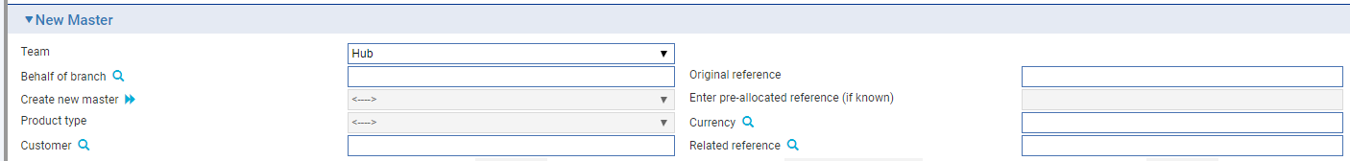

This is for use when entering transactions from the legacy system manually. It allows you to enter the legacy system's unique reference for the transaction. If you enter a value here, it must be unique within the system for Issued undertakings.

### Logging an Issued Undertaking

If your system has been configured to have a log step as part of your workflow the system will display a Log window allowing you to enter basic details of the Issued Undertaking. See the *SDK - Screen Tailoring User Guide* – Trade Innovation for details.

### Overall Screen Layout

The following table describes the general order of the input sections that are available when processing any type of undertaking request. Depending on the type of request up to 3 undertakings details are shown.

| Field | Details |
| --- | --- |
| Instructions received | Basic details of the undertaking request received from either the applicant or bank |
| Our undertaking request | The bank’s own undertaking details and request |
| Party details | The parties involved in the undertaking |
| Party notes | Sender to receiver notes relating to parties involved in the undertaking |
| Undertaking details | **Up to 3 sections** are shown dependent on the request type   * Issue - single set of ‘**Undertaking details**’ * Issue counter - ‘**Counter details to send’** and ‘**Local undertaking details’** * Issue counter / request counter - ‘**Counter details to send’** and ‘**Local undertaking details’**   Where the bank has received a Counter undertaking then an additional ‘**Counter received**’ details are shown |
|  | The following details can be entered for each undertaking:   * Undertaking details such as type Guarantee/Standby/ Dependent undertaking and applicable rules * Amount and additional amounts * Confirmation instructions (normally for Standby LC) * Documents and presentation instructions * Terms and conditions * Underlying transaction details * Automatic extensions & Reductions or increases   The following details are entered for the local undertaking   * Transfer instructions * Delivery of undertaking & Delivery to/Collection by * Contract details * Trade related details |
| Charge details | Charge details such as charge payer, tax payer, periodic charge cycle dates and charge account |
| Margin details | Details of any margin amounts taken |
| Collateral | Details of Collateral held |
| FX contracts | Details of any FX option contracts |
| Other details | Input branch, behalf of branch, responsible team and sundry codes |
| Reimbursement details | Details of any reimbursing banks (in later release) |
| Party details | List of parties associated with the transaction – this section provides links to Shared liability and Participation deals |

The following panes are used at an Input step to enter full details of the Issued Undertaking:

* Instructions received
* Our undertaking request
* Party details
* Party instructions
* Local undertaking - Main details
* Local undertaking - Amount details
* Local undertaking - Confirmation instructions
* Local undertaking - Document and presentation instructions
* Local undertaking - Terms and conditions
* Local undertaking - Underlying transaction details
* Local undertaking - Renewal details
* Local undertaking - Reduction / Increase
* Local undertaking - Transferable details
* Local undertaking - Delivery of undertaking
* Contract details
* Shipment details – for Trade related undertakings
* Goods – for Trade related undertakings
* Charges details
* Margin deposit
* Collateral
* FX contracts
* Other details
* Guarantee reimbursement details
* Party list

Instructions on using the Margin Deposit pane, the Collateral pane, the FX Contracts pane and the Party List pane are given in the Common Facilities User Guide – Trade Innovation.

The left hand menu allows you to switch to Multi-applicant/currency undertaking and vice versa

|  |  |  |
| --- | --- | --- |
|  |  |  |

When selected the following message is displayed. If you select **Yes** the screen details are reinitialized for the chosen undertaking type.

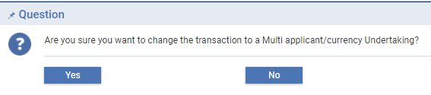

Multi-applicant and multi-currency processing is covered by separate documentation.

### Entering Full Details for the ‘Issue’ of an Undertaking

When a ‘*New Application’* is received from the Applicant or Principal (if not applicant) and the details of the undertaking are sent to the advising bank requesting them to advise the undertaking to the beneficiary, then in this scenario the bank’s request type is *‘Issue undertaking’.*

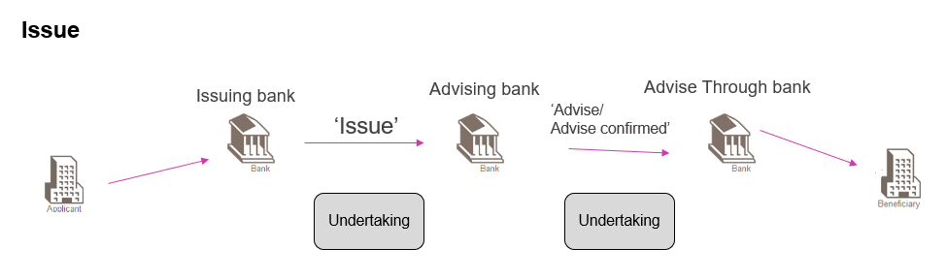

The following details can be entered:

#### Instructions received pane

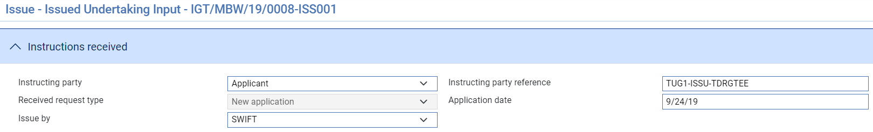

|  |  |  |
| --- | --- | --- |
|  | Field | Details |
|  | Instructing party | Options are   * Applicant or * Principal ( if not applicant) |
|  | Instructing party reference | Reference meaningful to the instructing party - applicant or principal party (if not applicant) |
|  | Received request type | Set to New application |
|  | Application date | Date application received |
|  | Issue by | How the undertaking should be issued by the bank e.g. SWIFT, Mail, Fax, Telex, Gateway |

Our Undertaking request

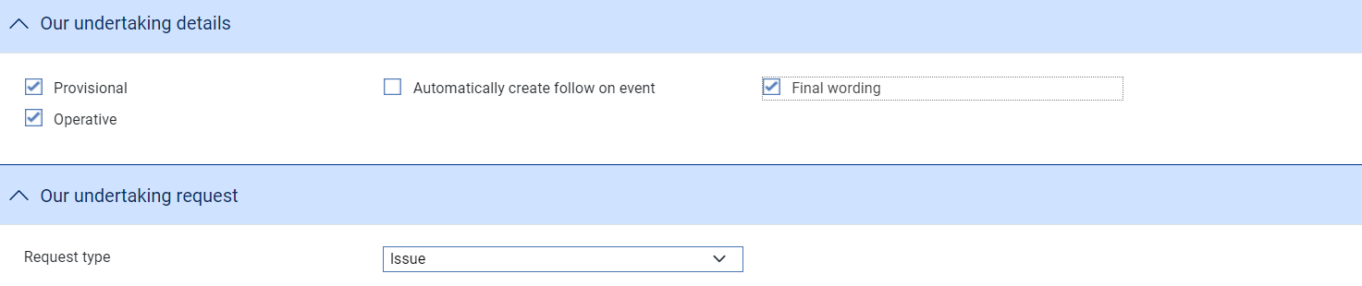

|  |  |  |
| --- | --- | --- |
|  | Field | Details |
|  | Provisional | Whether the master details are provisional |
|  | Automatically create follow on event | Whether the next event should be created automatically |
|  | Final wording | Whether undertaking wording has been finalised |
|  | Operative | Whether the undertaking is operative |
|  | Request type | Either   * Issue undertaking (ISSU) * Issue counter (ISCO) * Issue counter and request counter (ICCO)   If our undertaking request type is set to Issue undertaking (ISSU) a single set of Undertaking details are displayed for input.  If our undertaking request type is set to Issue counter (ISCO) or  Issue counter and request counter (ICCO) both Counter to send and Local undertaking details are displayed for input. |

#### Party details pane

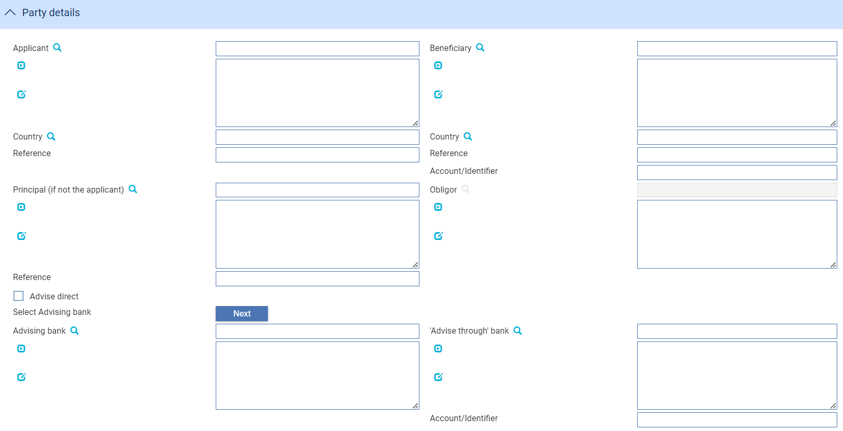

|  | Field | Details |
| --- | --- | --- |
|  | Applicant | Enter details of   * Applicant for the guarantee * Applicant countryApplicant reference |
|  | Beneficiary | Enter details of   * Applicant for the guarantee * Applicant countryApplicant reference |
|  | Principal (if not applicant) | The party such as a head office against whom liability will be booked |
|  | Obligor | The party obligated to reimburse the issuer. Set to either the Applicant or Principal (if not applicant) |
|  | Advise direct | Where Advise direct is selected, the Advising bank and Advise through bank are hidden. |
|  | Advising bank | The bank being requested to issue the undertaking. The bank can use the ‘Next’ button to select the next correspondent defined for the beneficiary country on a ‘round robin’ basis. |
|  | Advise through bank | A second bank through which the undertaking is to be advised |

#### Party instructions pane

This section allows the details of party notes to be entered

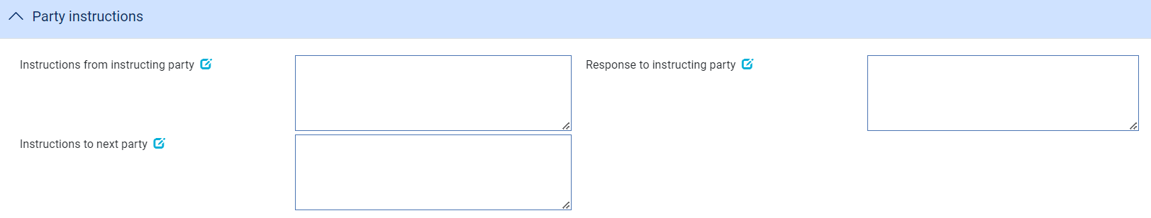

|  | Field | Details |
| --- | --- | --- |
|  | Instructions from instructing party | Any notes received from the instructing party e.g. Applicant or Principal (if not applicant) regarding the application |
|  | Response to instructing party | Any additional notes to the instructing party from the bank about the application such as notes regarding provisional or final version |
|  | Notes to advising bank | Any notes for the next advising bank |

#### Main details pane

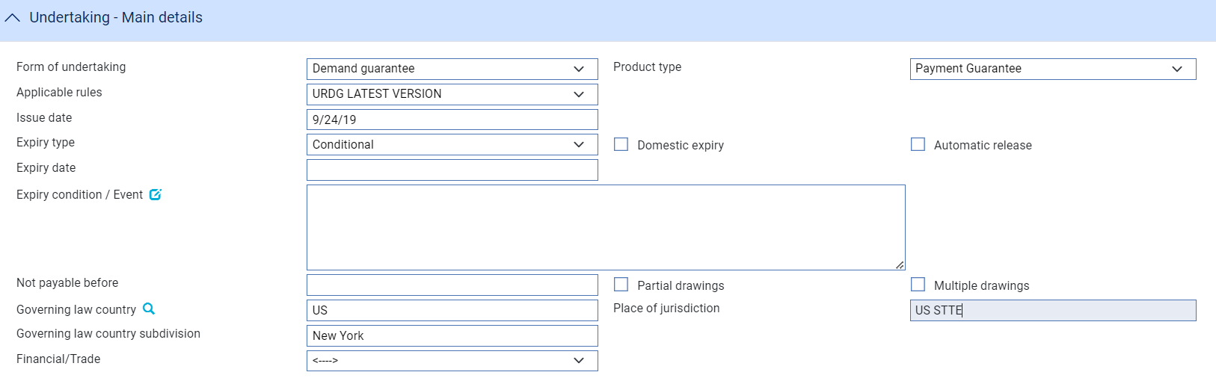

The following details can be entered

|  | Field | Details | |
| --- | --- | --- | --- |
|  | Form of undertaking | The form of undertaking type can be either   * Demand Guarantee (DGAR) * Standby letter of credit (STBY) * Dependent undertaking (DEPU) | |
|  | Product type | The product type associated with the undertaking. |
|  | Applicable rules | Applicable rules to which the undertaking is subject   * ISPR- The version of the International Standby Practices (ISP) that is in effect on the date of issue of the undertaking. * NONE- The undertaking is not subject to any rules. * OTHR -The undertaking is subject to another set of rules, or the undertaking is not subject to the version of the rules that is in effect on the date of issue, these must be specified in Narrative (2nd subfield). * UCPR -The version of the Uniform Customs and Practice for Documentary Credits (UCP) as published by the International Chamber of Commerce (ICC) that is in effect on the date of issue of the undertaking. * URDG -The version of the ICC Uniform Rules For Demand Guarantees (URDG) as published by the International Chamber of Commerce (ICC) that is in effect on the date of issue of the undertaking. | |
|  | Applicable rules narrative | Additional text (35 characters) can be added where ‘Other’ has been selected for applicable rules dropdown | |
|  | Issue date | The issue date of the undertaking | |
|  | Expiry type | Whether the undertaking has a specified expiry date or is open ended or is dependent on a documentary condition or event   * COND Expiry condition (including option for specified date of expiry). * FIXD Specified date of expiry (either with or without automatic extension). * OPEN No specified date of expiry. | |
|  | Demand type | * < - - > Default (allowed) * Multiple demands not permitted (NMLT) * Multiple and partial demands not permitted (NMPT) * Partial demands not permitted (NPRT) | |
|  | Expiry date | This field specifies the date when the undertaking will cease to be available. This can only be specified when expiry type is COND or FIXD | |
|  | Expiry condition/Event | Narrative can only be entered if Expiry type is ‘Expiry condition’ | |
|  | Not payable before | Date from which guarantee may be paid | |
|  | Partial drawings | Whether partial drawings are allowed | |
|  | Multiple drawings | Whether multiple drawings are allowed | |
|  | Domestic expiry | Whether domestic expiry | |
|  | Auto-release undertaking | Whether the undertaking is automatically released on expiry. If set to Yes the Expiry event is automatically generated (and released) after the grace days. If set to No the expiry event is not generated and charges continue to be generated as the undertaking is effectively treated as Open. | |
|  | Governing law country | The governing law country that is applicable to the undertaking. | |
|  | Governing law country subdivision | The governing law subdivision of the country applicable to the undertaking. | |
|  | Governing law text | The governing law that is applicable to the undertaking. | |
|  | Financial/Trade | Whether the undertaking is related to underlying trade or financial transaction. If set to Trade an additional section appears allowing the bank to enter further details. | |

When you enter details of the *Local Undertaking* when issuing a counter undertaking, the product type is replaced by the **Type of local undertaking** field. This allows you to provide information about the undertaking type to the next issuing bank

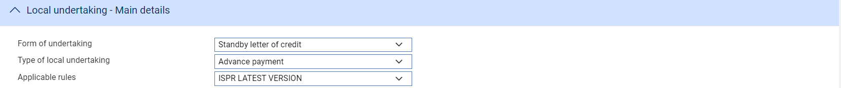



|  | Field | Details | |
| --- | --- | --- | --- |
|  | Type of local undertaking | Either   * APAY Advance payment * BILL Bill of lading * CUST Customs * DPAY Direct pay * INSU Insurance * JUDI Judicial * LEAS Lease * OTHR Other * PAYM Payment * PERF Performance * RETN Retention * SHIP Shipping * TEND Tender or bid * WARR Warranty/maintenance | |
|  | Additional text | Additional text for when type of *Other* |

#### Amount details pane

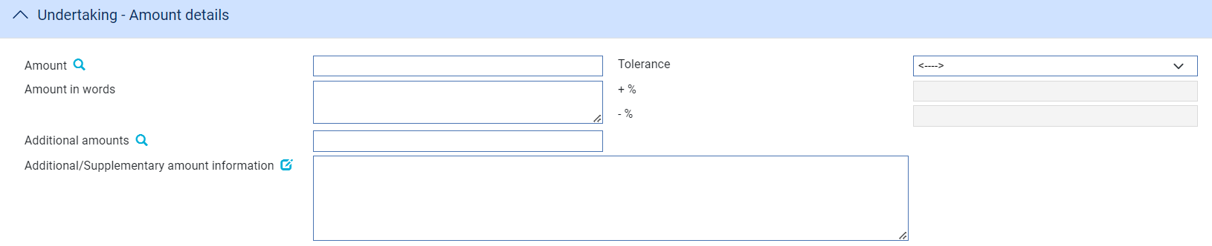

|  | Field | Details |
| --- | --- | --- |
|  | Amount | Amount and currency of the undertaking |
|  | Amount in words | Amount in words text |
|  | Additional amount | Amount and currency |
|  | Tolerance | Either   * About * Exact * Not exceeding * Other * Min/Max   A +/- tolerance can be specified where Other or Min/Max is selected |
|  | Additional/Supplementary amount information | This field can be used to add details about additional amounts related to the undertaking e.g. interest, tolerances. This field is a ‘clause’ text field allowing additional amounts and tolerance details entered to be mapped to this text field |

#### Requested Confirmation party pane

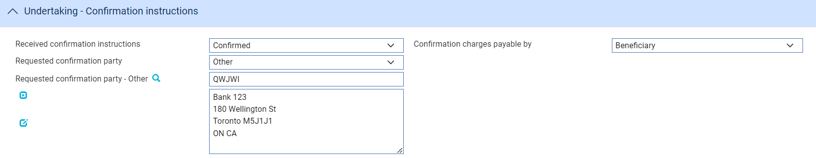

|  | Field | Details |
| --- | --- | --- |
|  | Confirmation instruction | Either   * Unconfirmed – default * Confirmed * May add |
|  | Confirmed by and  Requested confirmation party | Either   * <- - > - not set * Advising bank * Advise through bank * Other – to enter details of a specific bank |
|  | Confirmation charges payable by | Either   * <- - > - not set * Applicant * Beneficiary |

#### The Available With Details Pane

The Available with bank details can be entered for a Standby LC or Dependent undertaking.

The dropdown has the following values available allowing you to enter the details or select a named party

* (named bank)
* Any bank
* Any bank in city
* Any bank in country
* Advising bank
* Advise through bank
* Ourselves

If (named bank) is selected you can enter full details of a specific bank

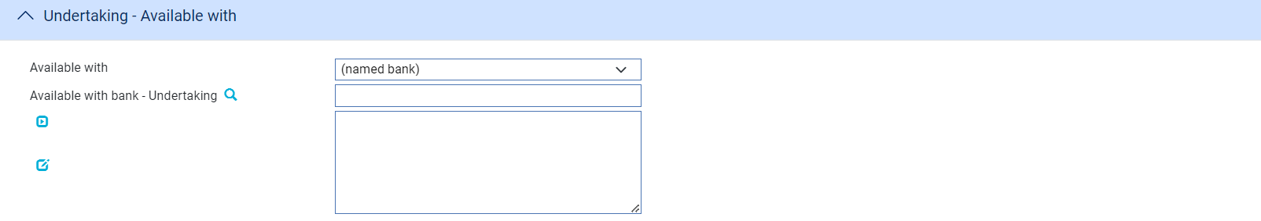

If Any bank is selected the following details are displayed



If Any bank in country is selected the following details are displayed allowing a country to be selected



If Any bank in city is selected the following details are displayed allowing a city name to be entered

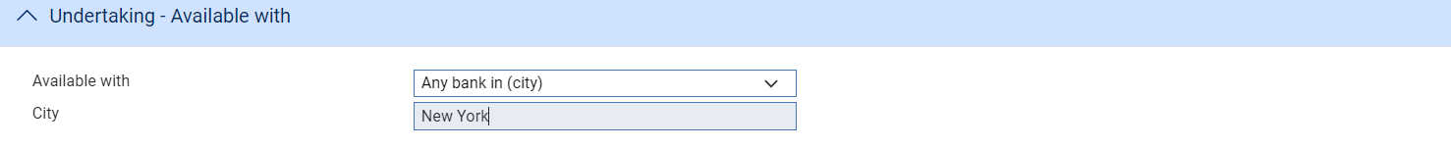

A named party is simply selected from the list as follows:



#### Documents, Terms and conditions and Underlying Transaction details panes

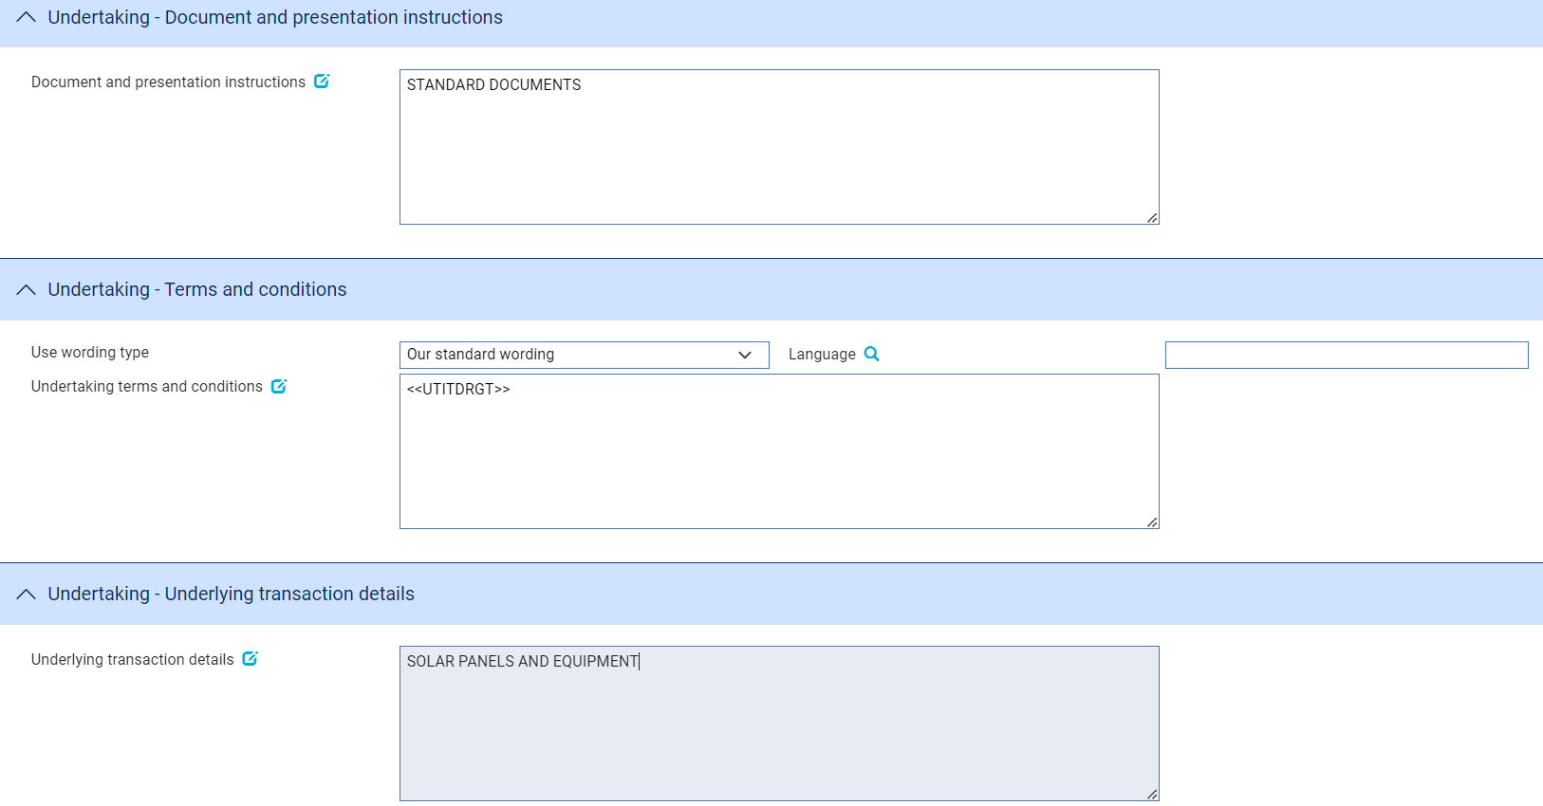

|  |  |  |
| --- | --- | --- |
|  | Field | Details |
|  | Document and presentation instructions | Presentation instructions (for example, form and/or place of presentation) including documents required to make a complying demand. |
|  | Standard wording | Wording type for the undertaking to the beneficiary can be specified as follows   * Standard wording- the bank’s standard clauses are used to construct the wording * Applicant wording attached – where specific wording is provided by the applicant * Beneficiary wording – where specific wording is required by the beneficiary * Other – Other bank wording as required |
|  | Language | If standard wording then the language can be specified allowing the clauses text to be sent in selected language |
|  | Undertaking terms and conditions | The applicable terms and conditions of the undertaking |
|  | Underlying transaction details | The underlying business transaction for which the undertaking is issued. |

#### Renewals

##### The First Renewal and Rolling Renewal Panes

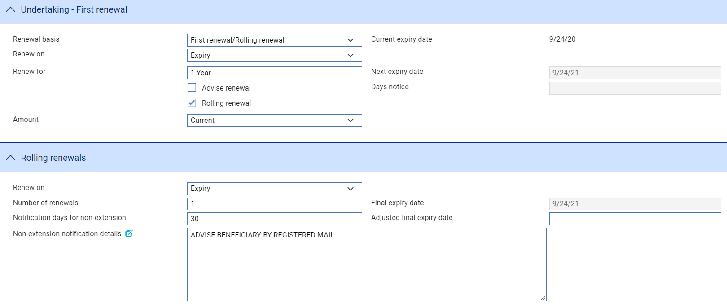

The fields in the First Renewal pane allow you to specify schedules for renewal. The fields in the Rolling Renewal pane are used to enter additional information for rolling renewals.

1. This information is not automatically mapped to outgoing SWIFT messages. Clauses should be used to map details of the first and rolling renewals into the relevant fields for SWIFT.

The following table explains what to enter into the fields in these panes:

| Field | What to Enter |
| --- | --- |
| Renew On | Select whether the undertaking is to be renewed on expiry on a calendar date. Then press Refresh. |
| Calendar Date | If you select 'Calendar' in the Renew On field, enter the date on which the undertaking is to be renewed. |
| Renew For | The renewal period. |
| Next Expiry Date | The system calculates and displays the next expiry date. This date cannot be overwritten. |
| Advise Renewal | If the parties are to be advised of the renewal, check this box, then enter a figure into the Days Notice field to indicate how soon before the renewal an advice notice is to be produced for them. |
| Rolling Renewal | Check this box if the renewal is a rolling renewal, meaning that it will be renewed more than once. The following additional fields appear: |
| Amount | Select 'Original' if the undertaking is to be renewed using the original amount; and 'Current' if it is to be renewed at the available amount at the time of the renewal. If you select 'Original', then any margin deposit amount is also increased to its original value. |
| Renew On | Select 'Expiry' if renewal is to occur automatically on expiry of the undertaking. Select 'Every' if renewal is to occur periodically, then press Refresh. In the fields that appear specify the period. |
| Frequency | The frequency with which the renewal is to take place. |
| Day in Month | If the frequency is monthly or longer, specify the day of the month on which the renewal should take place. |
| Number of Renewals | Enter a figure to indicate how many times the undertaking is to be renewed. This information is mandatory and the default is 1. |
| Notification days for non-extension | The number of days notice the customer is to be given of cancellation of the rolling renewal. |
| Non-extension notification details | Information related to the non-extension to the automatic expiry date extension,  such as notification method, and notification recipient details. |

##### The Regular Renewal Panes

Calendar

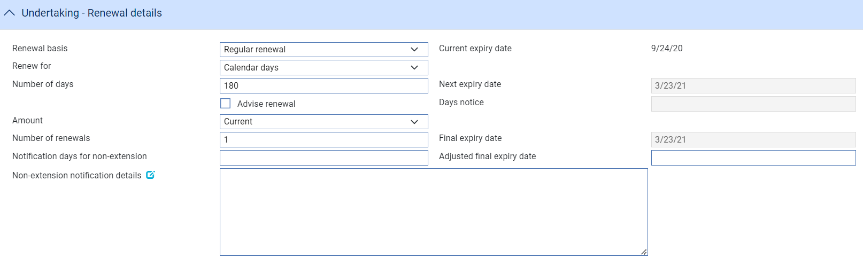

One year same day



Other

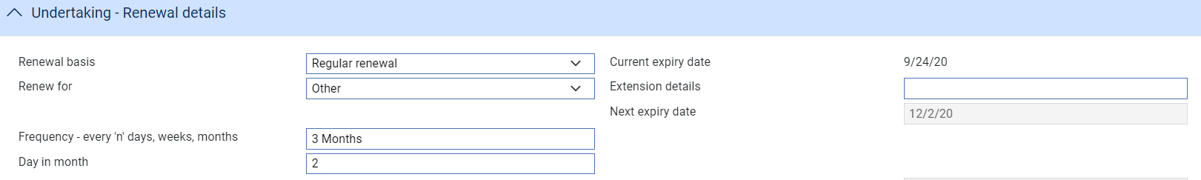

The fields in the Regular renewal pane allow you to specify the schedule for renewal. The following table explains what to enter into the fields in this pane:

| Field | What to Enter |
| --- | --- |
| Renew for | Select either  Calendar days – enter the number of days for the renewal  One year same day – same day one year later  Other – enter the extension details description together with the renewal details frequency e.g. every ‘n’ days, weeks, months and day in month if the frequency is monthly or longer |
| Next Expiry Date | The system calculates and displays the next expiry date. This date cannot be overwritten. |
| Advise Renewal | If the parties are to be advised of the renewal, check this box, then enter a figure into the Days Notice field to indicate how soon before the renewal an advice notice is to be produced for them. |
| Amount | Select 'Original' if the undertaking is to be renewed using the original amount; and 'Current' if it is to be renewed at the available amount at the time of the renewal. If you select 'Original', then any margin deposit amount is also increased to its original value. |
| Number of Renewals | Enter a figure to indicate how many times the undertaking is to be renewed. This information is mandatory and the default is 1.The system calculates the final expiry date. |
| Notification days for non-extension | The number of days notice the customer is to be given of cancellation of the rolling renewal. |
| Non-extension notification details | Information related to the non-extension to the automatic expiry date extension,  such as notification method, and notification recipient details. |

#### Reduction/Increase Pane



The fields in the Reduction/Increase pane allow you to specify schedules for reductions and increases. Reductions/increases can be regular or irregular, and the fields used to define them differ accordingly. If the applicant is to be advised of any reductions or increases, check the Advise Reduction/Increase box and enter the number of days notice to be given in the Days Notice field.

For regular reductions/increases, select 'Regular' in the Select Options field.

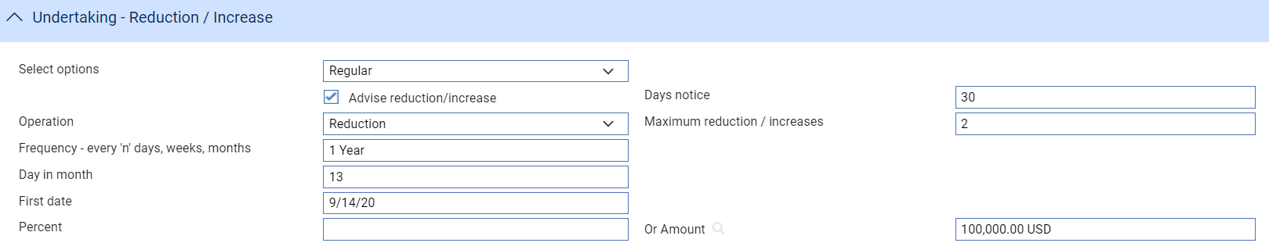

The Regular Reduction/Increase pane is displayed. The following table explains what to enter into the fields in this pane:

| Field | What to Enter |
| --- | --- |
| Operation | Select whether the amount is to be reduced or increased. |
| Maximum Reduction/Increases | If you selected Increase in the previous field, specify here the maximum number of increases that are to be allowed. |
| Frequency | The frequency at which the reduction/increase is to take place. |
| Day in Month | If the frequency is monthly or longer, specify the day of the month on which the reduction or increase will take place. |
| First Date | The system calculates the date of the first reduction/increase and displays it here.  If you left the Frequency field blank, for example if there is to be a single reduction/increase, then you can enter the date on which the reduction/increase is to take place here. |
| Percent/Or Amount | Specify the amount of each reduction/increase. You can specify this as a percentage of the original amount of the transaction, or as an amount. |

For irregular reductions/increases, select 'Irregular' in the Select Options field.

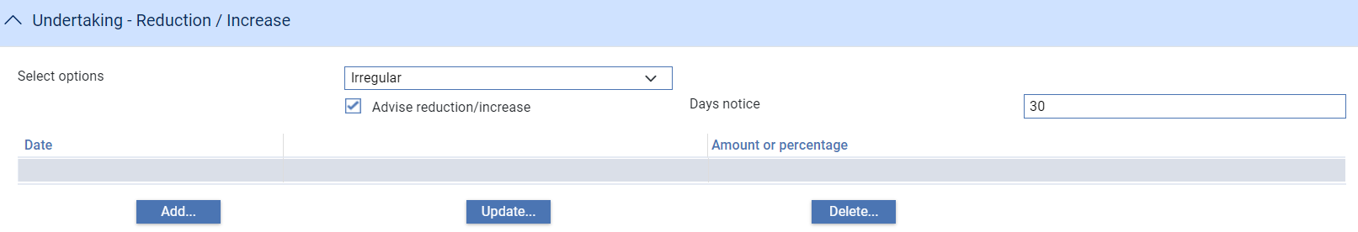

Use the Operation field to select whether the undertaking is to be reduced or increased. Use the Date field to enter the date the first reduction/increase will take place. Use either the Percent field or the Or Amount field to specify the amount by which the undertaking is to be reduced/increased.

When you close this window, the reductions/increases specified are listed in the Irregular Reduction/Increase pane, where you can amend and delete them in the usual way.

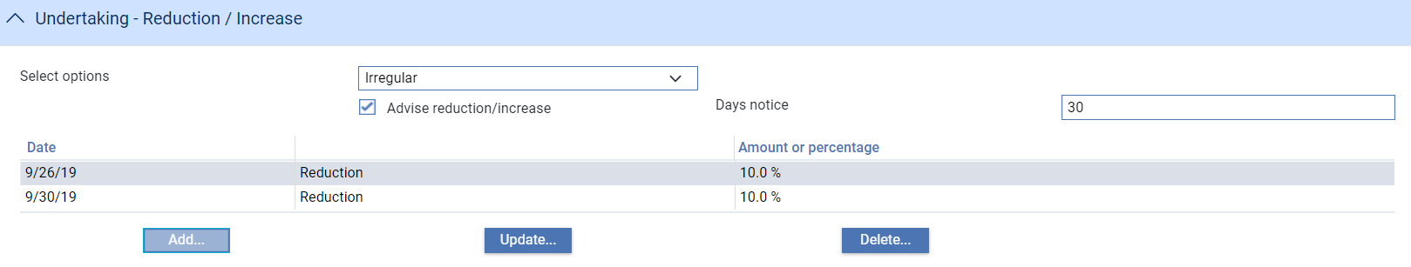

#### Transferable details pane

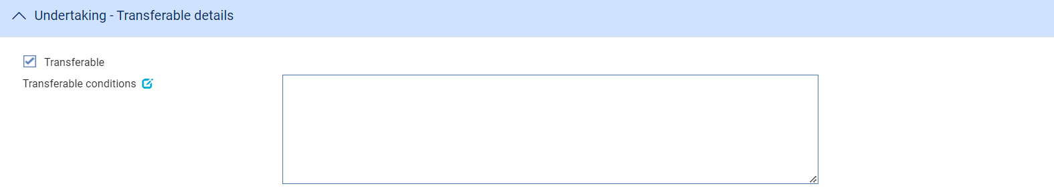

The following table explains what to enter into the fields in the Transferable details pane:

|  | Field | What to Enter |
| --- | --- | --- |
|  | Transferable | Whether the undertaking can be transferred to another party |
|  | Transferable conditions | Conditions under which transfer is allowed |

#### Delivery of Undertaking and Delivery To/Collection by pane

Beneficiary

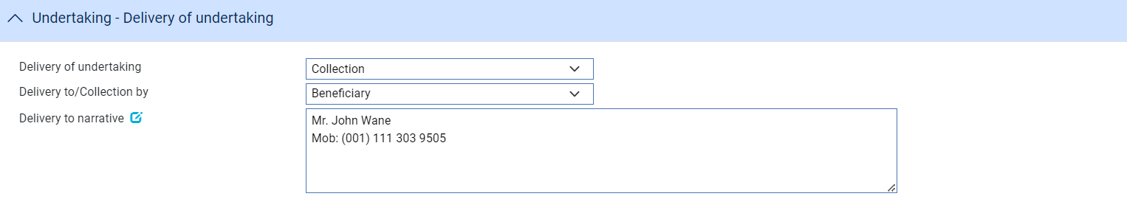

Other addressee

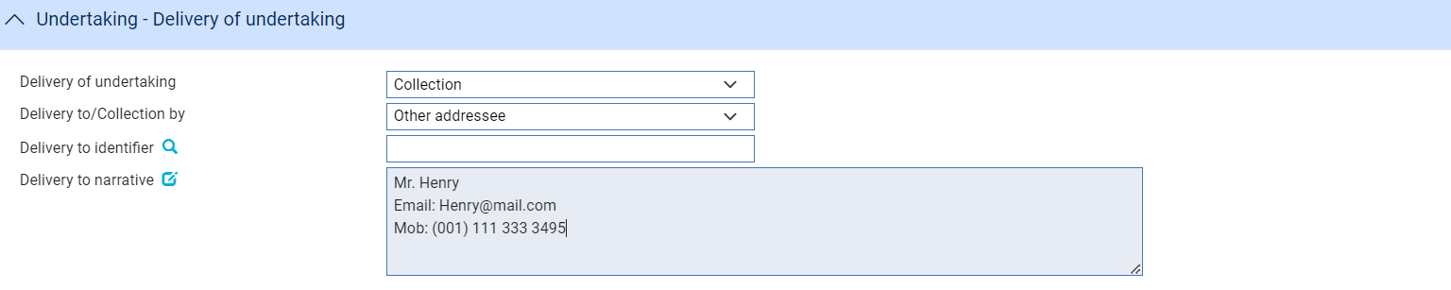

The following table explains what to enter into the fields in the Contract Details pane:

|  |  |
| --- | --- |
| Field | What to Enter |
| Delivery of undertaking | Enter the method to be used to deliver the undertaking. Select either   * Collection * Courier * Mail * Message - hand deliver * Other method * Registered Mail or Air Mail |
| Additional information | Enter any additional information when either Courier or Other method is selected |
| Delivery to/Collection by | Select either   * Beneficiary * Other addressee – this allows details of the party to whom the undertaking is to be delivered/collected by to be entered |
| Delivery to identifier | Available where selection to the field ‘Delivery to/Collection by’ is “Other addressee”. Allows the user to search the party and when selected shall populate into the ‘Delivery to narrative’ field. |
| Delivery to narrative | Allows the user to enter the delivery instructions that could include the Party name, address and other related instructions. |

#### The Contract Details Pane

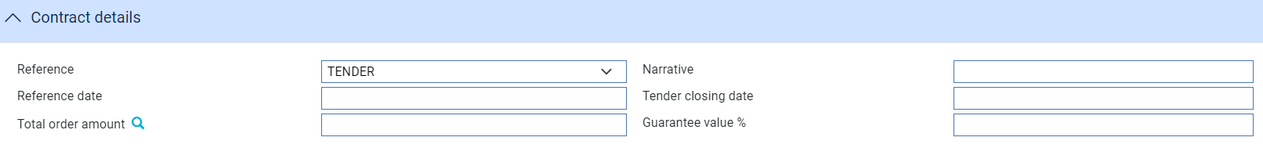

The following table explains what to enter into the fields in the Contract Details pane:

| Field | What to Enter |
| --- | --- |
| Reference | This field defines the contract reference type associated with the guarantee.  The codes available are:  TEND = TENDER  ORDR = ORDER  CONT = CONTRACT  OFFR = OFFER  DELV = DELIVERY  PINV = PROFORMA INVOICE  PROJ = PROJECT |
| Narrative | The narrative is used to describe the contract reference details. |
| Reference date | The contract reference date is used to specify the date of the reference, and optionally a secondary date (tender closing date). |
| Tender closing date (only shown when Reference=TENDER) | The tender closing date may only be used when the contract reference consists of TEND (TENDER) to specify the tender closing date. |
| Total order/contract amount | The total order amount specifies the currency and total amount of the order/contract. |
| Guarantee value % | The guarantee value as a percentage in relation to the total order or contract value. |

#### The Shipment Details Pane

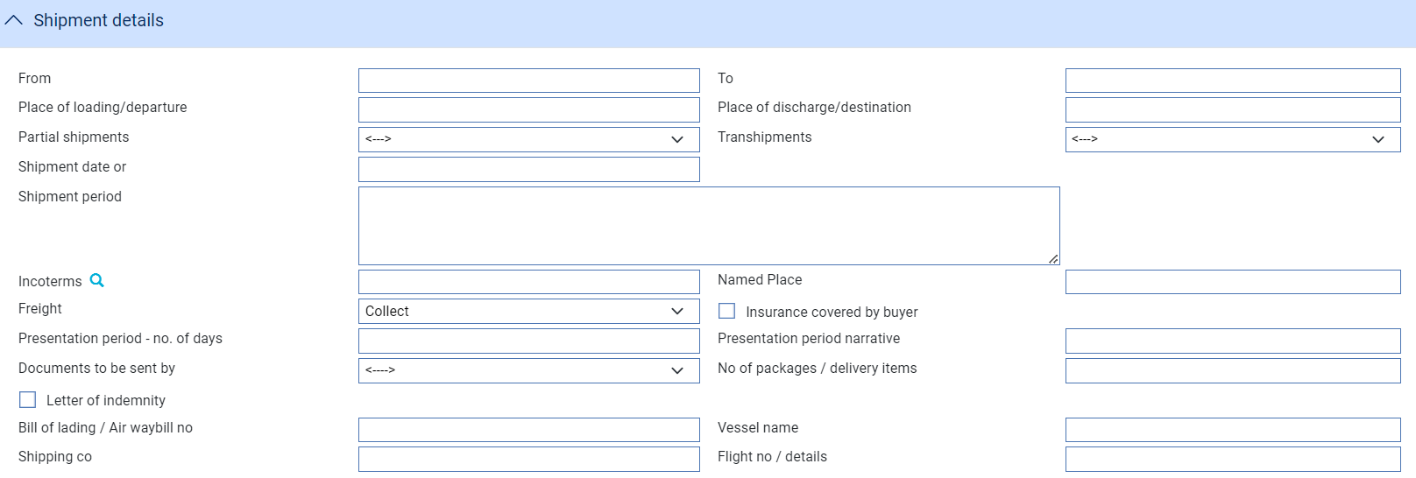

The Shipment Details pane is displayed only for trade-related undertakings. The following table explains what to enter into the fields in this pane:

|  | Field | What to Enter |
| --- | --- | --- |
|  | From | The port the goods are to be shipped from. |
|  | To | The port the goods are to be shipped to. |
|  | Place of Loading/Departure | The place of loading |
|  | Place of discharge/destination | Place of discharge |
|  | Partial shipments  /Transhipments | Select either   * Blank – no specified * Allowed - If partial shipments/transhipments are permitted for this letter of credit. * Not allowed - If partial shipments/transhipments are not permitted for this letter of credit * Conditional - If selected then the user should specify conditions in the required narrative field. |
|  | Shipment Date | The latest date the goods are to be loaded or despatched. |
|  | Shipment Period | A narrative text specifying the period of time during which goods are to be loaded or despatched. |
|  | Incoterm | Selected incoterm |
|  | Incoterm named place | Incoterm named place |
|  | Freight | When you select a value in the Incoterms field, the system automatically selects the appropriate value in this field using information set up for the selected incoterms to indicate whether freight is to be pre-paid or paid on collection. You can override this value. |
|  | Insurance covered by | When you select a value in the Incoterms field, the system automatically selects the appropriate value in this field using information set up for the selected incoterms to indicate whether the buyer is to provide insurance cover or not. The field is checked if insurance cover is to be provided by the buyer. You can override the value displayed here |
|  | Presentation Period | The latest date allowed for presentation of documents by the beneficiary. |
|  | Documents to be Sent By | The method to be used to send documents. |
|  | No of packages/delivery items | Specify how many mailings are to be made. |
|  | Letter of Indemnity | Check this box if a letter of indemnity is required. |
|  | Bill of Lading/ Air Waybill No. | The reference number of the bill of lading or air waybill. |
|  | Vessel Name | The name of the vessel, if known. |
|  | Shipping Co. | The name of the shipping company transporting the goods. |
|  | Flight No/Details | The flight number. |

#### The Goods Pane

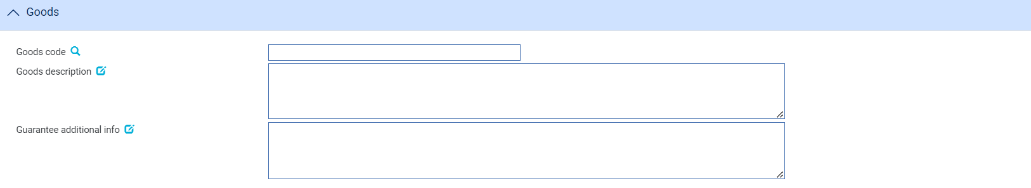

The Goods pane is displayed only for trade-related undertakings. The following table explains what to enter into the fields in this pane:

|  | Field | What to Enter |
| --- | --- | --- |
|  | Goods Code | Select a goods code. This field is for analysis purposes. |
|  | Goods Description | A narrative description of the goods being shipped. |
|  | Guarantee Additional Info | For guarantees, any additional information relating to the goods and documents to be sent. |

#### The Charges Details Pane

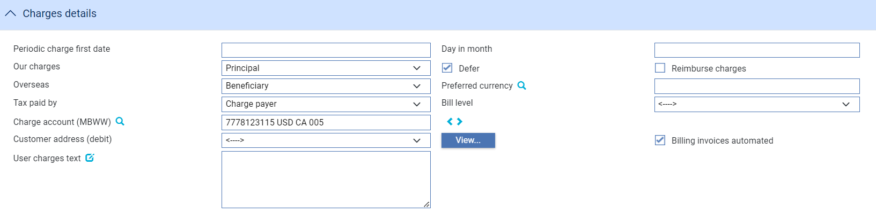

The following table explains what to enter into the fields in the Charges Details pane:

| Field | What to Enter |
| --- | --- |
| Periodic Charge First Date | The date periodic charges are first to be taken. If charges are taken in advance, enter the date on which charges are next to be taken. |
| Day in Month | The date on which charges are to be debited each month. |
| Our Charges | Select whether the charges are to be paid by the principal or the beneficiary, then click Refresh. |
| Defer | Indicate whether your own charges are to be collected now or deferred until payment. Check this box if the charges are to be deferred, otherwise leave it blank. |
| Reimburse Charges | Check this box if all the charges associated with the transaction are for the beneficiary, and you wish to debit these to the applicant's account as the guarantee is issued. If this is the case, the applicant is reimbursed once the beneficiary settles. (Any periodic charges, however, are collected in the usual way.) |
| Overseas | Specify which party - the beneficiary (the default) or the applicant - will pay overseas charges. |
| Preferred Currency | Specify the currency in which the applicant's charges will be collected. Typically, you would set this to your local currency. If you leave this field blank, the system uses the currency of the transaction. |
| Tax Paid By | Specify which party - the party liable for charges (the default) or your customer - will pay any tax due on charges on the guarantee. |
| Bill Level | Select whether charges for this undertaking should be billed at customer level, transaction level or product level. |
| Charge Account | The number of the account used for any charges debited to the customer. Charge accounting is normally controlled by the standing settlement instructions for charges. Entering an account number here overrides the account specified in the standing settlement instructions. |
| Customer address (debt) | The charge payer customer’s address defaults to their prime address. The customer’s alternative address can be selected using the list field.   1. This list excludes the customer’s prime and SWIFT address types. Use the adjacent View button to display the chosen address in full. |
| Billing invoices automated | This check box can be used to indicate whether the invoices for charges generated by the transaction (e.g. Billing settlement event) are automatically generated or not. |
| User Charges Text | Any additional information concerning the charges. |

#### The Other Details Pane

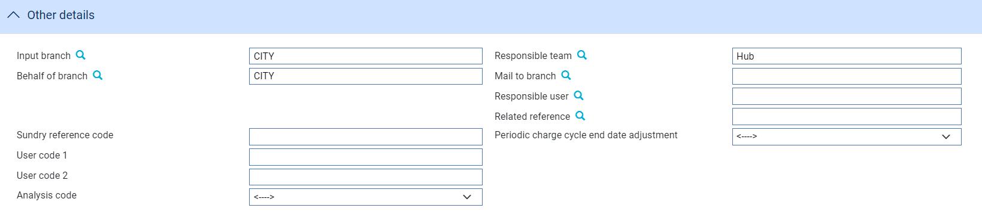

The following table explains what to enter into the fields in the Other Details pane. This pane may also include input fields defined by your bank:

| Field | What to Enter |
| --- | --- |
| Input Branch | The input branch for the transaction. The input branch is set from either:   * the accounting branch from the user’s team, or * the transaction branch for user if the user has a default transaction branch or is locked to a specific branch, or * a branch associated with the user where the user can enter transactions for several branches for a team |
| Behalf Of Branch | The behalf of branch for the transaction as entered by the user or set from the incoming SWIFT or gateway message. The behalf of branch determines the parameter sets that are to be used to generate charges, documents, postings, etc. during transaction processing. The branch can be changed to any other branch within the same main banking entity that shares the same parameter sets. |
| Sundry Ref Code /User Code 1/ User Code 2 | You may use these fields to enter values for analysis purposes. Your bank will have devised its own system for using these fields. |
| Responsible Team | The team that has overall responsibility for the master e.g. as the contact to resolve any queries or issues regarding the master and associated events. The system defaults the responsible team when creating the transaction as follows:   * Manual – set from team creating the transaction * Gateway – set from the team specified on the incoming message (if present and valid) otherwise to the team to which the transaction is assigned through workflow allocation based on the behalf of branch * SWIFT – set to the team to which the transaction is assigned through workflow allocation based on the behalf of branch   It can be changed, if required, to either the team associated with the primary customer, default team for the product or the user’s current team. |
| Mail To Branch | The mail to branch can be set to any branch within the main banking entity of the behalf of branch. |
| Responsible User | A user that has responsibility for the master e.g. as the contact to resolve any queries or issues regarding the master and associated events. This can be any user assigned to the responsible team. |
| Related Reference | If the guarantee is associated with an existing transaction, enter the reference number of the associated transaction here. |

#### The Reimbursement Details Pane

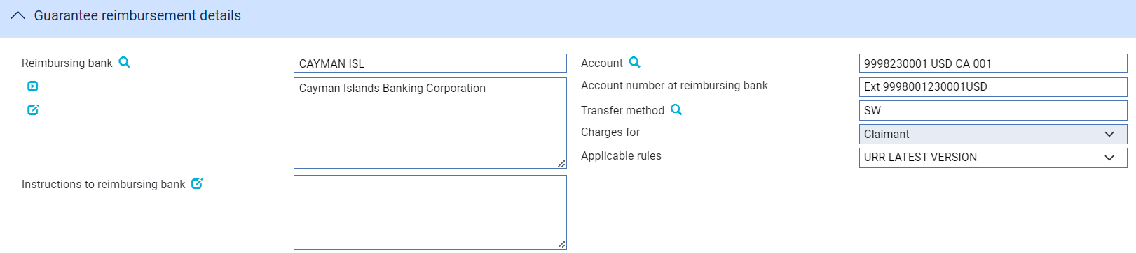

The following table explains what to enter into the fields in the Reimbursement Details pane:

| Field | What to Enter | |
| --- | --- | --- |
| Reimbursing Bank | If the transaction involves a reimbursing bank, use this field to identify it. | |
| Account | The number of the reimbursing bank's account in your bank's books to be credited. | |
| Account Number at Reimbursing Bank | The number of your bank's account with the reimbursing bank. | |
| Transfer Method | The method to be used to send the reimbursing bank instructions to the reimbursing bank. | |
| Charges For | Select whether the reimbursing bank's charges are paid by the claimant or the issuing bank. | |
| Applicable Rules | This allows you to select additional information regarding the terms of the reimbursement.  Select one of the following to indicate the rules applied to the issue of the documentary credit under reimbursement instructions: | |
| URR VERSION | The documentary credit is subject to the version of the ICC Uniform Rules for Bank to Bank Reimbursement, International Chamber of Commerce, Paris, that is in effect on the date of issue.  This is used as the default. |
| NOTURR | The documentary credit is not subject to the version of the ICC Uniform Rules for Bank to Bank Reimbursement, International Chamber of Commerce, Paris, that is in effect on the date of issue. |
| Instructions to Reimbursing Bank | Any instructions for the reimbursing bank. | |

#### The Miscellaneous details

Where the *EnableUndertakings* system option is set on, the system displays the enhanced undertaking screens. When an existing old style Guarantee transaction has some data that is no longer directly relevant to undertakings, this data is retained but shown in a separate window.

The following details are displayed in Miscellaneous data window. The menu option is only displayed if any of these fields are non-blank, but only fields that have data are shown in the window.

* Customer counter received
* Customer counter expiry date
* Expiry place
* Available By details
* Drafts drawn details
* Additional conditions
* Guarantee additional info
* Goods description
* Bank defined fields (controlled by system option and TF dictionary values)
* ReceiverOfUndertakings
* UT1xxx
* UT2xxx
* Special payment instructions for beneficiary
* Special payment instructions for receiving bank
* Instructions to paying bank

The window is accessed from the left hand menu as follows

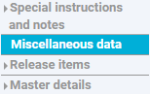

The following screen shows an example of the Miscellaneous details screen. 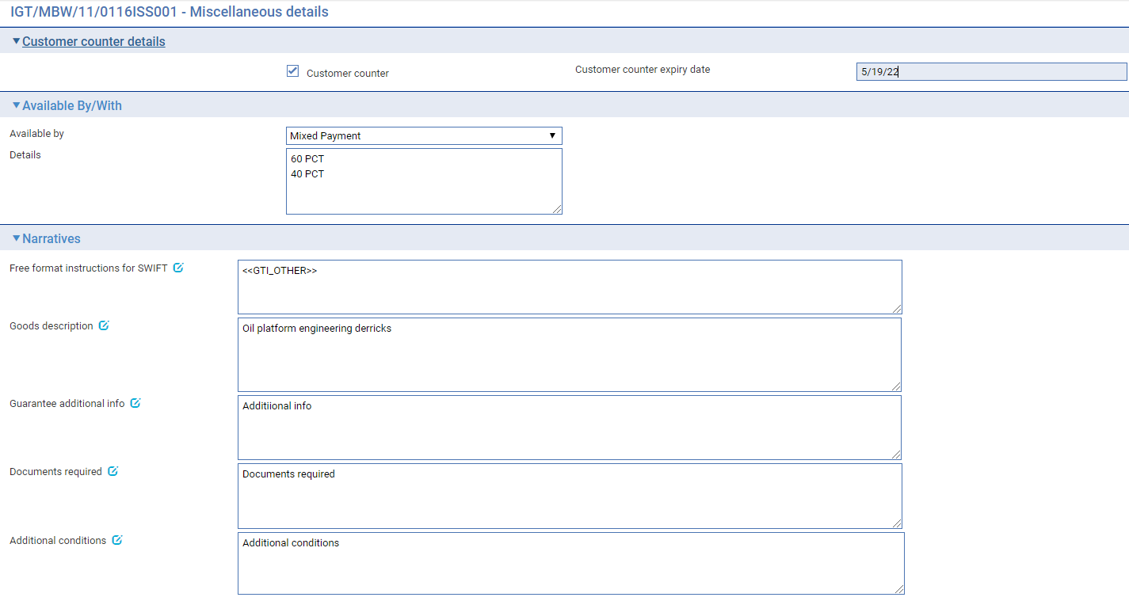

### Entering Full Details for an ‘Issue counter’ Undertaking

Where a ‘*New application’* is received from the Applicant or Principal (if not the applicant) and the details of the undertaking are to be sent to the next issuing bank requesting them to issue their local undertaking to the beneficiary, then the bank must enter details of the next issuing bank and the bank’s request type is set to *‘Issue counter’.* Thisallows you to enter the Issuing bank to whom a counter will be provided and details of the advising banks to be used when they in turn issue their local undertaking.

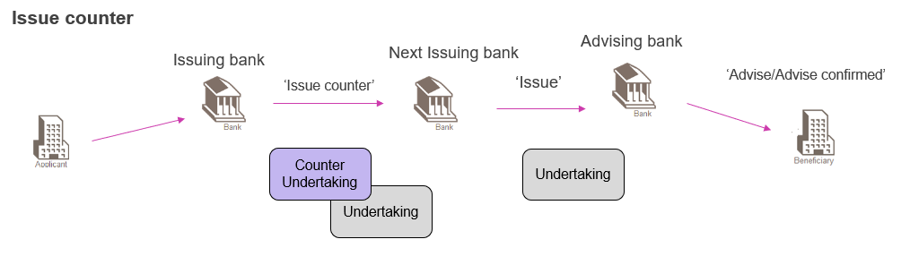

The following party details are entered

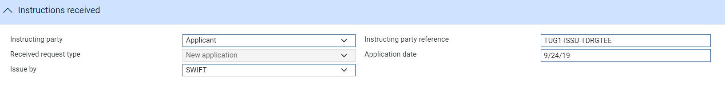

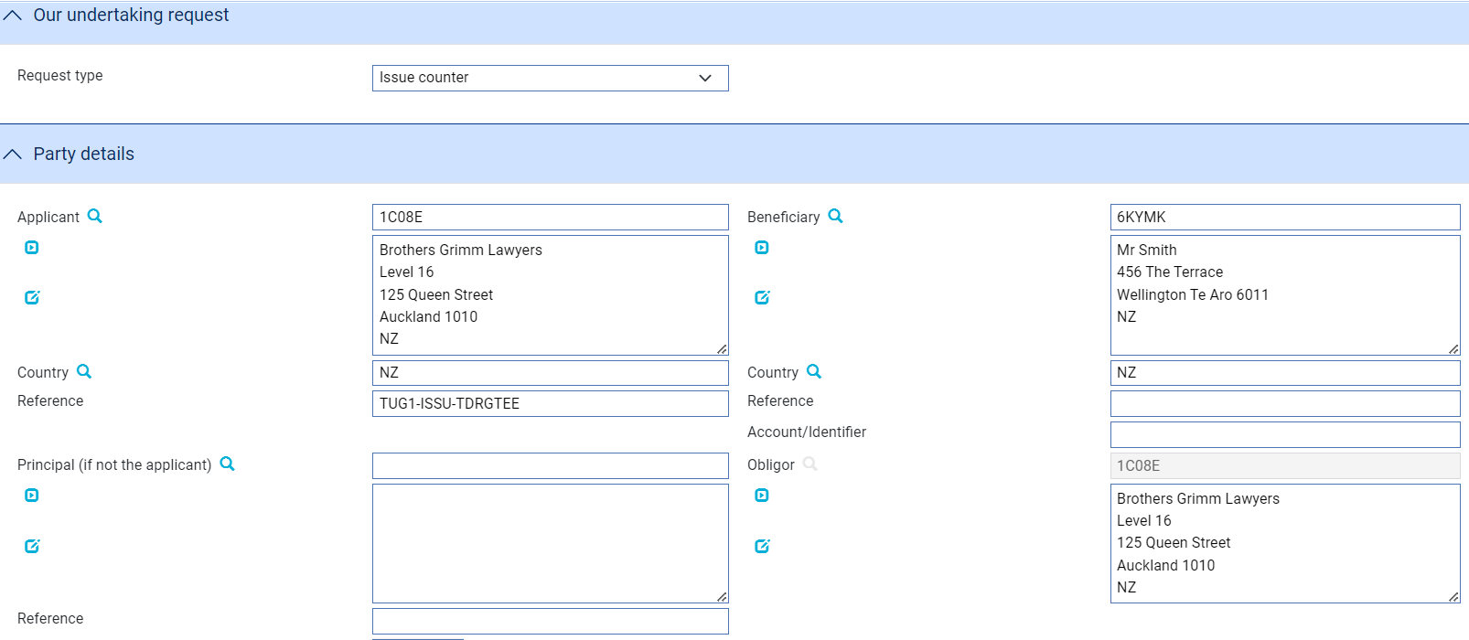

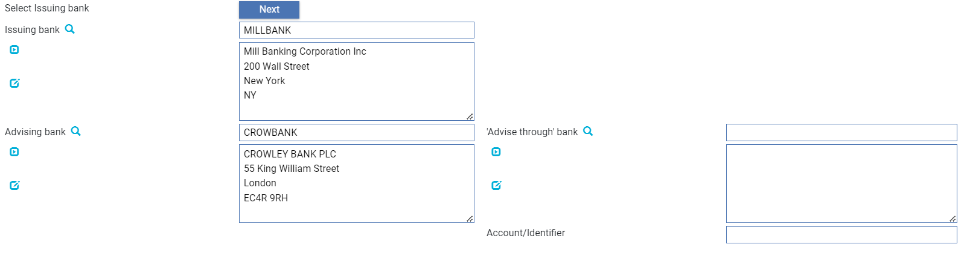

The ‘Counter to send’ details are then entered providing details of the counter undertaking for the next issuing bank.

The details consist of the following sets of fields, the details are entered as described above

* Counter to send - Main details
* Counter to send - Amount details
* Counter to send - Document and presentation instructions
* Counter to send - Terms and conditions
* Counter to send - Renewal details
* Counter to send - Reduction / Increase

### Entering Full Details for an ‘Issue counter/Request counter’ Undertaking

When our Request type is set to ‘*Issue counter/request counter’* this allows you to enter the next Issuing bank to whom a counter will be provided, together with the final issuing bank to whom the next bank issues their own counter and the details of the advising banks to be used when the final bank issues their local undertaking.

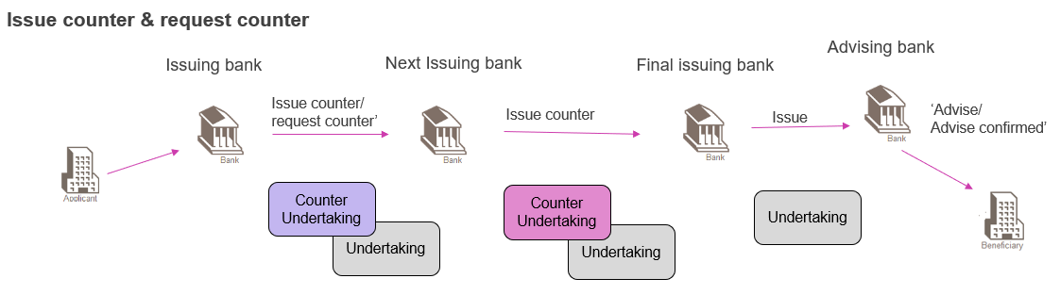

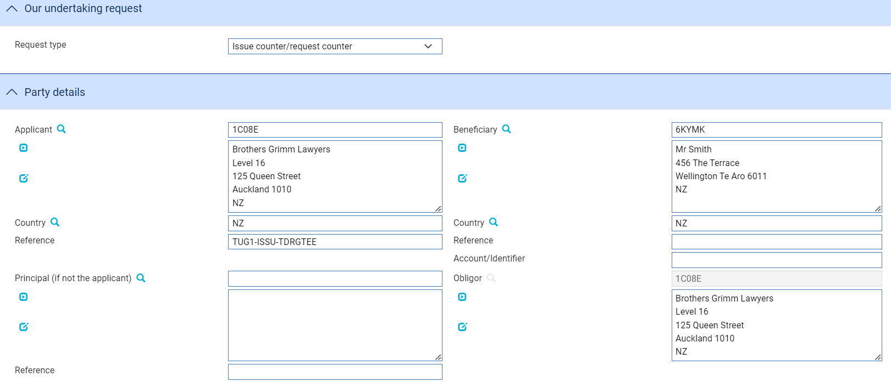

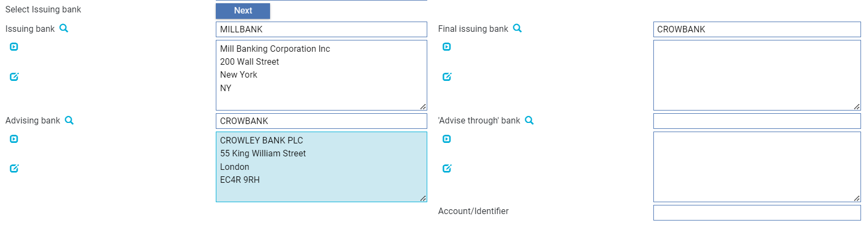

The ‘Counter to send’ details are then entered providing details of the counter to the next issuing bank.

The details consist of the following sets of fields as described above

* Counter to send - Main details
* Counter to send - Amount details
* Counter to send - Document and presentation instructions
* Counter to send - Terms and conditions
* Counter to send - Renewal details
* Counter to send - Reduction / Increase

When entering details of the Counter to send– Available with details – the following options are available:

* (named bank)
* Any bank
* Any bank in city
* Any bank in country
* Ourselves

### Local undertaking terms and conditions – additional notes

When issuing a counter undertaking, the bank can enter details of the local undertaking terms and conditions in the following way:

* Request the issuing bank to issue their own local undertaking using their standard wording in a Requested language based on the bank’s text, can be specified in Local undertaking - pane

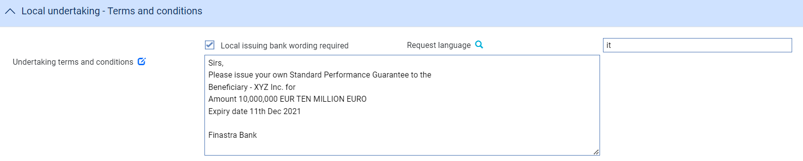

When the Request language browser is selected, the ISO Language browser is displayed allowing the relevant local language to be selected

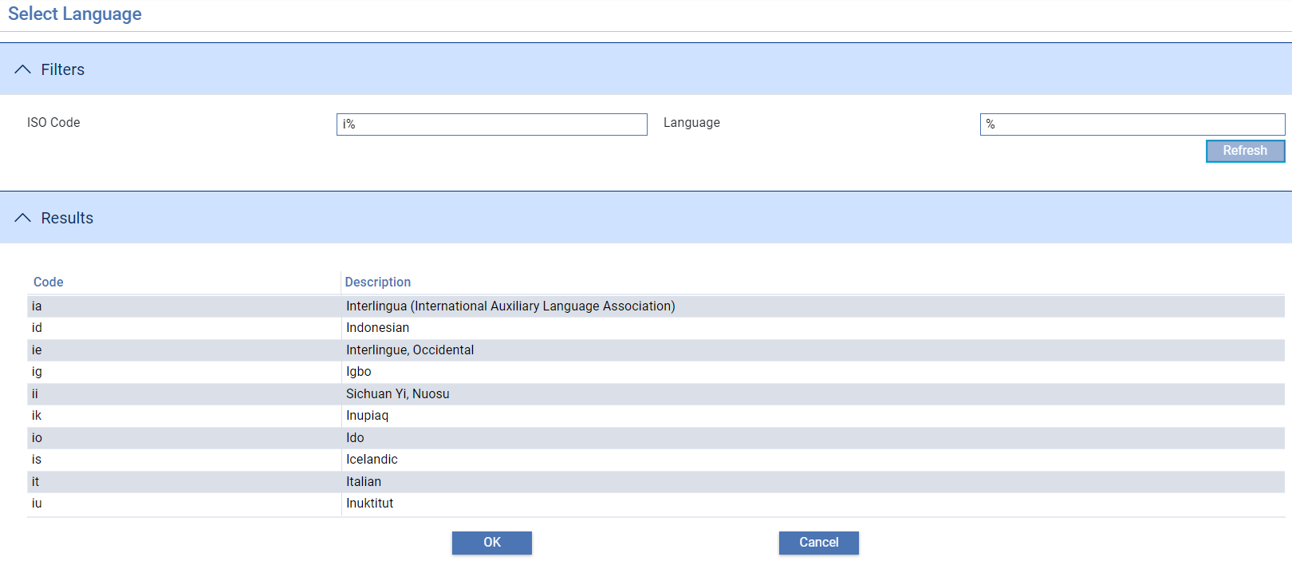

* Specify the actual wording of the undertaking to be used supplied by the Applicant, Beneficiary or Other party

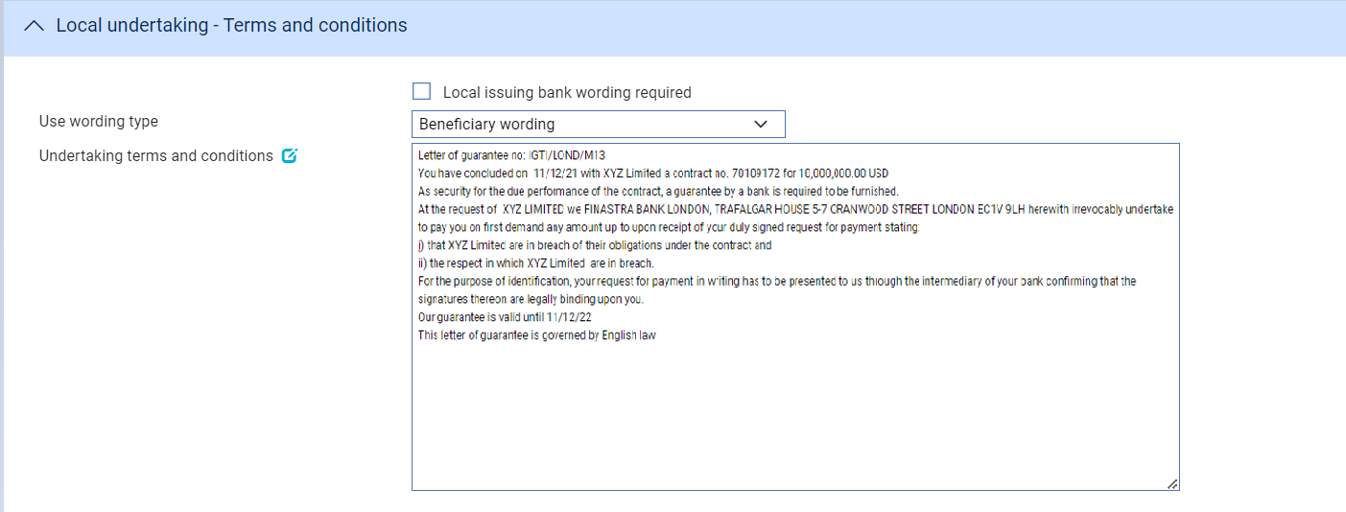

* Use that the bank’s own standard wording and clauses to generate the local undertaking text in a specified language

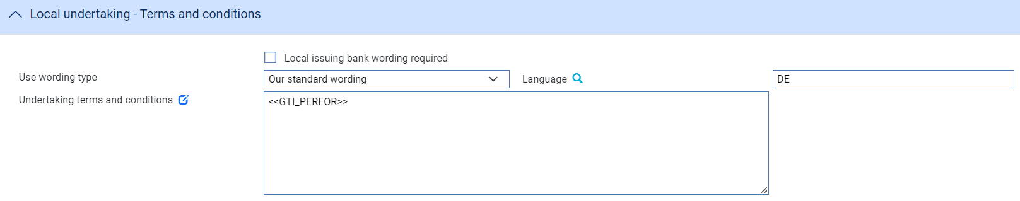

### Local undertaking – Available with

When Form of undertaking in the Local undertaking – Main details pane is ‘Standby letter of credit’, Local undertaking – Available with pane is displayed

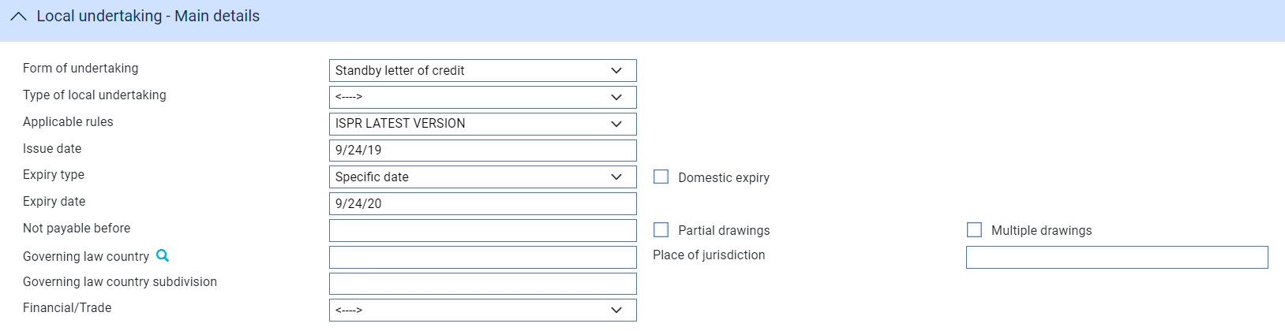



### Local undertaking – Party details

When issuing a counter undertaking, the issuing bank of the local undertaking can be specified in the Local undertaking - Party details pane.

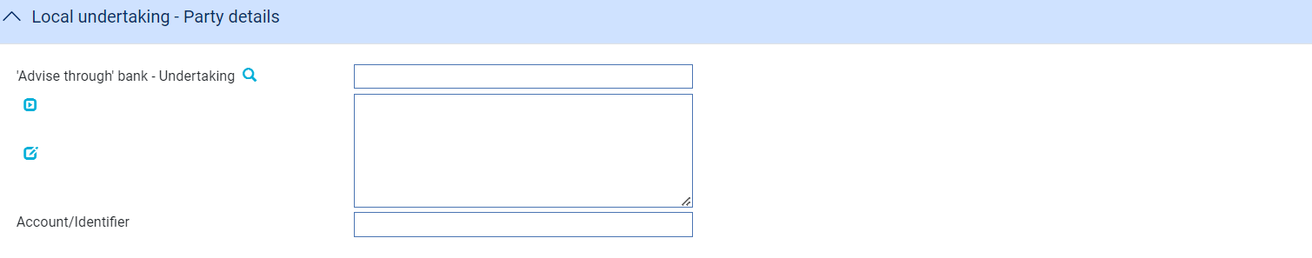

### Entering Full Details for an ‘Received counter’ Undertaking

Where a counter request is received from the Counter Received from bank as either a ‘*Counter received - Request issue’* or ‘*Counter received - request counter* ‘ you are able to record details of the parties involved and details of the Counter received undertaking as follows:

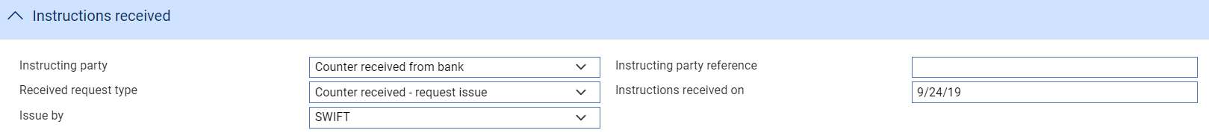



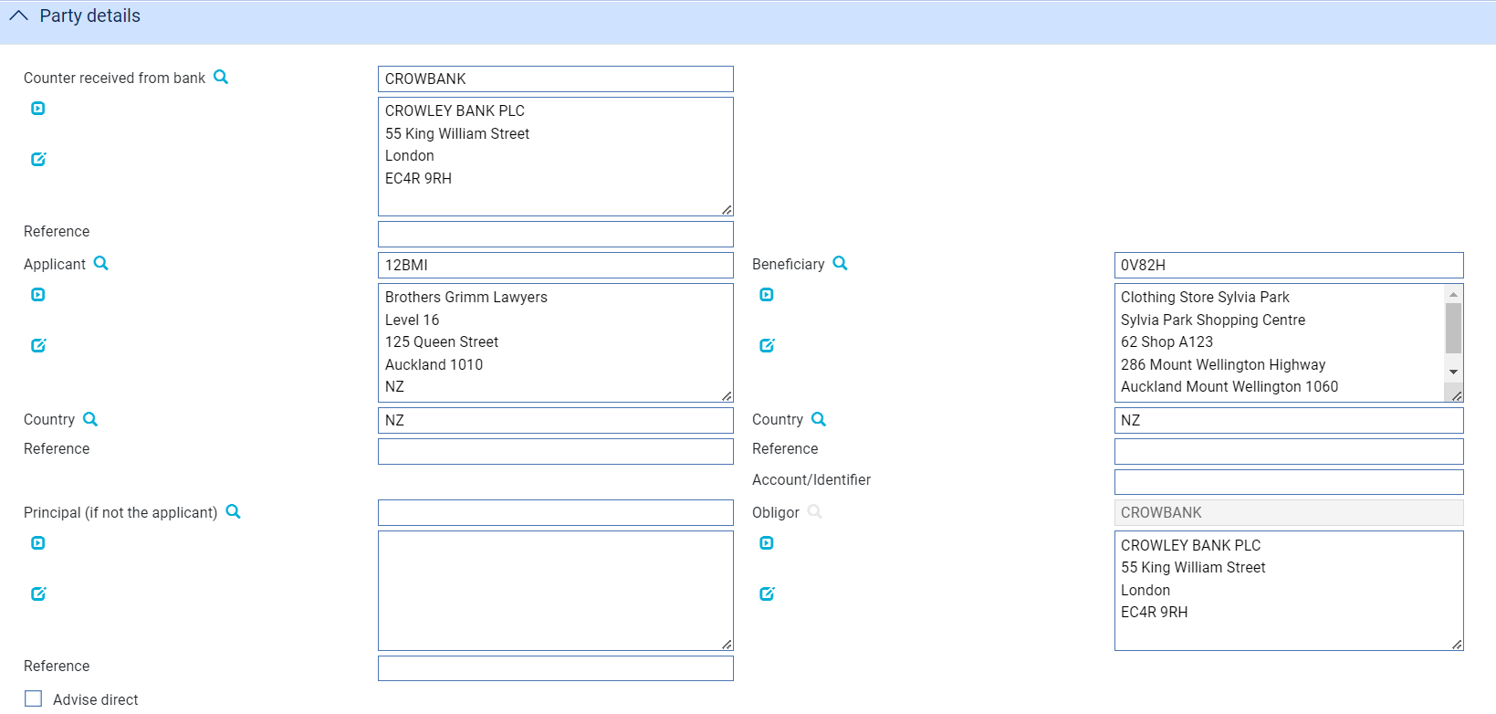

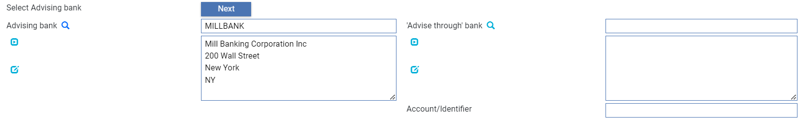

The ‘Counter received’ details are then entered consisting of the following sets of fields as described above

* Counter received - Main details
* Counter received - Amount details
* Counter received – Available with details
* Counter received - Document and presentation instructions
* Counter received - Terms and conditions
* Counter received - Renewal details
* Counter received - Reduction / Increase

### Available with – additional notes

When entering details of the Counter received – Available with details – the following options are available:

* (named bank)
* Any bank
* Any bank in city
* Any bank in country
* Counter received from bank

### Undertaking terms and conditions – additional notes

Where the received request type is ‘*Counter received - request counter*’ then the received local wording instructions are passed on to the next bank

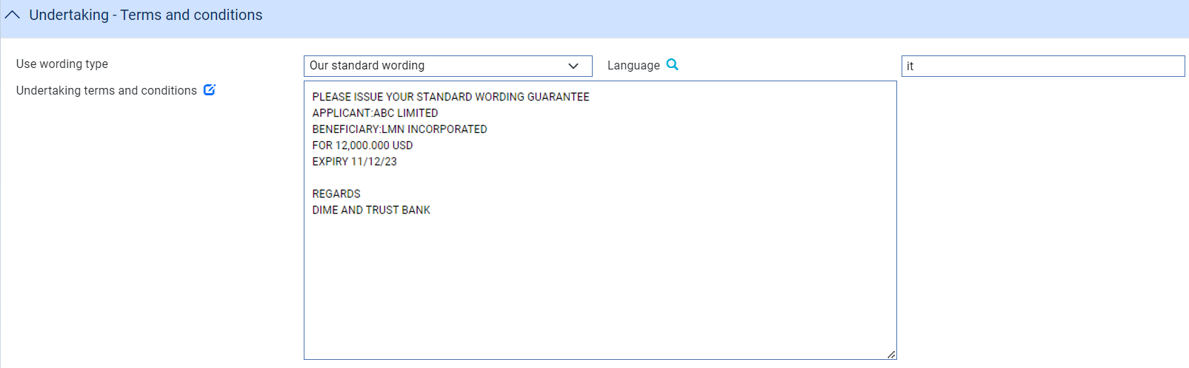 Where the received request type is ‘*Counter received - request issue*’ then the received details are used determine the require wording as either:

* the received wording

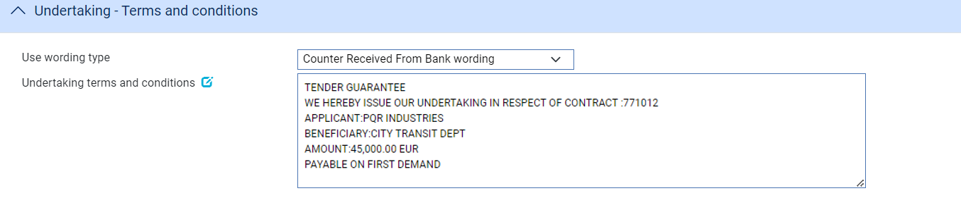

* Standard wording based on the received text

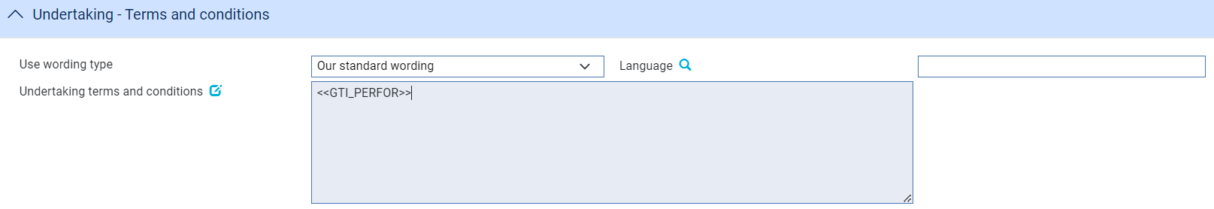

## The Issued Undertaking Master Summary Window

Once you create an issued undertaking, the system displays the basic details of the undertaking using the Master Summary window.

The screen is distributed into 4 areas

* Applicant details
* Undertaking Received request details ( if present)
* Beneficiary details
* Our undertaking request details

The **More..** button allows the user to see the current status of the master.

### Details

* The following details are shown for an **Issue (ISSU) undertaking**

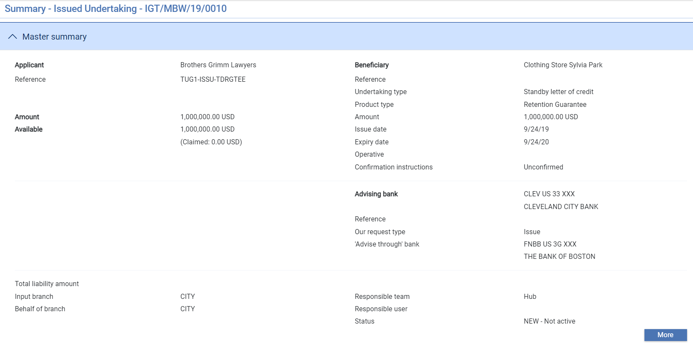

|  |  |
| --- | --- |
| **Applicant**   * Applicant * Applicant reference * Undertaking amount * Available amount and outstanding claim amounts * Additional amounts | **Beneficiary**   * Beneficiary * Beneficiary reference * Undertaking type * Product type * Amount * Issue date * Expiry date * Operative |
|  | **Our undertaking request details**   * Our request type *– Issue undertaking* * Advising bank * Advise through bank |

* The following details are shown for an **Issue (ISCO or ICCO) undertaking**

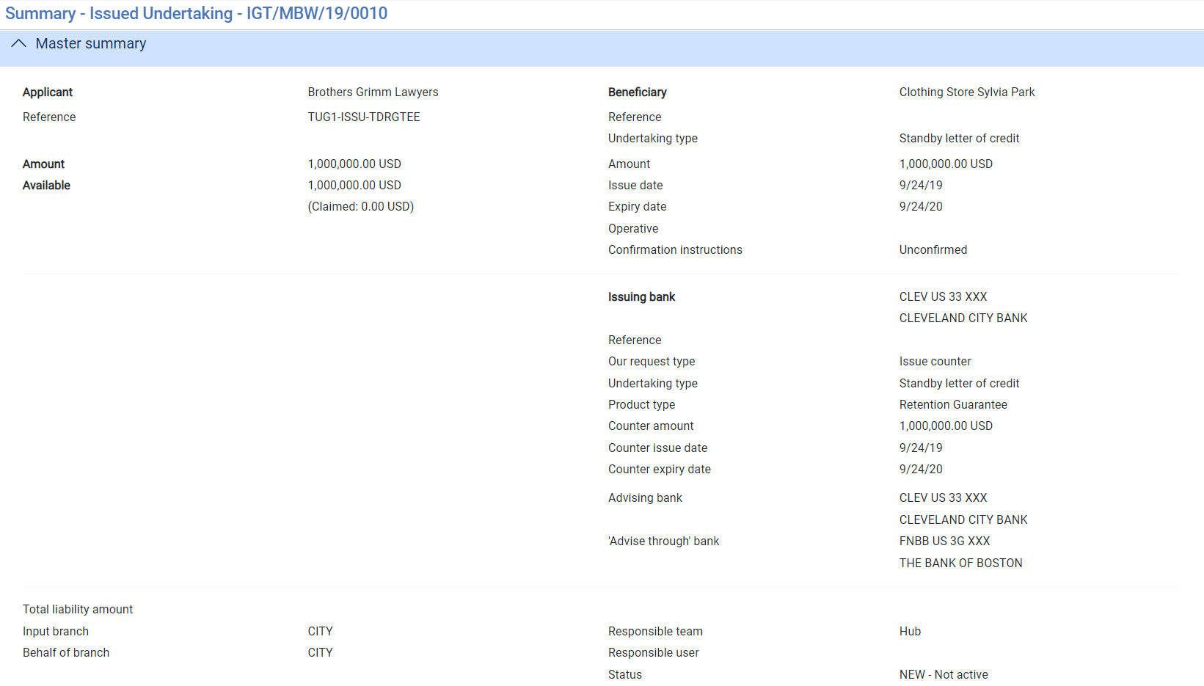

|  |  |
| --- | --- |
| **Applicant**   * Applicant * Applicant reference * Undertaking amount * Available amount and outstanding claim amounts * Additional amounts | **Beneficiary**   * Beneficiary * Beneficiary reference * Undertaking type * Product type * Amount * Issue date * Expiry date * Operative |
|  | **Our undertaking request details**   * Issuing bank * Our request type *– Issue counter or Issue counter & request counter* * Undertaking type * Counter guarantee amount * Issue date * Expiry date * Advising bank * Advise through bank |

* The following details are shown for a Receive ISCO – Counter received – request issue

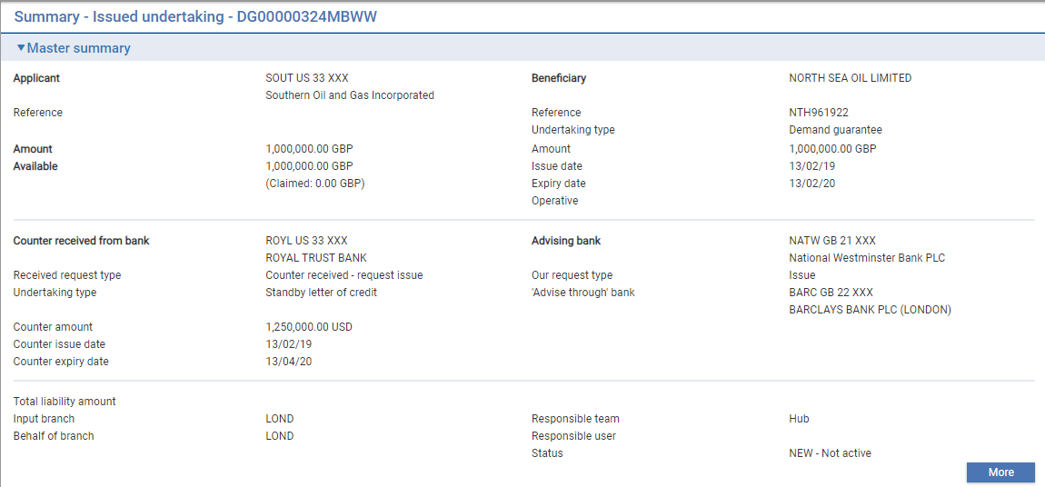

|  |  |
| --- | --- |
| **Applicant**   * Applicant * Applicant reference * Undertaking amount * Available amount and outstanding claim amounts * Additional amounts | **Beneficiary**   * Beneficiary * Beneficiary reference * Undertaking type * Product type * Amount * Issue date * Expiry date * Operative |
| **Counter received details**   * Counter received from bank * Counter received request *– Counter received – request issue* * Undertaking type * Counter guarantee amount * Issue date * Expiry date | **Our undertaking request details**   * Our request type *– Issue undertaking* * Advising bank * Advise through bank |

* The following details are shown for a Receive ICCO – Counter Received – Request Counter

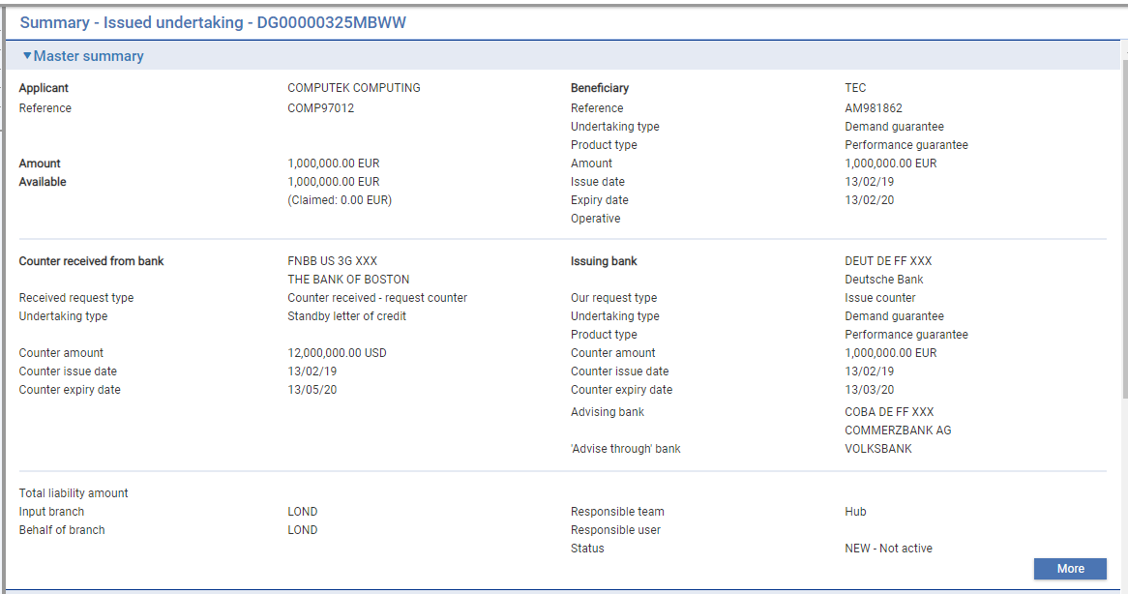

|  |  |
| --- | --- |
| **Applicant**   * Applicant * Applicant reference * Undertaking amount * Available amount and outstanding claim amounts * Additional amounts | **Beneficiary**   * Beneficiary * Beneficiary reference * Undertaking type * Product type * Amount * Issue date * Expiry date * Operative |
| **Counter received details**   * Counter received from bank * Counter received request *– Counter received – request counter* * Undertaking type * Counter Undertaking amount * Issue date * Expiry date | **Our undertaking request details**   * Issuing bank * Our request type *– Issue counter or Issue counter & request counter* * Undertaking type * Product type * Counter Undertaking amount * Counter issue date * Counter expiry date * Advising bank * Advise through bank |

From the Master summary window you can initiate new and continue pended events and enquiry on event history:

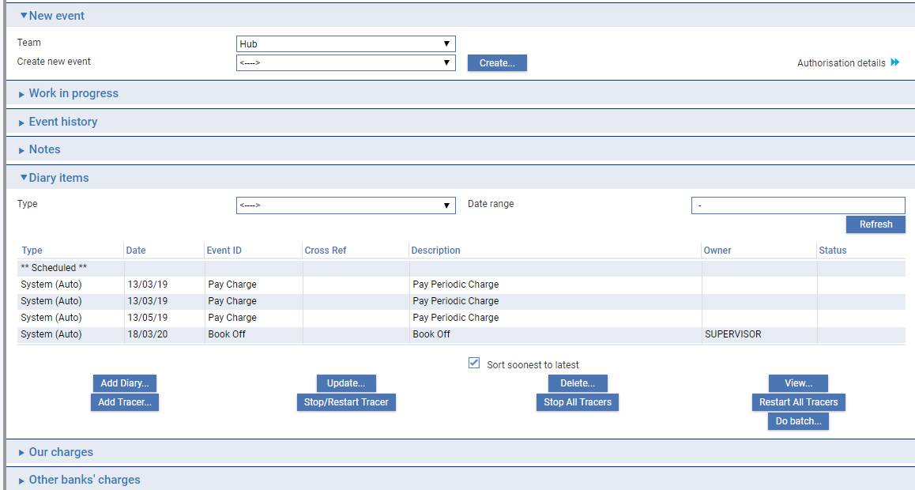

For more information on how the various panes and buttons in this window work see the Common Facilities User Guide – Trade Innovation.

# Acknowledgement

This chapter explains how to use the system to handle acknowledgement of an undertaking.

## Acknowledgement in Trade Innovation

You can use the Receive Acknowledgement event to view details of an acknowledgement you have received or enter details of an acknowledgement to be sent. You can create either a response to that message or a new message within the same event.

If your bank receives an acknowledgement via SWIFT, it uses it to create a Receive Acknowledgement event at an Input step for the appropriate guarantee.

To record an acknowledgement message, in the Master Summary window select 'Receive Acknowledgement' from the Create New Event drop-down list. The system opens the event at either a Log step or Input step. Depending on how your system is configured, panes and fields available in log steps can be tailored for each data capture step. See the *SDK - Screen Tailoring Guide* – Trade Innovationfor details.

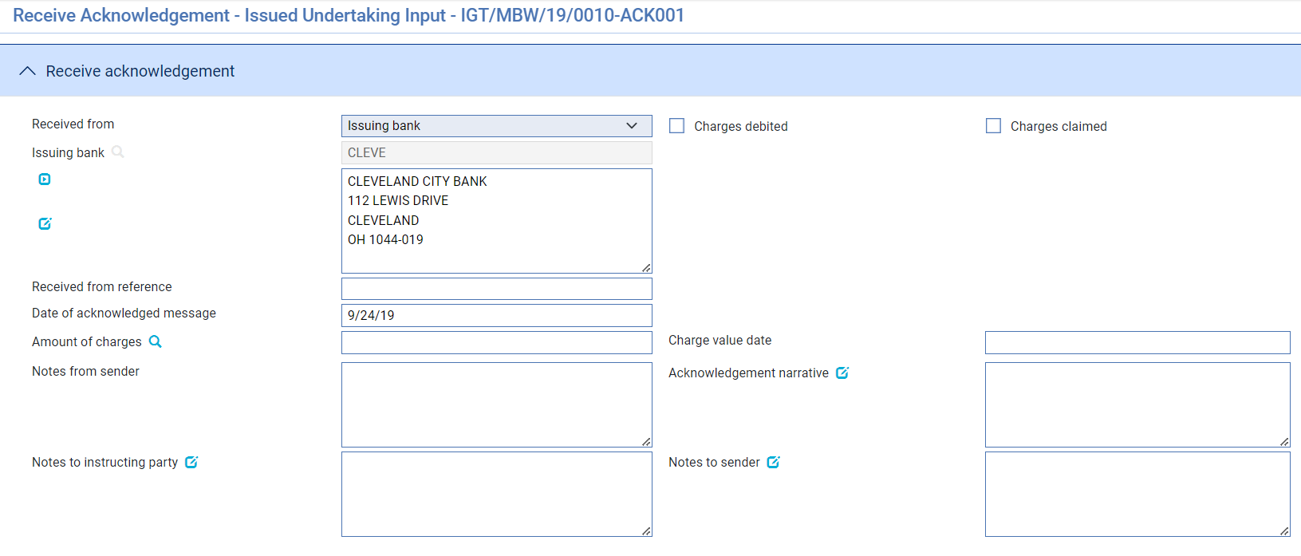

The default for the Received From party is the non-principal party.

Use the Received From Reference field to enter the Received From party's reference for the guarantee and the Narrative field to enter any narrative associated with the response. The Charges Claimed and Charges Debited boxes permit you to indicate, if appropriate, whether the advising bank is claiming or has debited its charges. You cannot check both of these boxes, but you can leave them both blank.

Use the Date Received field to enter the date your bank received the acknowledgement.

# Claims Received against an Issued Undertaking

This chapter explains how to use the system as the issuing bank to log the receipt of documents from the presenting bank, select the required payment action and to process notifications of claims received, including continuing claims that are left unpaid pending enquiries. It also explains how to enter details of loans, additional amounts, margin deposits and discounts against payments.

For information on payment actions including additional bank defined actions and their effect on charges see the Appendix.

For information on repaying a financing loan from within a payment event see the Financing User Guide – Trade Innovation.

## Claims and Requests for Payment

When the beneficiary presents documents to the paying or negotiating bank and requests payment, the bank will deal with the claim in one of the following ways:

* *Pay* - They may pay the presenter, if the payment is payable on demand, or enter details of future deferred or acceptance payments where applicable.
* *Request payment* - they may request payment from the issuing bank and pay the presenter when payment is advised.
* *Request to Pay or Extend* – This is used where the beneficiary gives the applicant opportunity to extend the undertaking rather than paying the demand. If the response is to *Extend* then the undertaking expiry date is extended.
* *Pay and Claim against counter or Claim against counter* – These options are used to claim against the counter undertaking from the counter issuing bank. These allow the presenting party to be paid and the counter claim settled separately or the demand paid once funds have been received.
* *Other options:* The bank can define additional payment actions for other business scenarios, such as where there are discrepancies in the documents:
* If the documents have minor discrepancies, they may make payment to the presenter, but reserving the right, if you as issuing bank reject the documents, to request repayment from the presenter
* If the documents have major discrepancies, they may request authorisation from you as issuing bank before they pay the claim

They may or may not send the documents presented for consideration with the claim advice, and so the documents may arrive under separate cover.

As issuing bank, you will use two different events within the system in response to claims advices received from the presenting bank:

* The Claim Received event to log information about an initial claim made by the presenter and to record the receipt of documents. You can use a Claim Received event to pay the claim, or you can complete the event without making payment whilst awaiting, for example, documents or responses to enquiries or counter claim.
* The Outstanding Claim event, to continue a Claim Received event, to enter details of documents received after the claim itself, or details of a response from the applicant following a request for payment. As for the Claim Received event, the Outstanding Claim event can be used to settle the claim, or it can be completed without making payment, whilst awaiting the result of further enquiries

An undertaking may have more than one Claim Received event, and each Claim Received event may have a history of several Outstanding Claim events associated with it. However, only one Outstanding Claim event can be in progress for each claim at any one time.

If the guarantee is participated, payment may result in a Drawdown/Revolve Commit Amt event being created as a subsidiary event, to increase the commitment amount available on the participation deal, if the deal is revolving.

### Assignments of Proceeds

During payment events the system permits you to set up new assignments for the transaction, and to access details of assignments already set up and allocate proceeds to them.

Each payment amount allocated to an assignment can be discounted as part of the payment event, if required. However, it cannot be discounted later, once the payment event has completed.

### Participated Deals

If the transaction is participated, payment may result in a Drawdown/Revolve Commit Amt event being created as a subsidiary event to increase the commitment amount available on the participation deal, if the deal is revolving.

### Licenses

If there is a license attached to a revolving transaction, the license amount must be sufficient to cover the maximum amount available under the transaction - that is, the transaction amount plus the maximum tolerance - multiplied by the number of revolving cycles.

See the Licenses User Guide – Trade Innovation for details of licenses.

### Financing Transactions

If your system has the financing module implemented, then while processing a payment the Finance pane will be available.

This allows you to record a financing transaction against the payment, as described in the Financing User Guide – Trade Innovation.

You can also repay a financing transaction from within the payment event.

### Payment at Maturity

For claims whose payment action was 'Pay at Maturity' ( or 'Accept') the system creates an outstanding payment event in the diary to handle the payment at the time of maturity. When the maturity date is reached the system processes the event during overnight processing. The event may require input or review and/or authorisation, in which case the system places the event in the Work in Progress pane for you to complete.

When you open an outstanding payment event for a maturity payment the system displays the relevant ‘Maturity’ response type.

## Claims Received

To initiate a claim, in the Master Summary window select 'Claim Received' from the Create New Event drop-down list and click **Create**. The system opens the event at either a Log step or Input step, depending on how the Workflow orchestration controlling the event is configured. See the *Workflow Tailoring User Guide* – Trade Innovation for details.

### Recording details of the Claim received

If your system has been configured to have a log step as part of your workflow the system will display a Log window allowing you to enter basic details of the Claim.

The following Input step uses the following panes:

* The Issued Undertaking Details pane (see page 42)
* The Main Claim Details pane (see page 43)
* The Payment Action pane (see page 45)
* The Payment Details pane (see page 46)
* The Additional Amounts pane (see page 49)
* The Associated Payment Details pane (see page 49)
* The Instructions pane (see page 50)
* The Documents/Notes pane
* The Other Beneficiary Bank pane (see page 50)
* The Reimbursing Details pane (see page 51)

Instructions on using the Documents/Notes pane are given in the Common Facilities User Guide – Trade Innovation.

#### The Issued undertaking Details Pane

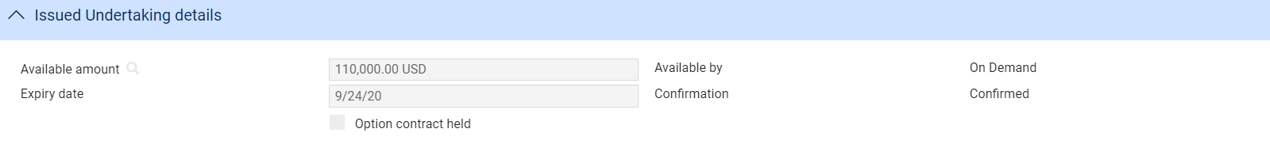

This provides some of the key details relevant to payment of the undertaking – read only.

#### The Main Claim Details Pane

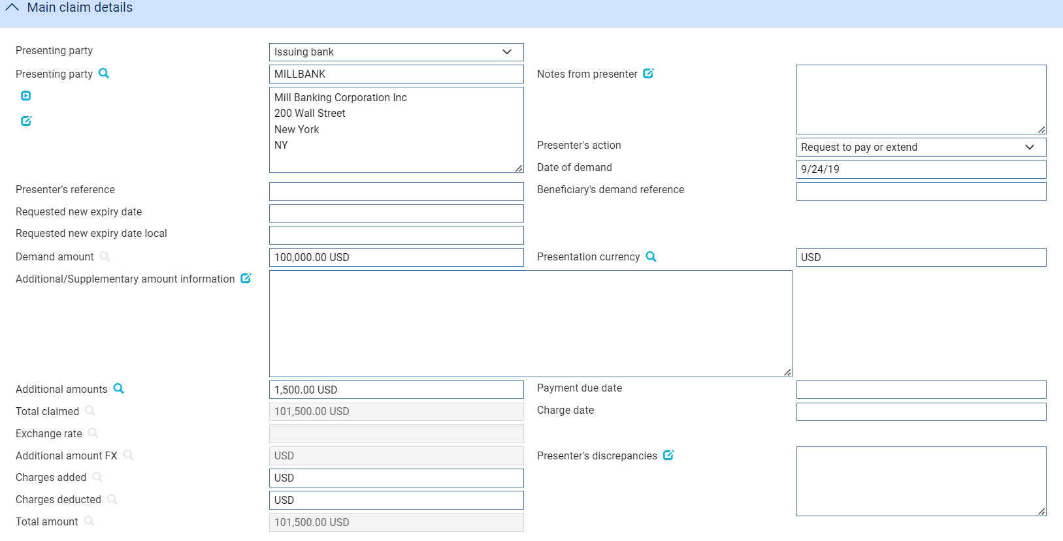

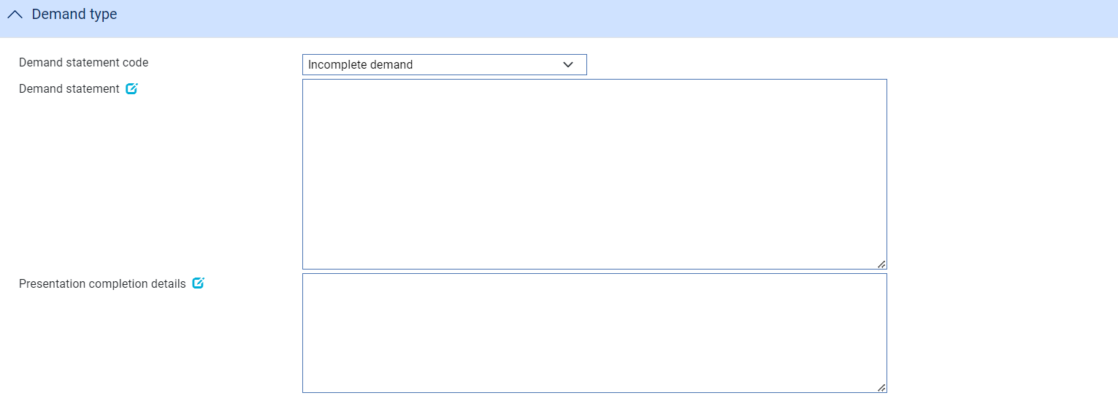

The following table explains what you should enter into the fields in the Main Claim Details pane.

|  | Field | What to Enter |
| --- | --- | --- |
|  | Presenting Party | The presenting party. You can use the first field to select a party already identified for the transaction using their party role, in which case their details are retrieved and displayed in the remaining fields in this pane.  Alternatively, if the presenting party has not been assigned a party role within the transaction, select 'Other presenting party' in the first field, then use the remaining fields to enter their details in the usual way.  Click **Refresh** once you have made a selection here.  The system uses the advising bank as the default, or the beneficiary, if the transaction was advised direct. |
|  | Presenter's Reference | The presenting party's reference for the claim. |
|  | Notes from Presenter | Any notes received from the presenting party. |
|  | Presenter's Action | Choose one of the following values from the drop-down list to indicate what action the paying bank has taken with regard to the claim:   * Request Payment * Request Pay or Extend * Request Authorisation to Pay * Pay and Claim Reimbursement * Request Acceptance * Sender has Debited our Account * Documents Sent On Approval * Other  1. The items in the list are configured by your bank and so may differ from the list above. |
|  | Date of the Demand | The date the documents were presented at the bank from whom you received the claim. |
|  | Presenter's Reference | The presenter's reference for the Demand |
|  | Beneficiary’s demand reference | The beneficiary’s reference for the Demand |
|  | Requested new expiry date | The requested new expiry date where the demand is to *Request Pay Or Extend* |
|  | Requested new expiry date local | The requested new expiry date. When the demand is to *Request Pay Or Extend* and the Request type is Issue Counter (ISCO) or Issue counter/request counter (ICCO), then a new expiry date for the local undertaking can be requested.   1. This date cannot be later than Requested new expiry date. |
|  | Presentation Amount | The system displays either the available amount of the transaction or the presentation amount, if entered during a Log step. |
|  | Presentation Currency | The currency of the amount being claimed. |
|  | Additional Amounts | Any additional amounts being claimed, and the currency in which they are being claimed. |
|  | Payment Due Date | The date payment is due, or the value date used to debit your account with the presenting bank. |
|  | Charge Date | The value date for any charges taken separately. |
|  | Exchange Rate | Exchange rate where additional amounts are in a different currency |
|  | Additional Amount FX | Exchange rate to convert the additional amounts to undertaking currency |
|  | Charges Added | The value and currency of any charges that the sender has informed you have been added to the payment amount. For complete reconciliation check that this amount is equal to the charges due to the presenting party. |
|  | Charges Deducted | The value and currency of any charges that the sender has informed you have been deducted from the payment amount. For complete reconciliation check that this amount is equal to the charges due from the presenting party. |
|  | Total Amount | The system calculates the total amount being claimed and then displays it in this field. |
|  | Presenter's Discrepancies | If the action involves a request for authorisation to pay, use this field to enter details of any discrepancies advised by the presenter or any notes in the supporting documents. |
|  | Demand statement code | Select whether the Demand is *Complete* or *Incomplete* |
|  | Demand statement | Details of the Demand |
|  | Presentation completion details | Where the demand is Incomplete enter further details of how the presentation documents will be completed |
|  | Transfer by/File name | The type of delivery channel and associated file name or reference. |

#### The Payment Action Pane

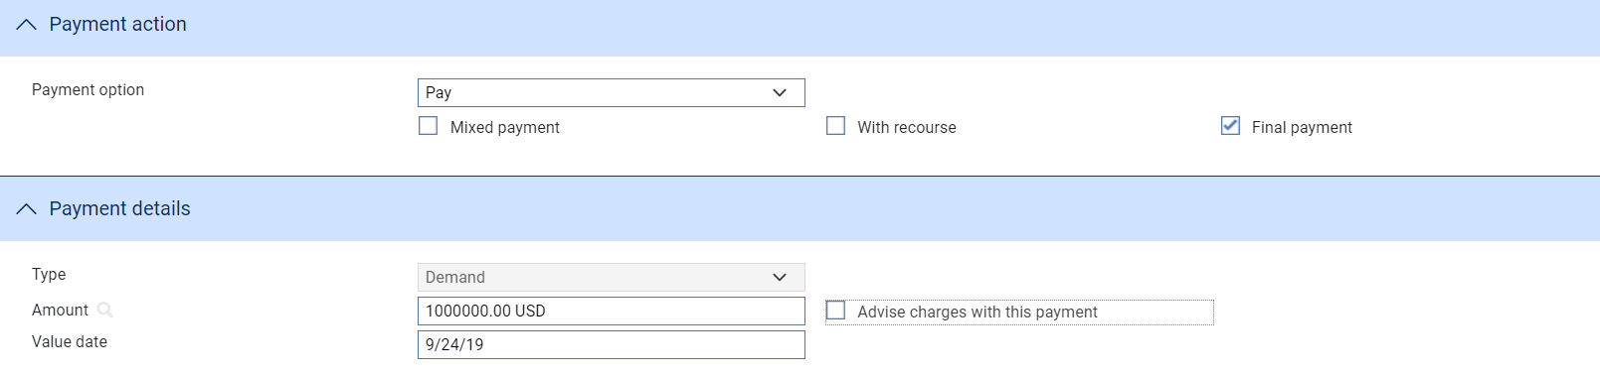

See the Appendix for a list of payment actions.

The Payment Action pane allows you to process the claim by selecting a payment action and then entering details of the payment.

The actions included in the Payment Option drop-down list vary, depending on whether the undertaking was a direct presentation by the beneficiary, and on the presenter's actions, for example whether they are requesting pay or extend, authorisation to pay or whether instead they have paid and are requesting reimbursement. Where a counter guarantee has been received, additional payment options ae available.

Normally for a Demand payment, details of the actual payment are entered into the Payment Details pane. However, if a mixed payment is required, to involve two or more part payments, check the Mixed Payment field. The system displays a Payments pane, which you can use to enter details of each of the part payments in turn.

Check the With Recourse box if the payment is with recourse; and the Final Payment box if the payment includes the final payment under the reimbursement authority.

If your payment action is 'Reject and Claim Refund' enter the date of the refund into the Refund Date field.

The payment action you select applies to all part payments. However, where the action is 'Pay' the individual status of a payment can be changed using the Pay Status field in the Payment Details window.

Note that:

* If you enter any part payment details, the value of all part payments must not exceed the value of the letter of credit, and must reconcile with the claimed amount
* Where the payment action for an individual part payment is 'Pay at Maturity' (or 'Accept'), the system creates a diary event which will cause an Outstanding Claim event to be generated automatically at the appropriate time to allow that part payment to be matured
* If the payment action is 'Pay' for a future dated payment, acceptance or deferred payment, the system generates the postings and funds movements for the future date, and no separate future Outstanding Claim event takes place. The forward-dated postings are held by the system until the value date is reached, then posted during batch processing
* If the payment action is *'Request Approval from Applicant’*, the system displays an additional field - Reasons for Authorisation request - in the Instructions To Send pane
* Where the payment action is a *Request to Pay or Extend* or *Extend* an additional expiry date field is displayed



* When the payment action is *Request to Pay or Extend,* or *Extend,* and Request type of the undertaking is Issue Counter (ISCO) or Issue counter/request counter (ICCO), a new field, Expiry date local, is displayed below the Expiry date.

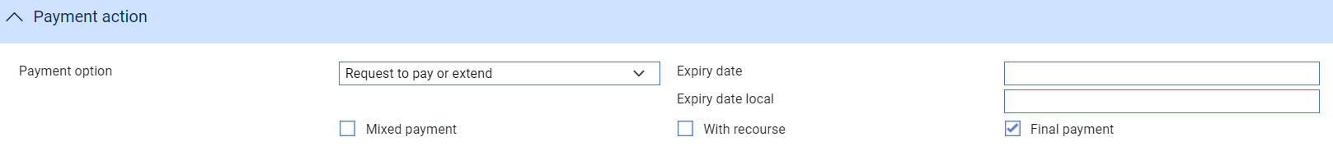

1. This date cannot be later than Expiry date.

* Where the payment action is *Extend* the system automatically creates an Amend event on release of the payment event.

1. The system is delivered with a standard set of ‘Presenter’s actions’ and ‘Payment actions’ which will typically cover the required processing for claims and documentary presentations. However, depending on your bank’s internal processes and requirements, it may be necessary to create additional Presenter’s and Payment actions that are more appropriate to your workflow.

Where this is required, your bank can use System Tailoring to define its own Parameter set based Presenter's actions and Payment actions for Issued undertakings and additionally, create Transfer presenter's actions and Response actions as required. A code and description can be entered for each of these actions together with the associated underlying payment ‘behaviour’ type, such as *General request, Pay, Pay and Claim against counter, Claim against counter, Request to Pay or Extend, Extend, Reject, or Pay at maturity* which then determines the subsequent processing of the payment when the action is selected.

See the *System Tailoring Guide* – Trade Innovationfor instructions on defining additional payment actions.

#### The Payment Details Pane

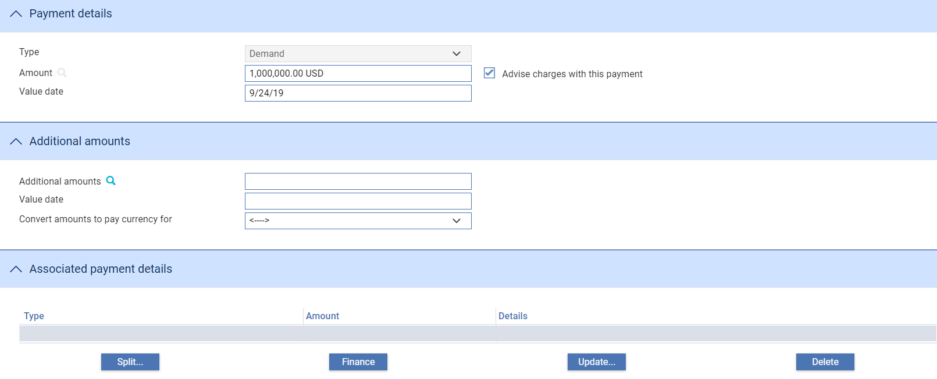

The Payment Details pane allows you to enter details of the payment you are making.

The Payment type is normally set to Demand for a received undertaking.

Where an existing master has an associated payment types of Sight, Deferred, Acceptance then the relevant screen is shown allowing the details to be entered or changed to Demand. However, once changed to Demand the payment type can no longer be changed .

Where a counter undertaking has been received from another bank, the button allows you enter details of your bank’s claim against that undertaking.

When selected, the following details can be entered:

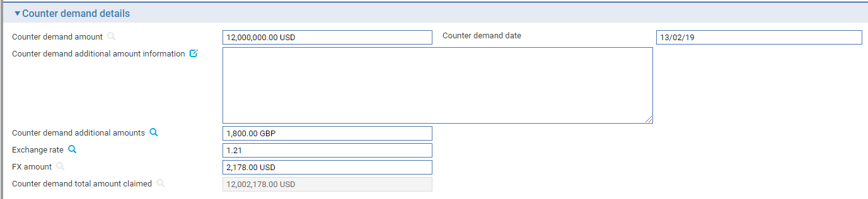

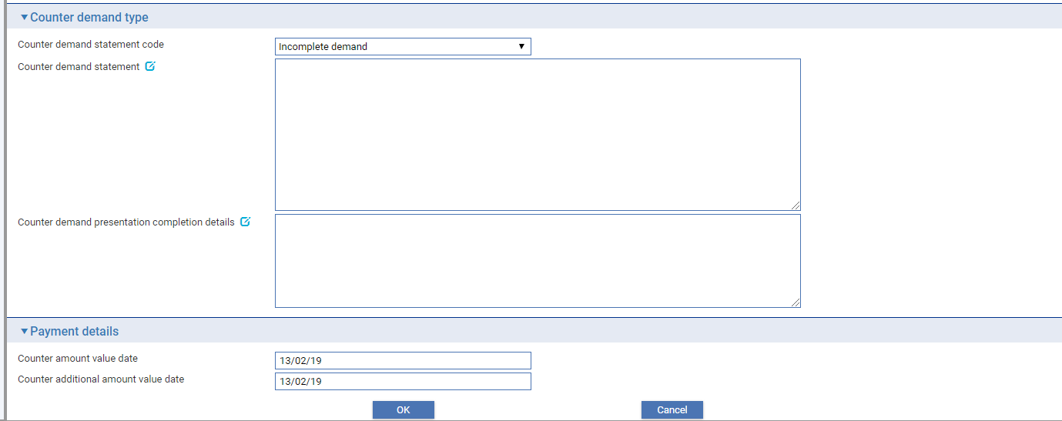

|  | Field | What to Enter |
| --- | --- | --- |
|  | Counter demand amount | Counter demand amount |
|  | Date of the Demand | The date the documents were presented at the bank from whom you received the claim. |
|  | Counter demand additional amount and information | Amount and details of any counter additional amount |
|  | Exchange Rate | Exchange rate where additional amounts are in a different currency |
|  | Additional Amount FX | Exchange rate to convert the additional amounts to undertaking currency |
|  | Counter Demand Total Amount | The system calculates the total amount being claimed and then displays it in this field. |
|  | Counter Demand statement code | Select whether the demand is *Complete* or *Incomplete* |
|  | Counter Demand statement | Details of the counter demand |
|  | Counter Demand Presentation completion details | Where the demand is Incomplete enter further details of how the presentation documents will be completed |
|  | Counter amount value date | Value date of counter demand amount |
|  | Counter additional amount value date | Value date of counter demand additional amounts |

For mixed payment, check the Mixed Payment field in the Payment Action pane. A new pane - the Payments pane - is displayed.

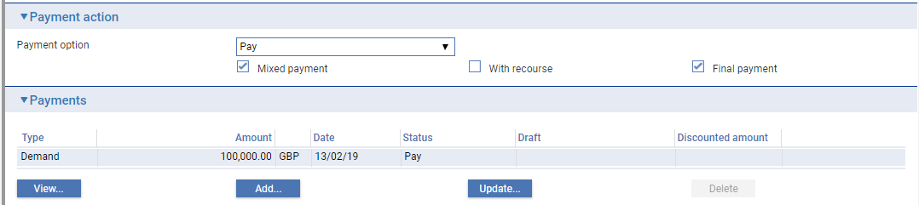

Select the payment listed in this window and click **Update**. In the window that appears, define the first part payment.

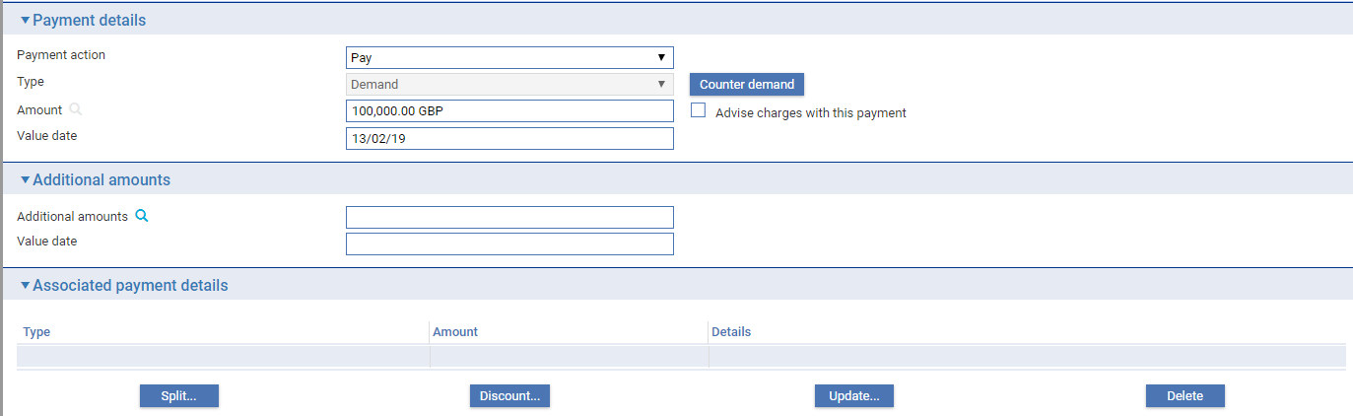

The fields are the same as those used in the Payment Details pane to define a single payment. When you close the window, the details of the part payment are listed in the Payments pane, from where you can select them and amend or delete them. Use the **Add** button to reopen the window to enter details of the next part payment.

Once you have entered details of a payment, or part payment, it is listed in the Payments pane.

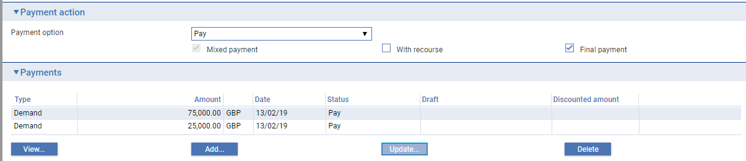

1. The system creates a first part payment for the full amount of the payment event. If you add more part payments, amend the amount of this first part payment accordingly.

The following table explains what to enter to define a payment or part payment:

| Field | What to Enter |
| --- | --- |
| Payment Action | This field is displayed only for mixed payments, and it initially reflects the payment action selected for the Demand in the main Input window. If the payment action involves refusal or leaves the claim outstanding, then you will not be able to alter the value in this field.  If the payment action involves paying the claim, then you can use this field to select a status for each individual part payment.  Select from the available options. |
| Type | Set to Demand. (Sight, Deferred or Acceptance may be displayed where an existing master is not *Available by* Demand allowing additional details to be entered such as the tenor period, draft id, hold and eligible). |
| Amount | The amount being claimed. |
| Advise Charges with This Payment | Check this box if charges taken or claimed are to be advised with this payment. |
| Value Date | For Demand or Sight payments, enter the value date of the payment.  For Acceptance and Deferred payment the value date of the payment is calculated using the value in the Period field.  The system issues a warning if this date does not leave enough time for any pre-debit notification required. |
| Start Date/Period/From/ After | For acceptance and deferred payments, the start date of the payment period.  Use the Period field to define the period (as, for example, 1 month or 10 days), then use the From/After field to indicate whether the period will be calculated from or after the base date. |
| Draft Identifier | If there is a draft identifier, enter it here. |
| Hold | This field is displayed for sight and acceptance payments. Check it if drafts are being held, and uncheck it if they are being returned to the claimant.  You can discount a draft only if this and the Eligible box are checked. |
| Eligible | This box must be checked for you to be able to discount a part payment. For sight and acceptance payments, the Hold box must also be checked. |

#### The Additional Amounts Pane



The following table explains what to enter into the fields in the Additional Amounts pane:

|  |  |
| --- | --- |
| Field | What to Enter |
| Additional Amounts | Any additional amount. |
| Value Date | The value date of any additional amount. |
| Margin Amount For | Where relevant, the amount to be taken as a margin deposit. |

#### The Associated Payment Details Pane

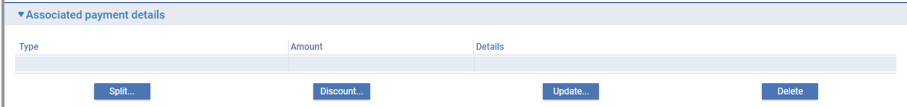

The Associated Payment Details pane allows you to apply further processing against the payment or part payments being made. As payments are entered they are listed in this pane. You can select them individually and enter details of a loan or discount or license drawdown.

See Chapter *Processing Additional Payment Details* for instructions on using this pane to apply further processing against the payment or part payments being made.

#### The Instructions Pane

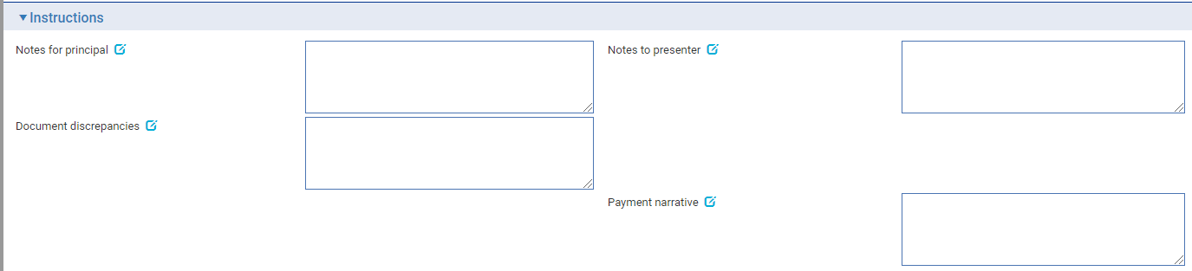

The Instructions pane allows you to enter notes for the principal (applicant or counter issuing bank), and the presenter.

Depending on the setting of the system option DiscrepancyFieldAlwaysVisible the Document Discrepancies field may be displayed here, even if the payment action would not normally require it to be populated. When the system option is switched on, the field allows you to enter minor discrepancies for your bank's own audit purposes, where the payment action does not normally involve reporting discrepancies.

#### The Documents Pane

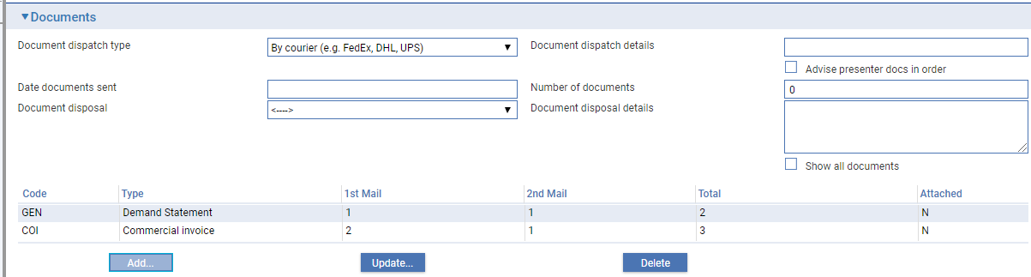

For instructions on using the fields in the Documents/Notes pane to identify any documents being presented see the Common Facilities User Guide – Trade Innovation.

The buttons in this pane allow you to identify the documents required by or received against a transaction; and to subsequently view, amend or delete those documents.

#### The Other Beneficiary Bank Pane

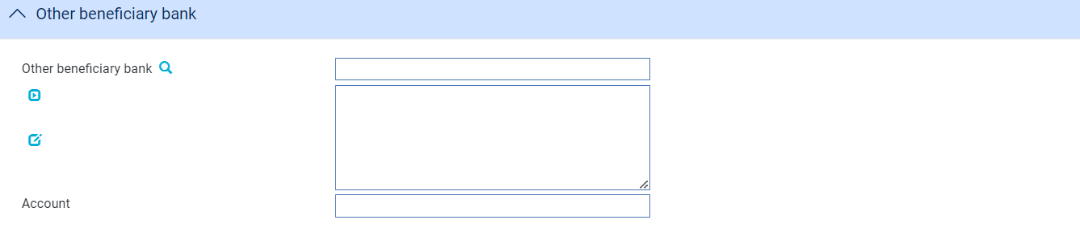

The following table explains what to enter into the fields in the Other Beneficiary Bank pane

| Field | What to Enter |
| --- | --- |
| Other Beneficiary Bank | The party the presenter of the guarantee wants you to pay (if other than the presenter). |
| Account | The number of the account to be credited with the bank identified in the Other Beneficiary Bank field. |

#### The Reimbursing Details Pane

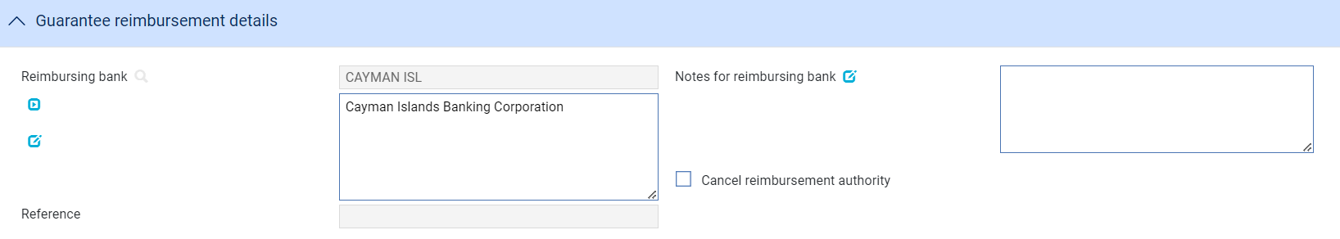

The following table explains what to enter into the fields in the Reimbursing Details pane:

| Field | What to Enter |
| --- | --- |
| Reimbursing Bank | The reimbursing bank. |
| Notes to Reimbursing Party | Any notes to the reimbursing bank. |
| Reference | The reimbursing bank’s reference, if known. |
| Cancel Reimbursement Authority | Where the payment leaves an outstanding balance you can use this box to cancel the reimbursement authority. If you check this box, the system can be configured to generate an MT747 Amendment to Authorisation to Reimburse message for the reimbursing bank instructing it to cancel the reimbursement authorisation.  If you cancel a reimbursement authorisation in this way, you must include the CANC codeword in the Notes to Reimbursing Bank fields. |

## Continuing a Claim

If you select a payment action during the Claim Received event that involves requesting payment or requesting pay or extend or other request payment that leaves the claim incomplete, then the Outstanding Claim event allows you to log the response received and continue the claim.

To continue the claim, in the Master Summary window select 'Outstanding Claim' from the Create New Event drop-down list and click **Create**. The system opens the event at either a Log step or Input step, depending on how the Workflow orchestration controlling the event is configured. See the *Workflow Tailoring User Guide* – Trade Innovation for details.

### Selecting the Claim to Continue

If there is only one outstanding claim, the system retrieves it and displays its details. If there is more than one outstanding claim, you must use the **Select** button to select the one to continue. When you click this button the system displays the Select Payment Event window.

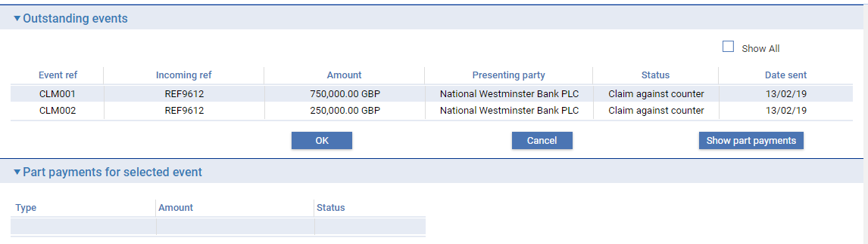

This window lists all completed Claim Received events that have not been paid. The window does not show any claims currently in progress. If you check the Show All box, The system also includes in the list all completed Claim Received and Outstanding Claim events that have been paid in full or been rejected.

If you check the Show All box, the system also includes in the list all completed payment events that have been paid in full or been rejected. You can initiate an outstanding claim event against a completed claim event in order to issue general correspondence or to reject a previously-paid claim.

You can view details of the part payments associated with a claim by selecting the event and clicking **Show Part Payments**.

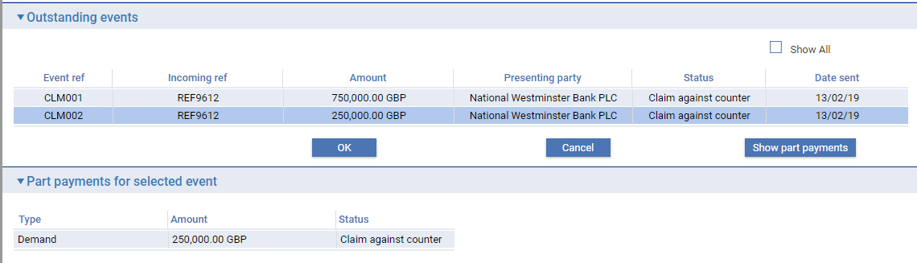

When you select an event and then click **OK**, the system closes the window and displays information taken from that event.

### Entering the Full details of a Response

The table below lists the fields shown for the response details for the outstanding presentation.

If your system has been configured to have a log step as part of your workflow the system will display a Log window allowing you to enter basic details of the response received.

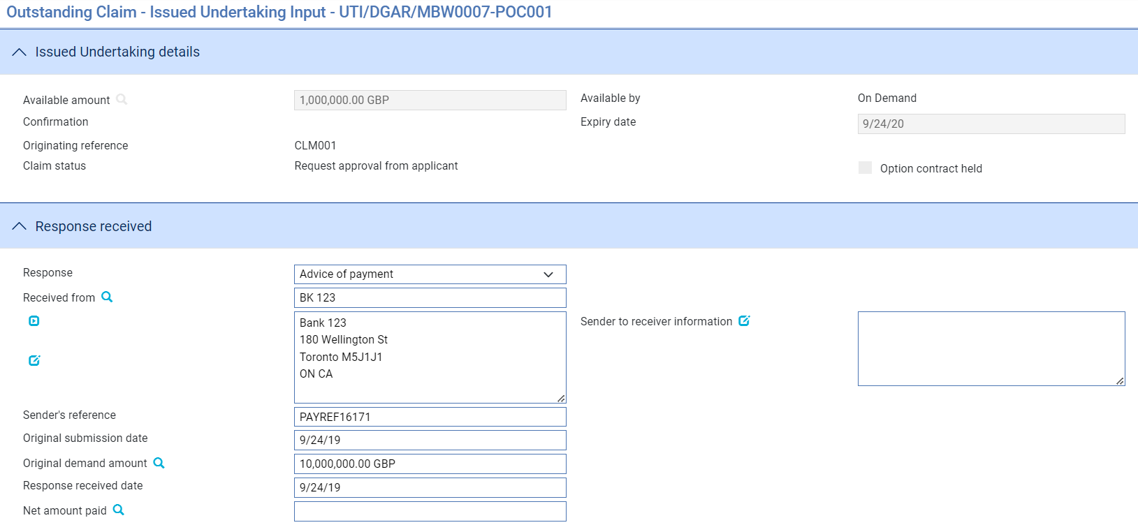

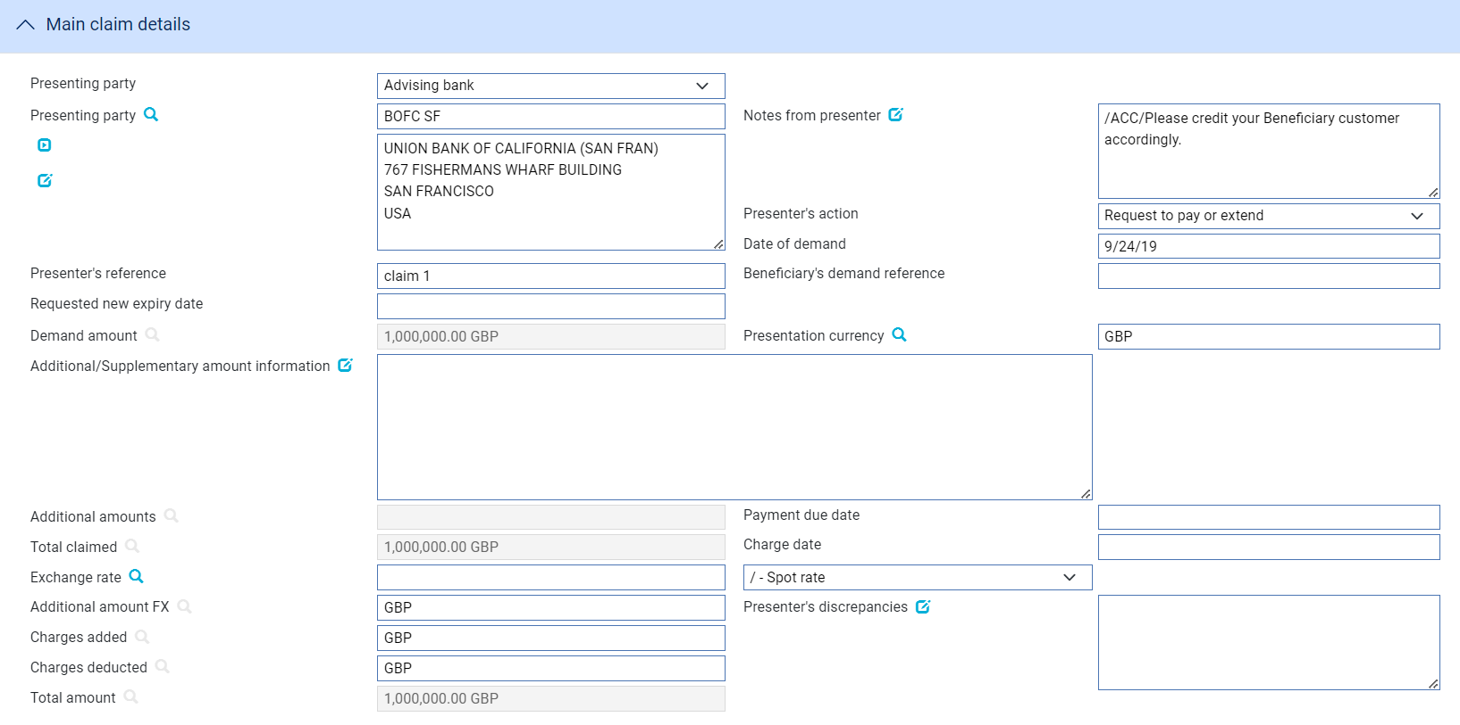

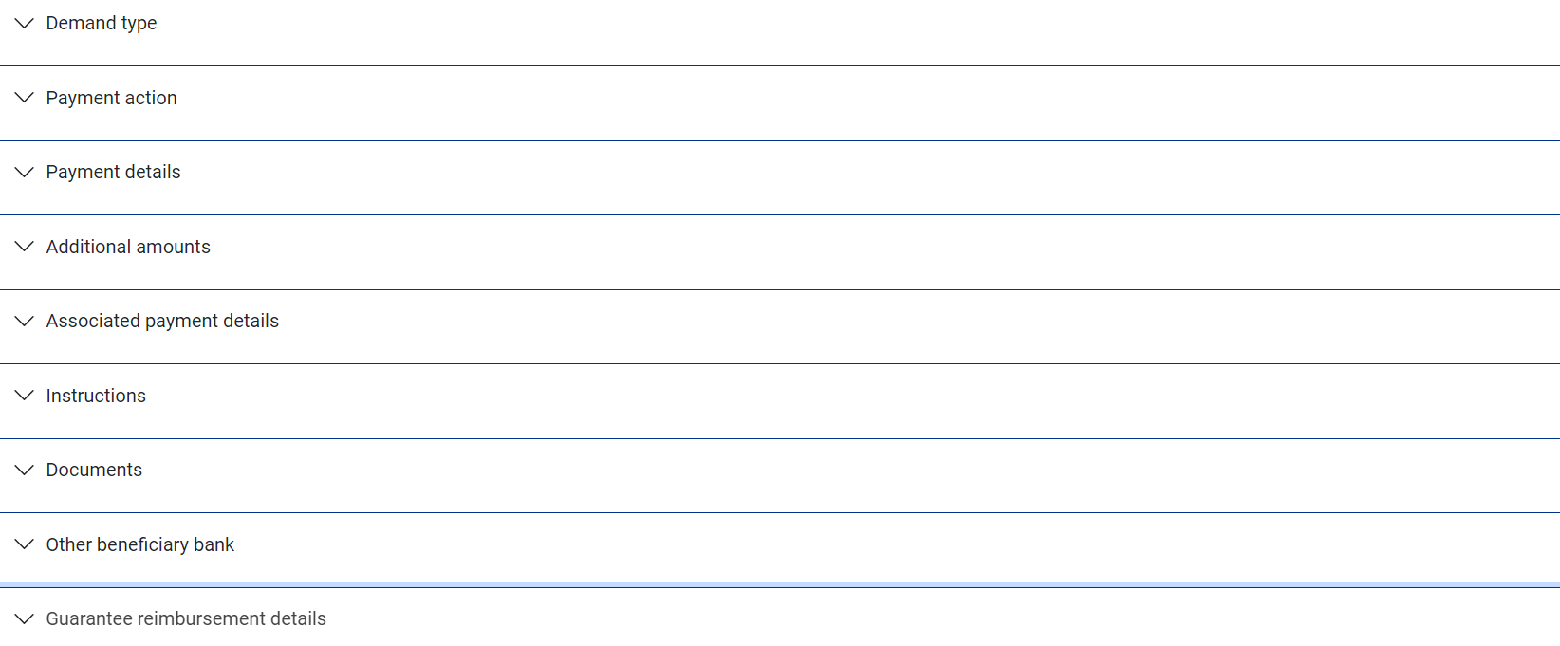

If there is only one outstanding claim, the system retrieves it and displays its details. If there is more than one outstanding claim, use **Select** (see page 51) to select the one to continue.

Use the Received From fields to identify the party from whom you received the response, and enter their reference for the response into the Sender’s Reference field.

The Response field allows you to identify the type of response received. You can select from the following values:

* Advice of payment
* Pay or Extend Response – Pay
* Pay or Extend Response - Extend
* General (see page 54)
* Documents Received (see page 54)
* Refusal (see page 55)
* Authorisation to Pay (see page 56)
* Maturity (see page 41) (if the event has been generated automatically from a diary action)
* Reverse Payment (see page 57)

The fields shown in the window vary, depending on what response type you select.

#### Advice of payment

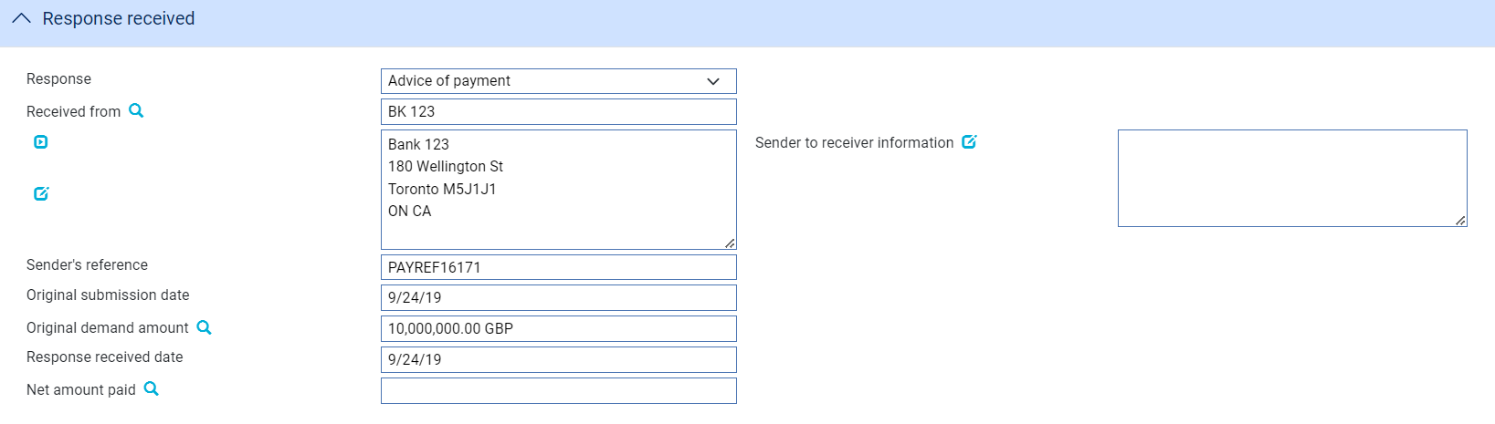

The following table explains what to enter into the fields displayed when you select Advice of Payment:

|  |  |
| --- | --- |
| Field | What to Enter |
| Sender to Receiver Information | Any narrative from the sender. |
| Payment Advice Date | The date of the original payment advice. |
| Amount Originally Claimed | The amount claimed on the original payment advice. |
| Response Received Date | The date on which you received the response. |
| Net Amount Paid | The total amount being paid by the sender of the message. |

#### Pay or Extend Response – Pay

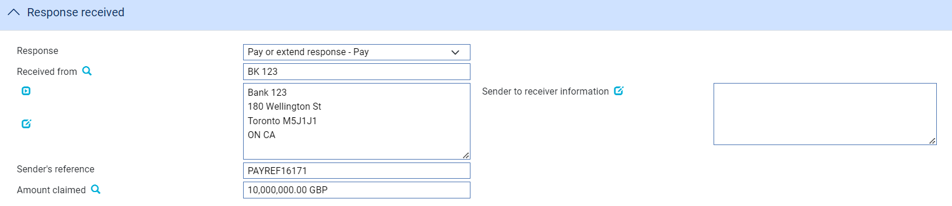

The following table explains what to enter into the fields displayed when you select a Pay or Extend response of *Pay*:

|  |  |
| --- | --- |
| Field | What to Enter |
| Sender to Receiver Information | Any narrative from the sender and sender’s reference |
| Date of the extend or pay request | The date of the original Demand |
| Amount claimed | The amount claimed on the original Demand |

#### Pay or Extend Response – Extend

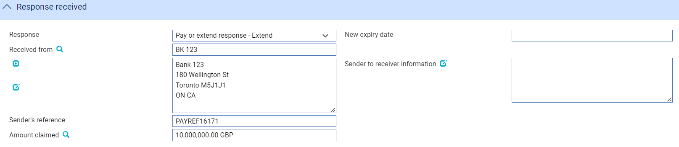

The following table explains what to enter into the fields displayed when you select a Pay or Extend response of *Extend*:

|  |  |
| --- | --- |
| Field | What to Enter |
| New Expiry Date | The new expiry date to which the undertaking is to be extended.   1. This field is mandatory when the response received is ‘Pay or Extend Response – Extend’ and request type of the undertaking is Issue counter (ISSU). This scenario is applicable when Instructing party is Counter Issuing bank and request type is Issue. |
| New Expiry Date Local | The new expiry date to which the Local undertaking is to be extended.   1. This field is mandatory when response received is ‘Pay or Extend Response – Extend’ and request type of the undertaking is Issue counter (ISCO) or Issue counter/request counter (ICCO). |
| Sender to Receiver Information | Any narrative from the sender and sender’s reference |
| Date of the extend or pay request | The date of the original Demand |
| Amount claimed | The amount claimed on the original Demand |

#### General/Documents Received/Invoices Received

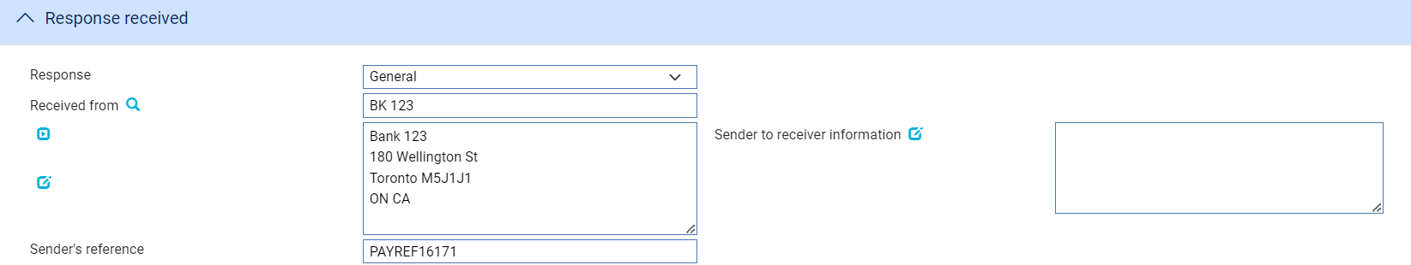

Use the Sender to Receiver Information field to enter any narrative from the sender and the Sender's Reference field to enter the sender's reference for the event. If you select 'Documents Received', you should also enter details of the documents received.

#### Refusal

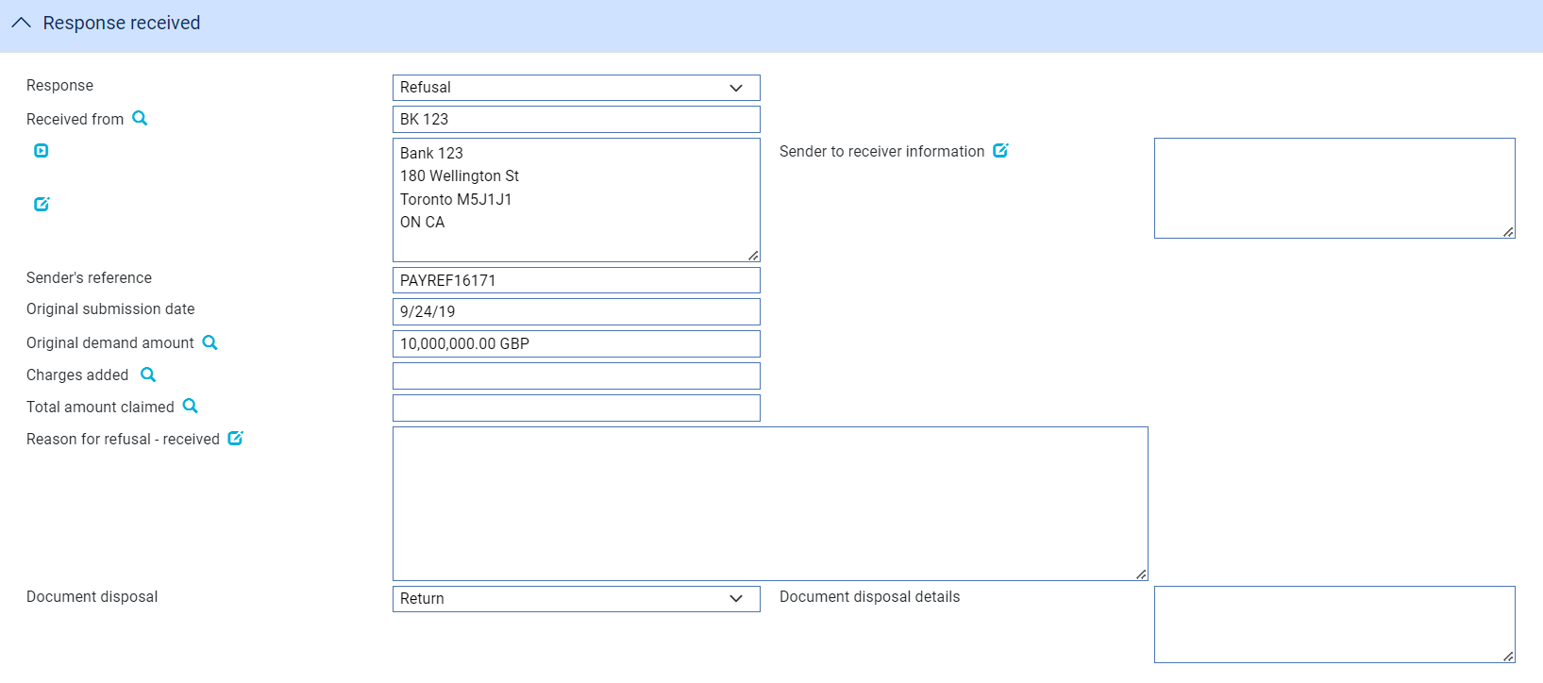

The following table explains what to enter into the fields used to record refusal:

|  |  |
| --- | --- |
| Field | What to Enter |
| Disposal of Documents | Use this dropdown to indicate the disposal action for the documents. Choose Hold if you intend to hold documents received. Choose Notify if you intend to forward them to the applicant. If documents are refused and are to be returned to the sender you should choose Return. You can also choose Previous Instructions as an action. |
| Sender to Receiver Information | Any narrative from the sender, which can be the applicant or the applicant's bank. |
| Payment Advice Date | The date the original payment advice was sent. |
| Amount Originally Claimed | The amount claimed on the original payment advice. |
| Charges Added | Any charges (with currency) being claimed by the sender as the result of refusing the claim. These represent other bank's charges due from the seller. |
| Total Amount Claimed | The total amount (with currency) being claimed for refund. This is the total of the original amount plus any charges added. |
| Discrepancy Details Received | Narrative giving the reason for the refusal received from the sender. |

#### Authorisation to Pay

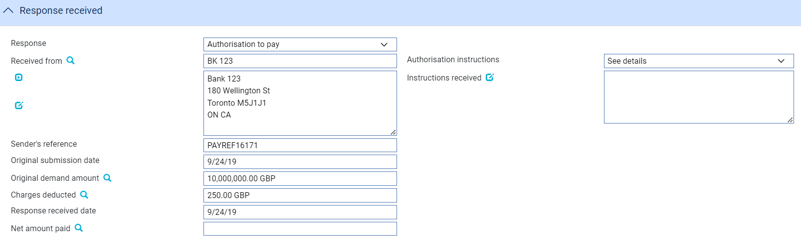

The following table explains what you should enter into the fields used to record authorisation to pay:

|  |  |
| --- | --- |
| Field | What to Enter |
| Authorisation Instructions | Select from one of the following:   * Accept * Debit Selves * Pay and Claim Reimbursement * See Details * Negotiate |
| Instructions Received | The terms of the authorisation. |
| Payment Advice Date | The date of the original payment advice. |
| Amount Originally Claimed | The amount claimed on the original payment advice. |
| Charges Deducted | Any charges being deducted by the sender.  For complete reconciliation check this amount using the Charges Summary window. See the Common Facilities User Guide– Trade Innovation for instructions. |
| Net Amount Paid | The net amount being paid. |

#### Adjust Maturity

The Adjust Maturity payment action enables you to change the value date of a future-dated payment that was specified during the payment event that you are continuing - referred to here as the source event. This may be necessary if, for example, the advising bank requests you to change the date of a future payment.

This action is available only if the AllowAdjustMaturity system option is set on and only in the following circumstances:

* In an Outstanding Claim event or an Outstanding Presentation event
* When the payment action selected in the event that you are continuing was 'Pay'
* The payment date is in the future

Unlike the other payment actions, this action is not available during a Claim Received or Documents Presented event.

You can change the following value dates, provided they are in the future:

* For the payment, in the Value Date field
* For any additional amounts
* For associated charges, using the Settlement Details window (see the Common Facilities User Guide – Trade Innovation)

When you change such a value date the system identifies charges in the source event that were due to be taken on a future value date that has not yet been reached, supersedes them in the source event and includes them in the current event set to 'Take'. Their value date can be changed using the Settlements window.

The system also identifies postings projected in the source event with a value date that has not yet been reached and stops the original projections being posted and generates replacement projections with the revised value date.

Any SWIFT payment messages that have not yet been released are stopped and new messages generated, as appropriate, from the current event. However, If messages from the source event have already been released:

* For funds movement messages (such as MT202 or MX equivalent pacs.009), the equivalent messages in the new event are automatically suppressed
* For event document messages (such as MT756), you should set up rules to prevent the issue of such duplicate messages

Any charges or additional amounts that had no value date entered for them will be automatically assigned the new value date for the payment.

Value dates that have passed cannot be changed. For example, if the original claim included part payments and the value date for one of those has now passed, you cannot change the value date for that part payment.

You can enter explanations for or comments on the change in the Notes to Applicant and Notes for Presenter fields.

#### Reverse Payment

The Reverse Payment payment action allows a payment to be refunded where, for example, a claim is initially paid but is subsequently found to be discrepant. The payment action is available only when a transaction is flagged as having multiple payments, with a single part payment that has already been paid.

When this payment action is selected, the part payment that has already been paid is set to ‘Paid/Reversed’.

Your bank will need to define postings to reverse the part payment. This might involve the reinstatement of any liability, if appropriate.

### Entering the payment action detail

As part of the Claim response (Outstanding claim), if the selection of the payment option is ‘Extend’, then input to Expiry date local is mandatory where the request type of the undertaking is either Issue counter(ISCO) or Issue counter/request counter. If the request type is a direct issue(ISSU), then the field Expiry date local is not available but input to Expiry date field is mandatory.

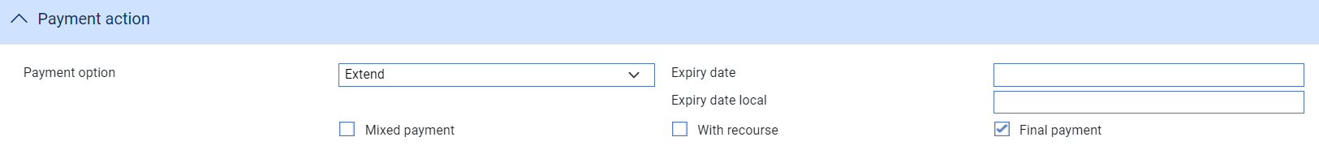

# Repaying a Loan

This chapter explains how to use the system to record repayments of loans made against part payments.

1. The functionality described in this chapter is used to repay loans against an issued undertaking for systems where the financing module is not implemented. It is also used to repay loans entered on your system prior to the implementation of the financing module. If your system has the financing module implemented see the Financing User Guide – Trade Innovation for information on repaying loans against an issued undertaking.

## Repaying Loans

Loans can be repaid in part or in full using the Repay Finance event. In the Master Summary window select 'Repay Finance' from the Create New Event drop-down list. The system opens the event at either a Log step or an Input step (see page 59), depending on how the Workflow orchestration controlling the event is configured. See the *Workflow Tailoring User Guide* – Trade Innovation for details.

### Logging the Loan Repayment

As the event is opened, the system retrieves details of all loans associated with the transaction and lists them.

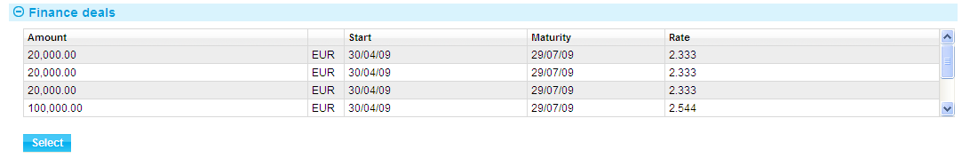

Highlight the one that is to be repaid, then click **Select**. The system retrieves details of that loan and displays them. You can subsequently use the Select button during an Input step to select a different loan, if necessary.

### Entering Full Details of the Loan Repayment

One set of fields is used if the loan has interest paid at inception.

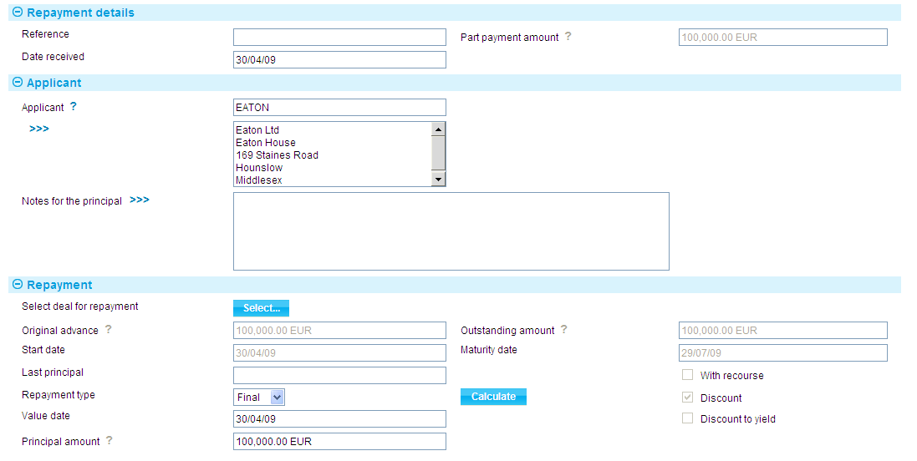Another set of fields is used if interest on the loan is due at maturity.

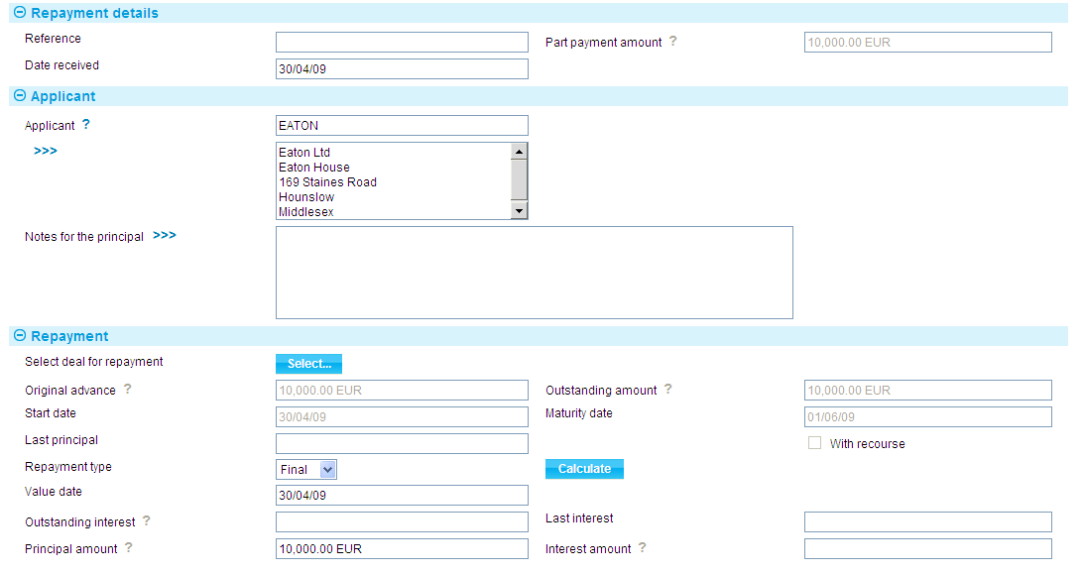

The following table explains what you should enter into the fields in this window. You can use them to repay the loan in full or in part:

| Field | What it Shows |
| --- | --- |
| Reference | The applicant's reference for the loan repayment. |
| Date Received | The date on which you received the repayment. The system uses today's date as the default. |
| Part Payment Amount | The amount of the part payment against which the loan was made. |
| Applicant | Displays the applicant's details. |
| Notes for Applicant | Any notes for the applicant regarding the repayment. |
| Original Advance | Displays the amount and currency of the original loan, excluding any repayments that may have been made. |
| Outstanding Amount | Displays the amount of the loan still outstanding, and the code of the currency of the amount. This is the original amount minus any principal repayments that have been made. |
| Start Date | Displays the start date of the loan. |
| Maturity Date | Displays the date on which the loan is due to be repaid in full. |
| With Recourse | Displays whether the original advance was with recourse or not. |
| Discount | For a discounted loan, this box is checked to indicate that interest on the loan was paid at inception. |
| Discount to Yield | For a discounted loan, this box is checked if the discount to yield formula was used to calculate the discount instead of the standard discount formula. |
| Outstanding Interest | For non-discount loans, this field shows any outstanding interest (with the relevant currency code). If the repayment is against a discounted loan, then the system will not display the interest amount field as interest will have been taken at inception. |
| Last Interest | For non-discount loans, this field shows the value date of the most recent payment of interest against the loan. |
| Last Principal | Displays the value date of the most recent repayment of principal against the loan. |
| Repayment | Indicate whether the repayment is a partial payment or a final repayment of the balance of the loan. |
| Value Date | The date on which the repayment is to be made. The value date cannot be before the last processing date if interest is being paid. If principal only is being paid, the value date cannot be before the last interest payment date. |
| Principal Amount | Displays the amount of the loan outstanding, with the code of its currency. If you use the Repayment field to indicate that this is the final payment against the loan, then you cannot alter the amount shown here. However, if you use the repayment field to indicate that this is a partial payment, then you can enter the amount of the loan being repaid into this field. |
| Interest Amount | If you have used the Repayment field to indicate that this is a final payment, the system displays the balance of the interest still outstanding in this field, and you will not be able to alter it. If, however, you have used the Repayment field to indicate that this is a partial repayment, then enter the amount of interest being paid with this part payment, together with the relevant currency code. |

If you have used the Repayment field to indicate that this is a final payment, the system displays the balance of the interest still outstanding in this field, and you will not be able to alter it. If, however, you have used the Repayment field to indicate that this is a partial repayment, then enter the amount of interest being paid with this part payment, together with the relevant the amount entered for the value date, and interest will be posted for the loan for the value date entered.

#### Repaying the Loan in Full

To repay the loan in full, select 'Final' in the Repayment Type field. The system displays the full amount of the loan outstanding in the Principal Amount field, and for non-discount loans the full amount of any interest due in the Interest Amount field. You cannot overtype these figures. The system repays the outstanding amount using the value date entered for the loan repayment.

#### Making Partial Repayments

To enter a partial repayment, select 'Partial' in the Repayment Type field, then enter the amount of the principal being repaid in the Principal Amount field and for non-discount loans any interest being repaid in the Interest Amount field. The balance of the loan will be reduced by the amount entered for the value date, and interest will be posted for the loan for the value date entered.

# Renewing an Issued Undertaking

This chapter explains how Issued Undertakings are renewed, and renewals advised in the system using the Renewal and Advise Renewal events.

## Renewals

When you first enter details of an undertaking on your system, the system permits you to define a schedule to determine when, how often and for how much (the original amount of the undertaking or its current amount) the guarantee is to be renewed for. If the customer requires a renewal advice, you can also specify how soon before the renewal happens the advice is to be produced.

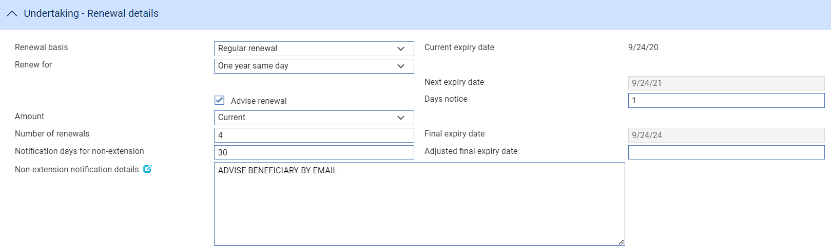

The system also allows you to define the number of days prior to the final expiry date that the beneficiary should be advised of that the undertaking will not be extended together with details on how the beneficiary should be notified.

For information on the system's diary facility see the Common Facilities User Guide – Trade Innovation.

The system uses this schedule to create diary entries for the undertaking which automatically generate the renewal advice and renew the undertaking on the appropriate dates.

The system uses two events to handle renewal advices and renewals:

* To generate the renewal advice or non-extension notification, the system uses the Advise Renewal event (see page 63)
* To generate the renewal itself, the system uses the Renewal event (see page 65)

Each of these two events can be configured to be generated and released automatically, requiring no manual intervention. Alternatively, they may be configured so that they require review and/or authorisation before they can be released, in which case the system generates an event at the Review step and lists it in the Work in Progress pane in the Summary window.

Upon release of the Renewal event, the system updates the expiry date of the undertaking and creates a new diary event for expiry, for production of the next renewal advice and for the next renewal itself, as appropriate.

If your bank has implemented credit limit checking, then, if a Renew event is configured to be generated automatically during overnight processing and a limit exception is reported, the Renew event will be generated at the Approval step in the Work in Progress pane.

### Licenses

If there is a license attached to the guarantee, then there may be additional validation during the renewal event:

* If the original amount is renewed, there must be sufficient available amount on the license
* If amount available on the license is insufficient for the renewal, you can attach new licenses to the transaction and make further reservations
* If the license expires at renewal, you may attach a new license

See the Licenses User Guide – Trade Innovation for details of licenses.

### Participated Deals

If the undertaking is participated and is being renewed for the original amount, renewal may result in a Drawdown/Revolve Commit Amt event being created as a subsidiary event.

## Reviewing and Authorising a Renewal Advice

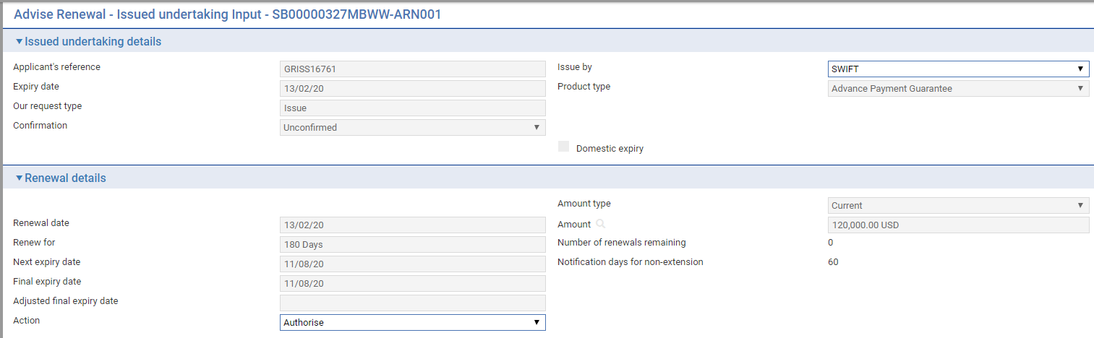

The following table lists the fields in the window used to review and authorise Advise Renewal events, explaining what they show and what to enter into those fields that permit input:

| Field | What it Shows |
| --- | --- |
| Applicant's Reference | The applicant's reference for the undertaking. |
| Issue By | The method used to send the renewal advice. |
| Product Type | The type of undertaking. |
| Expiry Date | The expiry date of the undertaking. |
| Our Request Type | The bank’s request type |
| Confirmation | The confirmation status of the undertaking, either Confirmed, Unconfirmed or May Add |
| Domestic Expiry | This box is checked if the expiry is domestic, and blank if the expiry is overseas. |
| Amount Type | Indicates whether the undertaking is being renewed at the original amount or the current amount. |
| Renewal Date | The date on which the undertaking is to be renewed. |
| Amount | The amount of the undertaking after renewal. |
| Renew For | The renewal period. |
| Number of Renewals Remaining | The number of renewals remaining. |
| Next Expiry Date | The new expiry date of the undertaking. |
| Final expiry | The calculated final expiry date |
| Adjusted final expiry date | Adjusted final expiry |
| Notification days for non-extension | The notice period for advising non-extension |
| Action | This field is used to either authorise or reject the renewal advice.  If you reject an Advise Renewal event, the reduction or increase itself still occurs when it is due. |

When the Event is released the *Extra information* displays the Authorisation or Rejection of the Renewal advice as follows:

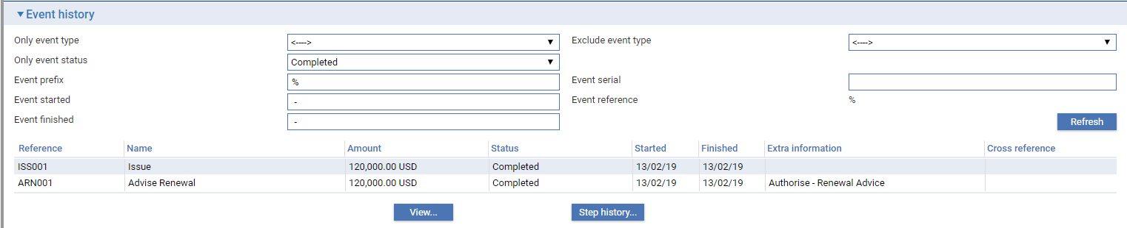

## Non-Extension Notification Renewal advice

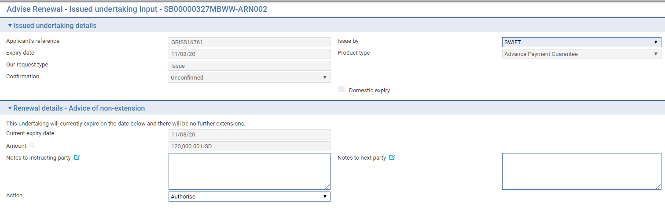

The following table lists the fields in the window used to review Advise Renewal events, explaining what they show and what to enter into those fields that permit input:

| Field | What it Shows |
| --- | --- |
| Applicant's Reference | The applicant's reference for the undertaking |
| Issue By | The method used to send the renewal advice |
| Product Type | The type of undertaking |
| Expiry Date | The expiry date of the undertaking |
| Our Request Type | The bank’s request type |
| Confirmation | The confirmation status of the undertaking, either Confirmed, Unconfirmed or May Add |
| Domestic Expiry | This box is checked if the expiry is domestic, and blank if the expiry is overseas. |
| Non-extension details | Text ‘This undertaking will currently expire on the date below and there will be no further extensions’ |
| Notes to Instructing Party | Notes to instructing party |
| Notes to Next Party | Notes to next party |
| Action | Allows the user to Approve or Reject the Renewal |

When the Event is released the *Extra information* displays the Authorisation or Rejection of the Non-Extension Renewal advice as follows:

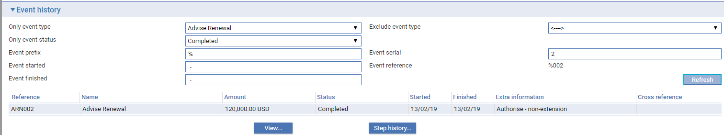

## Reviewing and Authorising a Renewal

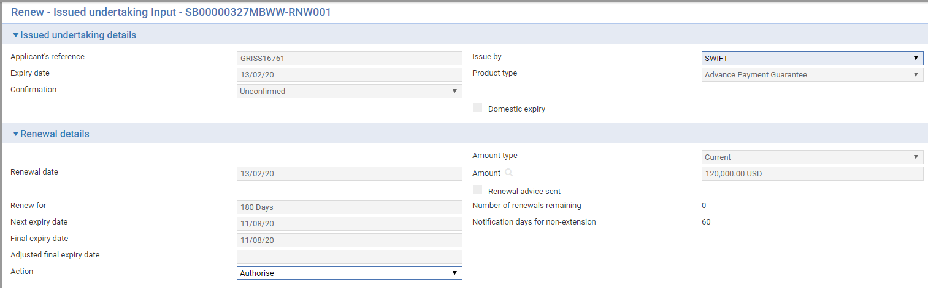

The following table lists the fields in the window used to review and authorise Renewal events, explaining what they show and what to enter into those fields that permit input:

| Field | What it Shows |
| --- | --- |
| Applicant's Reference | The applicant's reference for the undertaking. |
| Issue By | The method used to send the advice. |
| Expiry Date | The expiry date of the undertaking. |
| Product Type | The type of undertaking. |
| Our Request Type | The bank’s request type |
| Confirmation | The confirmation status of the undertaking, either Confirmed, Unconfirmed or May Add: |
| Domestic Expiry | This box is checked if the expiry is domestic, and blank if the expiry is overseas. |
| Amount Type | Indicates whether the undertaking is being renewed at the original amount or the current amount. |
| Renewal Date | The date on which the undertaking is to be renewed. |
| Amount | The amount of the undertaking after renewal. |
| Renewal Advice Sent | This field is checked if a renewal advice has been sent for this renewal. |
| Renew For | The renewal period. |
| Number of Renewals Remaining | The number of renewals remaining. |
| Next Expiry Date | The new expiry date of the undertaking. |
| Final expiry | The calculated final expiry date |
| Adjusted final expiry date | Adjusted final expiry |
| Notification days for non-extension | The notice period for advising non-extension |
| Action | Allows the user to Approve or Reject the Renewal |

When the Event is released the *Extra information* details the Authorisation or Rejection of the Renewal as follows:

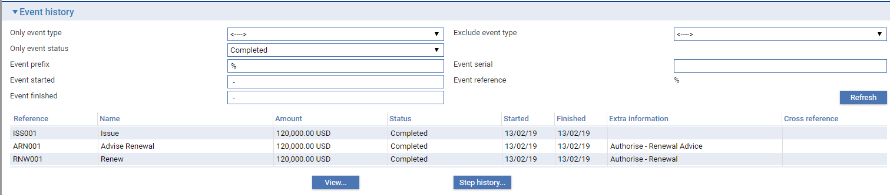

# Reducing and Increasing Undertakings

This chapter explains how undertakings are reduced and increased, and any such changes advised in the system using the Reduction/Increase and Advise Reduction/Increase events.

## Reductions and Increases

When you first enter details of an undertaking on your system, the system permits you to define a schedule to determine when, how often and by how much (as a fixed amount or a percentage of the original value) the undertaking is to be reduced or increased. If an advice of the reduction or increase is required, you can also specify how soon before the reduction or increase happens the advice is to be produced. The system uses this schedule to create diary entries for the relevant undertaking or counter undertaking which automatically generate the advice and reduce or increase the undertaking on the appropriate dates.

For information on the system's diary facility see the Common Facilities User Guide – Trade Innovation.

The system uses two events to handle advices and reductions or increases:

* To generate the advice, it uses the Advise Reduction/Increase event (see page 68)
* To generate the reduction or increase itself, it uses the Reduction/Increase event (see page 67)

Each of these two events can be configured to be generated and released automatically, requiring no manual intervention. Alternatively, they may be configured so that they require review and/or authorisation before they can be released, in which case the system generates an event at the Review step and lists it in the Work in Progress pane in the Master Summary window.

If your bank has implemented credit limit checking, then, if a Reduction/Increase event is configured to be generated automatically during overnight processing and an overline condition is reported, the event will be generated at the Approval step in the Work in Progress pane.

### Licenses

If there are reductions on an undertaking that has a license attached, you may reinstate the unutilised reserved license amount.

If there are increases on an undertaking that has a license attached, the additional amount plus the original amount will be validated against the license amount available. You have the option of adding new licenses and making further reservations, as necessary. The system will also re-check the license validity date.

See the Licenses User Guide – Trade Innovation for details of licenses.

## Reviewing and Authorising a Reduction/Increase Advice

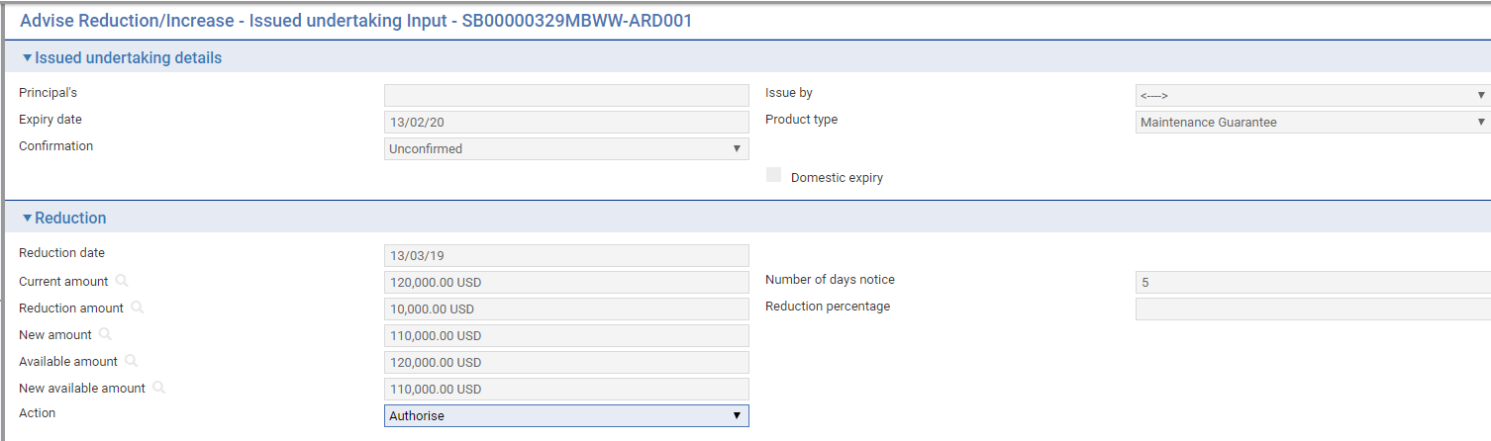

The following table lists the fields in the window used to review and authorise Advise Reduction/Increase events, explaining what they show and what to enter into those fields that permit input:

|  |  |
| --- | --- |
| Field | What it Shows |
| Principal’s reference | The principal’s reference for the undertaking. |
| Advise By | The method used to send the advice. |
| Expiry Date | The date of the undertaking. |
| Product Type | The type of undertaking. |
| Confirmation | The confirmation status of the undertaking, either Confirmed, Unconfirmed or May Add |
| Domestic Expiry | This box is checked if the expiry is domestic, and blank if the expiry is overseas. |
| Reduction/Increase Date | The date on which the undertaking is to be reduced or increased. |
| Current Amount | The current amount of the undertaking. |
| Increase/Reduction Amount | The amount of the reduction or increase. |
| New Amount | The amount of the undertaking after the reduction or increase has been applied. |
| Available Amount | The available amount and currency of the undertaking,before the reduction or increase takes place. |
| New Available Amount | The available amount of the undertaking after the reduction or increase has taken place. |
| Number of Days Notice | Indicates how many days before the reduction or increase takes place the advice is to be produced. |
| Reduction/Increase Percentage | The amount of the reduction or increase, expressed as a percentage of the original undertaking amount. |
| Action | Click on one of the choices in this pane to either authorise the event or to reject it.  If you reject an Advise Reduction/Increase event, the reduction or increase itself still occurs when it is due. |

## Reviewing and Authorising a Reduction or Increase

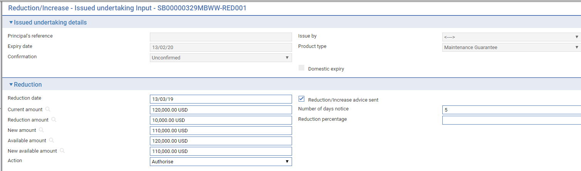

The following table lists the fields in the window used to review and authorise Reduction/Increase events, explaining what they show and what to enter into those fields that permit input:

|  |  |
| --- | --- |
| Field | What it Shows |
| Principal's Reference | The prinicipal's reference for the undertaking. |
| Advise By | The method used to send the advice. |
| Expiry Date | The expiry date of the undertaking. |
| Product Type | The type of undertaking. |
| Confirmation | The confirmation status of the undertaking, either Confirmed, Unconfirmed or May Add |
| Domestic Expiry | This box is checked if the expiry is domestic, and blank if the expiry is overseas. |
| Reduction/Increase Date | The date on which the undertaking is to be reduced or increased. |
| Reduction/Increase Advice Sent | This field is checked if an advice of the reduction/increase has been sent. |
| Current Amount | The current amount of the undertaking. |
| Increase/ Reduction Amount | The amount of the reduction, and its currency. |
| New Amount | The amount of the undertaking after the reduction or increase has been applied. |
| Available Amount | The available amount and currency of the undertaking, before the reduction or increase takes place. |
| New Available Amount | The available amount of the undertaking after the reduction or increase has taken place. |
| Number of Days Notice | Indicates how many days before the reduction or increase takes place an advice is to be produced. |
| Reduction/Increase Percentage | The amount of the reduction or increase, expressed as a percentage of the original undertaking amount. |
| Action | Click on one of the choices in this pane to either authorise the event or to reject it. |

# Making Changes to an Issued Undertaking

This chapter explains how to use the system to make amendments to an undertaking issued and, where necessary, to record beneficiary approval for the amendment.

It also describes how to use the Adjust event to make other changes to the master record.

## Amendments

An undertaking can be amended using an Amend event (see page 75) at any time between the release of the Issue event and book-off.

Typically, an amendment will be initiated by either

* the issuing bank at the request of the applicant or
* the counter received from bank

The bank then passes details of the amendment on to the next bank in the processing chain, which will record the details and then inform the next advising bank or the beneficiary, as appropriate.

If beneficiary approval is not required for the amendment, then accounting entries and changes to the master record as a result of the amendment are carried out as soon as the Amend event has been released.

If the beneficiary's approval is required for the amendment, then the amendment does not take effect until the beneficiary's approval has been obtained and recorded in the system using a Beneficiary Response to Amend event (see page 75). If this is the case, then no accounting entries are produced for the Amend event, although any charges due can be paid, if required. Once beneficiary approval has been recorded using a Beneficiary Response to Amend event, then the appropriate accounting entries are made once the Beneficiary Response to Amend event has been released. If beneficiary approval is required, then the changes made during the amendment are not applied to the master record until beneficiary approval has been obtained.

If the amendment increases the amount of an undertaking that is already participated, a Drawdown/Revolve Commit Amt event may be created as a subsidiary event to decrease the commitment amount available on the participation deal. If the amendment decreases the amount of an undertaking that is already participated, a Drawdown/Revolve Commit Amt event may be created as a subsidiary event to increase the commitment amount available on the participation deal, if the deal is revolving.

You can also use an Amend event to reinstate an expired or cancelled guarantee's master record.

1. If you amend the expiry date of an undertaking that has rolling renewal based on the expiry date, you will need to amend the rolling renewal schedule manually.

### Reversal Postings

You can use the reversal posting facilities to set up the necessary postings to handle amendments which may have an effect on any previous liability accounting, such as changes to confirmation instructions or the tenor of a payment.

### Licenses

If the master record is attached to a license, the License pane is available for you to view and amend any details of additional reservations or reinstatements when the amount or currency change.

There will also be some additional validation when you make an amendment to a master attached to a license. For example:

* If you make an amendment after the Valid To date on the license has passed, the system will either reject the amendment or allow a new license to be added, depending on how your system has been set up
* If you change the shipment date, the new shipment date must be between the Valid From and Valid To dates on the license
* If you change the amount or currency, the new value will be validated against those on the license. The license amount may be reserved or reinstated for the amended amount

1. If you are increasing the amount of a master record, then a reservation is automatically made against the license. If you are decreasing the amount, then a reinstatement is automatically made. If you change the currency, you may reinstate in the old currency and make a reservation in the new currency (assuming that the license in question allows multiple currencies).

If the master record is amended so that its status changes from Cancelled or Expired, the reinstated letter of credit value will be validated against the available amount on the license.

If the amendment requires beneficiary approval then any reservations or drawdowns required occur in the Ben Response to Amend event instead, provided that the amendment is approved.

See the Licenses User Guide – Trade Innovation for details of licenses.

### Maintaining Liability

You can change the way that liability on a transaction is shared by using the Maintain Liability event. Maintain Liability events can be used to:

* Participate a transaction
* Share customer liability on a transaction

When you click **OK** or **Pend** on the Input window of an Amend event for a participation deal, a Maintain Liability subsidiary event is automatically generated for each transaction affected by the amendment. You can use the Subsidiary Events link from the Master Summary window to view this event but it is processed and released via the participation deal Amend event.

See the Participated Deals User Guide – Trade Innovation for the Maintain Liability event.

### Handling More than One Amendment at a Time

The system permits you to have more than one Amend event in progress at the same time. If you attempt to open an Amend event for a master record that already has an Amend event in progress, or is awaiting the beneficiary's response to an amendment, the system will warn you of the fact, but will allow you to continue. The system will show the current details held for the master when the Amend event is created or opened at an Input step.

You can check whether any changes have been made to master record details between an Amend event requiring beneficiary approval being initiated and that approval being received. The Beneficiary Response to Amend event allows you to display a list of master record fields, and indicates in this list any fields where the information held on the master record differs from that held in the Beneficiary Response to Amend event. Should you discover a field that has been updated since the Amend event was initiated, you can choose whether or not to overwrite the value currently held in the master record with the value held in the Beneficiary Response to Amend event.

If your system is configured so that Amend events need to be reviewed before release, then during these later steps the supervisor will be advised of the existence of another Amend event that has completed while the current event has been at the Review step. They can then decide how each Amend event should be handled to ensure that the required changes are implemented.

## Displaying Changes

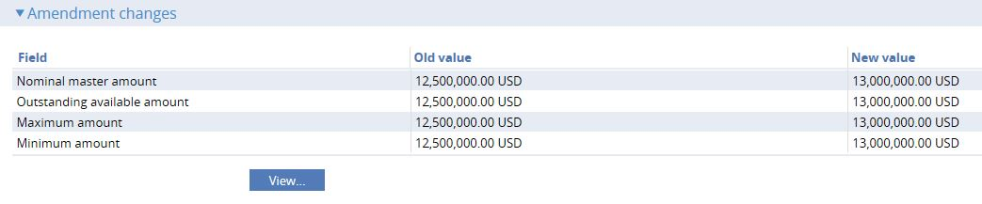

When making amendments or adjustments to a transaction the Changes button allows you - and reviewers - to list those fields that have changed within the event. It opens a window that lists those fields whose value has changed and shows for each the value before the current event and the new value resulting from the event.

For free-format narrative fields, your bank can configure the system so that it shows either the entire content of the field in the New Value column, or just a certain number of lines (defined by the system option ViewChangesLineCount) followed by the text:

>>> plus n more lines. 'View' for details.

where n is the number of additional lines not displayed.

Selecting that entry in the list and clicking **View** displays the entire content of the field.

This window is displayed automatically when the event is opened for review or authorisation.

### Dealing with Intervening Changes

When entering the beneficiary's response to an Amend event, the Changes button permits you to check whether any master record details have changed since the amendment event was initiated.

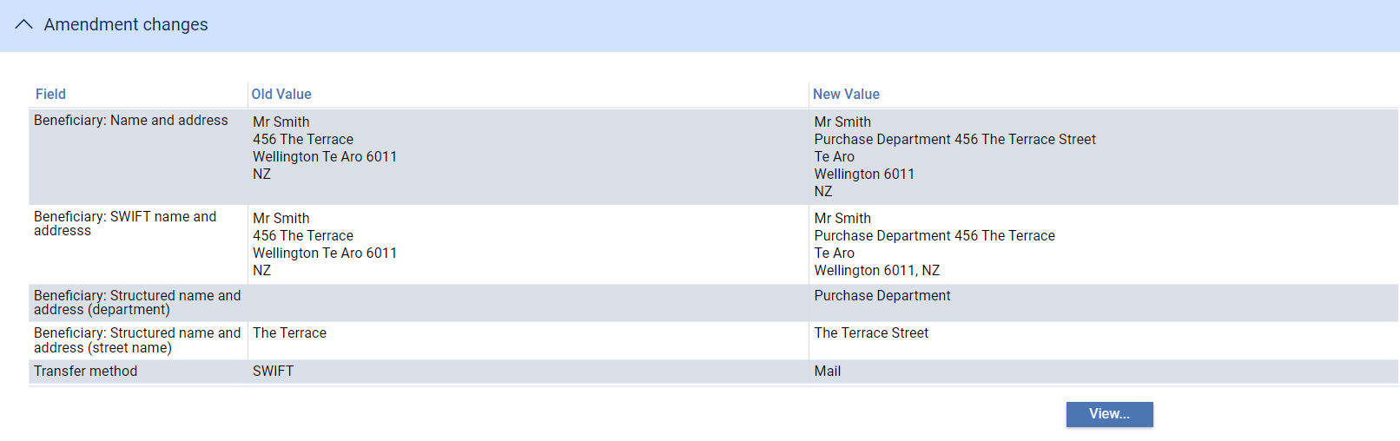

It lists those fields whose value has changed and shows for each:

* The value before the event was initiated (Old Value)
* The new value resulting from the change made in the event (New Value)
* If another event has taken place since the amendment event was initiated which has changed the value of fields held on the master record, the current value of those fields (Master Value). If this field is blank, no intervening change in value has taken place

You can see any changes made by clicking the **View** button. The window displayed allows you to see any intervening changes made by clicking the Intervening button.

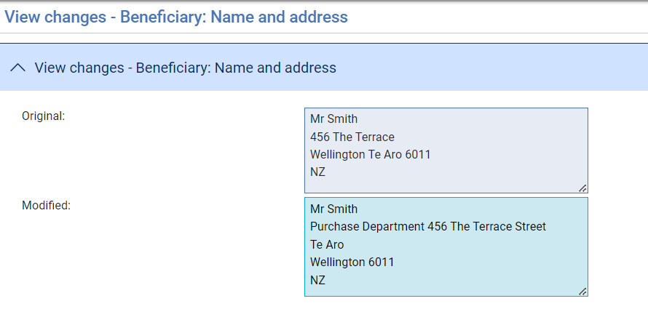

## Amending an Issued Undertaking

To amend an issued undertaking, in the Master Summary window select 'Amend' from the Create New Event drop-down list and click **Create**. The system opens the event at either a Log step or Input step. Depending on how your system is configured, panes and fields available in log steps can be tailored for each data capture step. See the *SDK - Screen Tailoring Guide* – Trade Innovation for details.

The Amendment request details can be entered as follows:

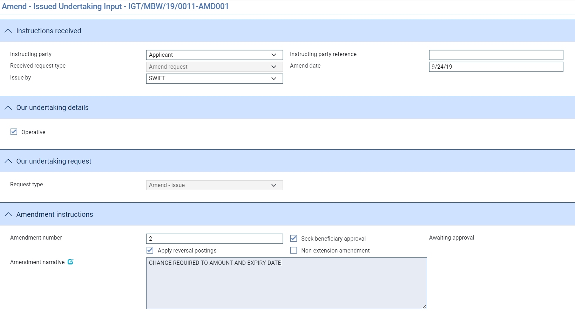

The **View Event Changes** button on the menu bar allows you to display any changes that have been made to the master.

The following table lists additional fields displayed and explains what to enter into them:

| Field | What it Shows |
| --- | --- |
| Received from party | Set to either the Applicant, Principal(if not applicant) or Counter received from bank |
| Received from reference | Instructing party reference ( if required) |
| Received request type | Either   * *Amend request* * *Amend* – *counter received/ request issue* * *Amend* – *counter received/request counter* |
| Amendment number | Sender’s amendment number for this amendment |
| Amendment Date | The date of the amendment. This defaults to today's date. |
| Issue by | Transfer method to be used to advise the amendment |
| Request type | The bank’s request type – either   * *Amend - issue* * *Amend - issue counter* * *Amend – Issue counter/request counter* |
| Seek Beneficiary Approval | If the amendment requires beneficiary approval, check this field. |
| Apply Reversal Postings | Check this field if your bank has set up reversal postings for this event and wishes to apply them when the event is released. |
| Non-extension amendment | Used to indicate that the undertaking will no longer be extended beyond the current expiry date |
| Amendment Narrative | Identify the changes made and the reasons they were made. |

Amending the Undertaking details:

The Undertaking details are displayed as for the Issue event and the current details can be changed as required.

When entering amendment details:

* If you amend the expiry date of an undertaking that has rolling renewal based on the expiry date, you will need to adjust the rolling renewal schedule manually.
* If the amount of the undertaking has changed, you can enter the new amount in one of two ways:
* Use the Increase/Decrease field to select whether the change involves an increase or a decrease, then use the Increase/Decrease Amount to enter the value of the increase/decrease. When you press Refresh, the system calculates the amended amount and displays it in the Amount field
* Type the new amount into the Amount field
* An additional *Amendment details to send* field is present in the Undertaking details or Counter to send/Local undertaking details to convey details of amendments not covered by structured fields in the MT767 - Amendment to Demand Guarantee/Standby LC:

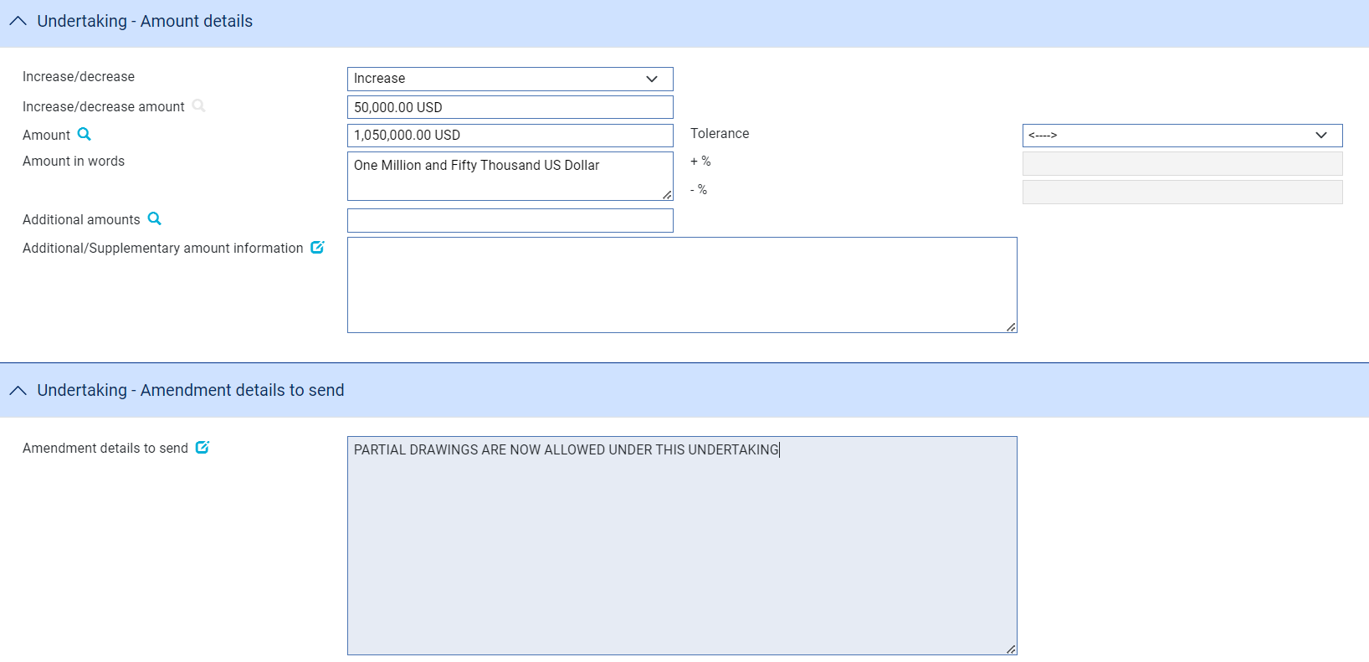

## Recording the Beneficiary's Response to an Amendment

If, when amending an undertaking you check the Seek Beneficiary Approval flag, then the amendment does not take effect until the beneficiary's approval has been obtained and recorded in the system.

To enter details of the beneficiary's response, in the Master Summary window select 'Beneficiary Response to Amend' from the Create New Event drop-down list and click **Create**. The system opens the event at either a Log step or Input step, depending on how the Workflow orchestration controlling the event is configured. See the *Workflow Tailoring User Guide* – Trade Innovation for details.

If there is only one amendment event awaiting a beneficiary response, the system retrieves it and displays its reference. If there is more than one amendment event awaiting beneficiary response, then the **Select** button permits you to select the one to which the beneficiary's response relates.

If there is only one amendment event awaiting a beneficiary response, the system retrieves it and displays its reference. If the undertaking has more than one amendment event awaiting beneficiary response, then the  button permits you to select the one to which the beneficiary's response relates.

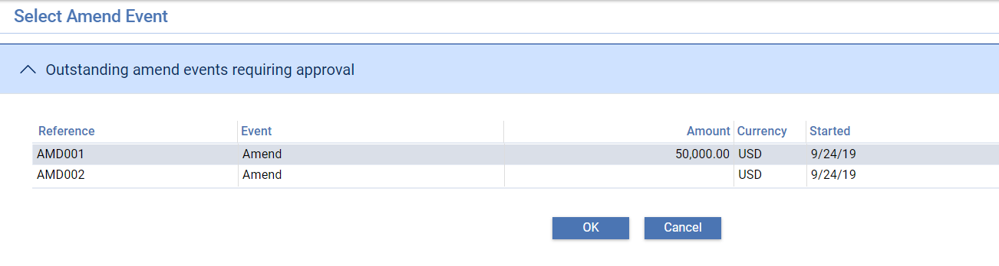

If Approved the following details are shown allowing details of the Approval to be entered together with response notes to the instructing party and the received from bank.

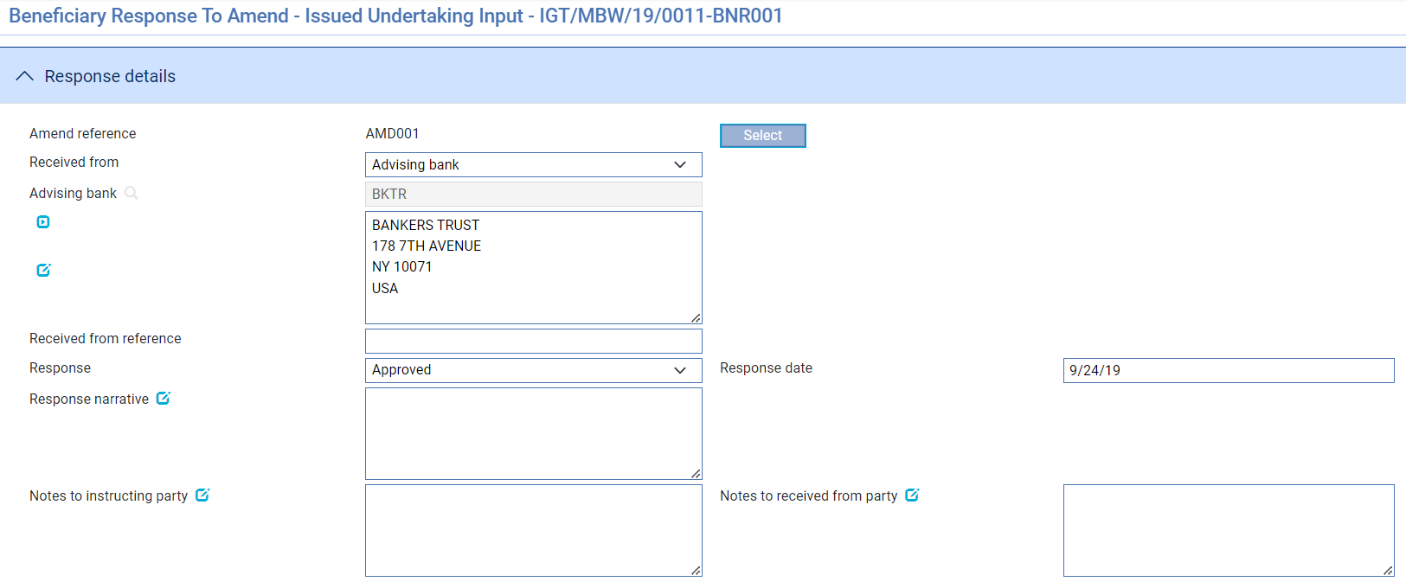

The **View Event Changes** button on the menu bar allows you to display any changes that have been made to the master.

If Rejected then an additional ‘Reasons for rejection’ fields is shown:

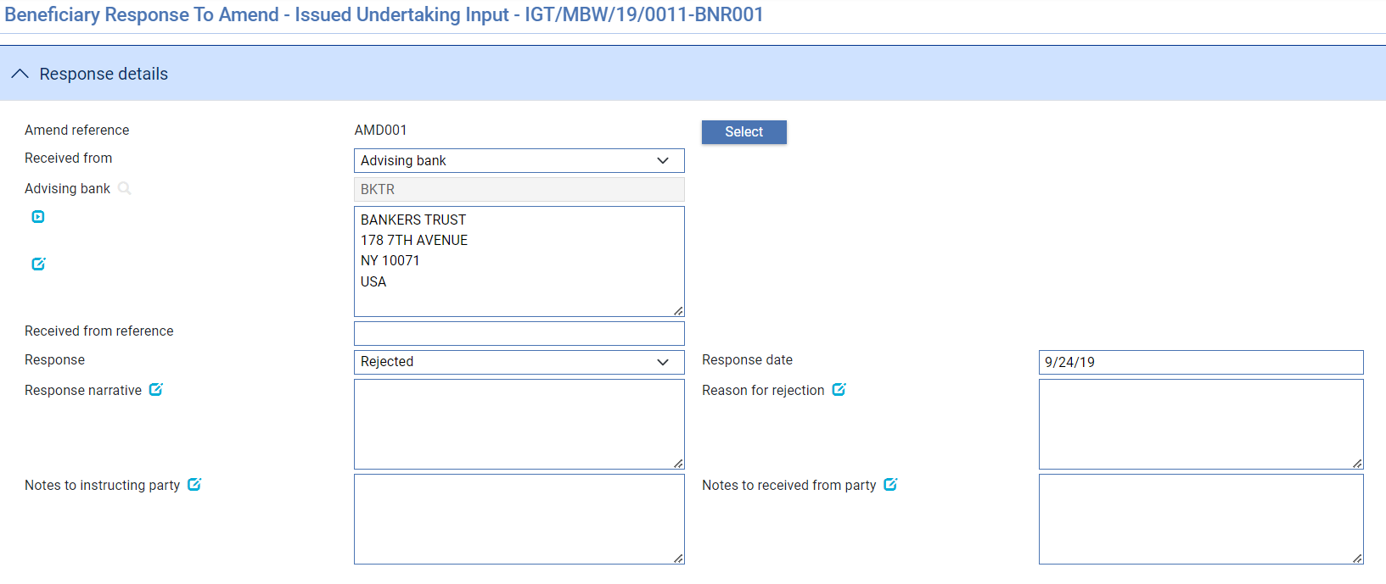

## Making Adjustments to the Master Record

The functionality of the Amend event (see page 75) allows you to make all the changes that are likely to be required in the normal course of business at the request of the applicant, and which may require beneficiary approval. The system includes an Adjust event (see page 77), which contains additional functionality to allow you to make changes to all the information recorded for a transaction, with the exception of your bank's reference number for the transaction, and the status of a transaction's master record.

The Adjust event is designed to allow you to make changes where you need to alter details but do not need to notify other parties. This functionally is intended to allow you to correct mistakes, and should be used cautiously. If you make any changes using this functionality, you should ensure that the proper reconciliations are carried out.

1. Unlike the Amend event, the Adjustment event does not require a sender’s amendment number to be recorded or a bank’s amendment number as all changed are internal to the bank’s processing.
2. Once you have initiated an Adjust event, the system will prevent you from opening any other event for the transaction until the Adjust event has completed. If you attempt to open an Adjust event while another event for the master is in progress, the system will warn you of the fact and prompt you to abort the Adjust event. Unless you are attempting to make an adjustment to allow the pre-existing event to complete, you should abort the Adjust event and wait until the pre-existing event has completed before attempting the Adjust event again. If you continue with the Adjust event, then the system will prevent any further work on the pre-existing event until the Adjust event has completed.

### Adjusting an Issued undertaking

To adjust an undertaking, in the Master Summary window select ‘Adjust’ from the Create New Event drop-down list and click **Create**. The system opens the event at either a Log step or Input step. Depending on how your system is configured, panes and fields available in log steps can be tailored for each data capture step. See the *SDK - Screen Tailoring Guide* – Trade Innovation for details.

The Adjustment details can be entered as follows:

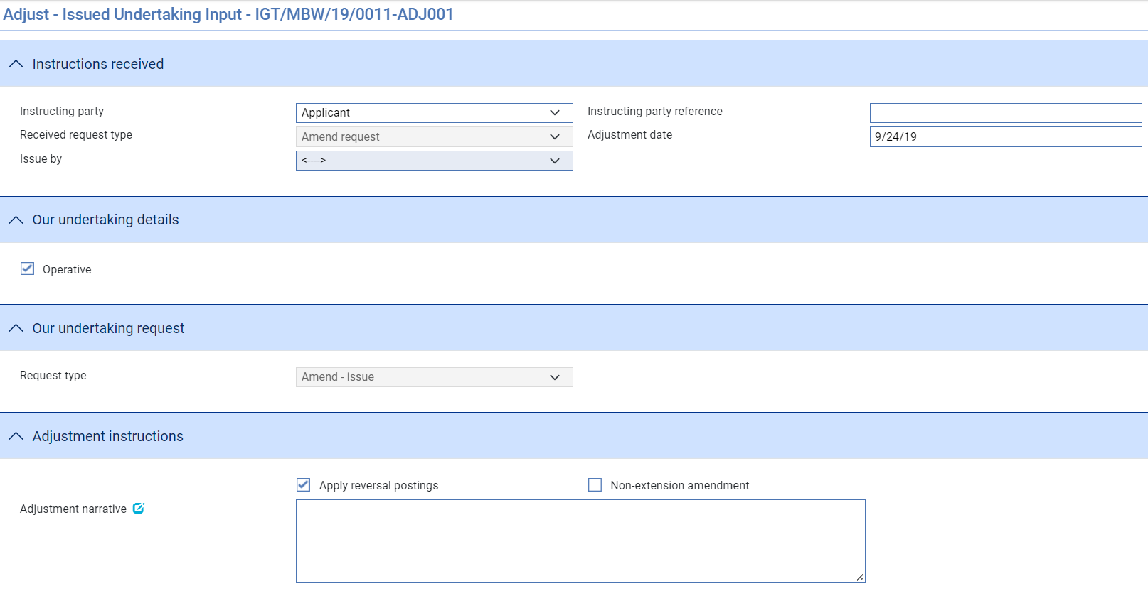

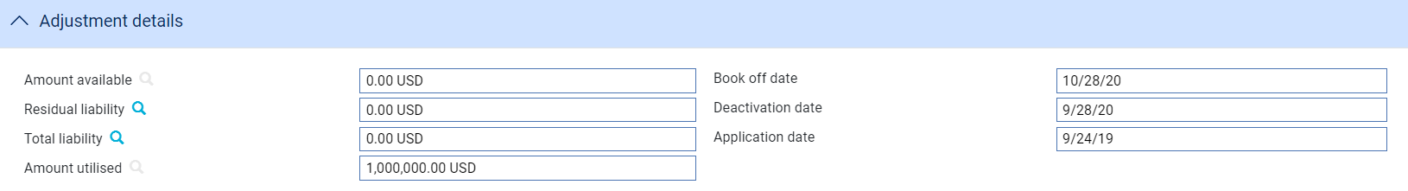

The remainder of the screen can be used to adjust any of the details related to the undertaking as for the amend event.

The **View Event Changes** button on the menu bar allows you to display any changes that have been made to the master.

The following table lists the adjustment fields displayed and explains what to enter into them

| Field | What it Shows |
| --- | --- |
| Received from party | Set to either the Applicant, Principal(if not applicant) or Counter received from bank |
| Received from reference | Adjustment reference ( if required) |
| Received request type | Either   * *Amend request* * *Amend* – *counter received/ request issue* * *Amend* – *counter received/request counter* |
| Adjustment Date | The date the adjustment was made. This defaults to today's date. |
| Advise by | Transfer method to be used to advise the adjustment |
| Request type | The bank’s request type – either   * *Amend - issue* * *Amend - issue counter* * *Amend – Issue counter/request counter* |
| Apply Reversal Postings | Check this field if your bank has set up reversal postings for this event and wishes to apply them when the event is released. |
| Non-extension amendment | Used to indicate that the undertaking will no longer be extended beyond the current expiry date |
| Adjustment Narrative | Identify the changes made and the reasons they were made. |
| Amount Available | This field displays the amount outstanding on the undertaking. |
| Residual Liability | The system displays the outstanding liability amount as shown on the master record. Use this field to overwrite the figure shown on the master summary if, for any reason, the master figure is incorrect. |
| Total Liability | The system displays the outstanding liability amount as shown on the master record. Use this field to overwrite the figure shown on the master summary if, for any reason, the master figure is incorrect. |
| .Amount Utilised | The amount of the guarantee utilised so far. |
| Book Off Date | The system displays the guarantee's book-off date, which you can amend. The system will then book off the guarantee when the new book-off date is reached. |
| Deactivation Date | The system displays the date on which the guarantee will become inactive (after its expiry date and any days grace period has elapsed). You can amend this date.  See the System Tailoring User Guide – Trade Innovation for the days grace period, which may be different for master records expiring locally and those expiring abroad. |
| Application Date | This option helps to adjust the application date. |
| Issue Date | The issue date of the undertaking. |
| Apply Reversal Postings | Check this field if your bank has set up reversal postings for this event and wishes to apply them when the event is released. |

During an Adjust event you can view charges and add optional charges, but cannot edit existing charges. To change charges, use a Maintain Charges event.

# Cancelling an Issued Undertaking

This chapter explains how to use the system to cancel an undertaking and, where necessary, to record beneficiary approval for the cancellation.

## Cancellations

An undertaking can be cancelled at any time after the release of the Issue event and book-off. However, you cannot cancel an undertaking on which there is work in progress.

Typically, cancellation will be initiated by the issuing bank at the request of the applicant. The issuing bank then passes details of the cancellation on to the next bank in the processing chain, which will record them and inform the next advising bank or the beneficiary, as appropriate.

The system provides:

* A Cancel event (see page 80) which allows you to initiate the cancellation of an issued undertaking. The Cancel event includes the facility to create messages to forward details of the cancellation
* A Beneficiary Response to Cancel event (see page 82), which allows you to enter details of a beneficiary's response to a cancellation notification

If beneficiary approval is not required for the cancellation, then as soon as the Cancel event has been released, accounting entries are produced to reduce the liability and liability outstanding to nil and the master record is given the status CAN, although it is not removed from the system.

If a margin deposit was made to cover the guarantee, then accounting entries are generated by the Cancel event to repay unutilised funds back to the customer's account.

If an undertaking that has a license attached is cancelled, any unutilised amount reserved can be reinstated (provided that the Automatically Reinstate parameter has been set and a reservation had previously been made).

If the beneficiary's approval is required for the cancellation, then the cancellation does not take effect until the beneficiary's approval has been obtained and recorded using the system. If this is the case, then no accounting entries are produced for the Cancel event, although any charges due can be paid, if required. Once beneficiary approval has been recorded using a Beneficiary Response to Cancel event, then the appropriate accounting entries are made once the Beneficiary Response to Cancel event has been released. If beneficiary approval is required, and is not forthcoming, then the cancellation does not take effect.

1. A cancelled undertaking can be reinstated using the Amend event.

### Participated Deals

If a transaction is participated, cancelling it may result in a Drawdown/Revolve Commit Amt event being created as a subsidiary event to increase the commitment amount available on the participation deal, if the deal is revolving.

## Cancelling an Issued Undertaking

With the appropriate master record open, in the Master Summary window select 'Cancel' from the Create New Event drop-down list and click **Create**. The system opens the event at either a Log step or Input step. Depending on how your system is configured, panes and fields available in log steps can be tailored for each data capture step. See the *SDK - Screen Tailoring Guide* – Trade Innovationfor details.

The fields displayed on the cancellation screen are dependent on the Instructing party and request type.

If Issue – then the following screen is display – allowing details of the instructions from the applicant to be entered and cancellation details.

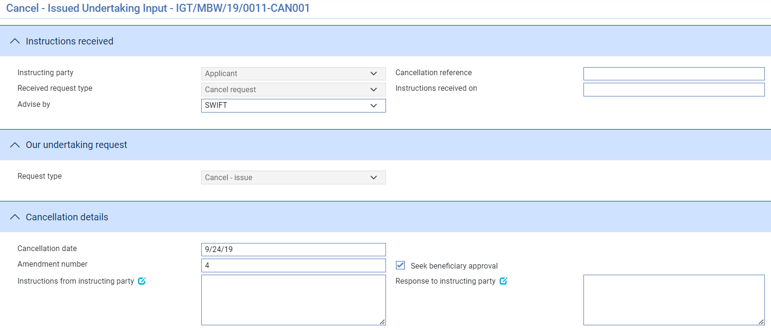

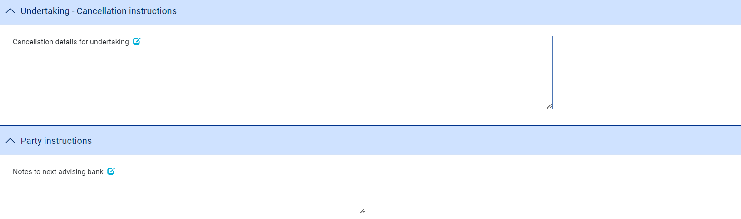

The following table lists these fields and explains what to enter into them:

| Received from party | What to Enter |
| --- | --- |
| Received from party | Set from either Applicant, Principal (if not applicant) or Counter received from bank |
| Cancellation reference | A reference for the cancellation request. |
| Received request type | Either   * *Cancel request* * *Cancel request* – *counter received/ request issue* * *Cancel request* – *counter received/request counter* |
| Instructions received on | Date instruction received |
| Amendment number | Amendment number -where request is from counter received from bank |
| Advise By | This field is displayed for Issued undertakings only. Use it to identify the method of transmission to be used to send details of the cancellation. |
| Request type | The bank’s cancellation request type   * *Cancel - issue* * *Cancel - issue counter* * *Cancel – Issue counter/request counter* |
| Cancellation Date | The date when the cancellation takes effect. This defaults to today's date, but you can change it.  Any refunds to the customer are calculated with effect from the cancellation date. |
| Seek Beneficiary Approval | Check this box if beneficiary approval is required for the cancellation. |
| Amendment number | The Bank’s amendment number for this cancellation |
| Cancellation details for local undertaking | Cancellation details for the undertaking |
| Instructions from instructing party | Any instructions regarding the cancellation. |
| Notes to instructing party | Response to the instructing party |
| Notes to next Advising Bank/issuing bank | Any instructions to the advising bank or issuing bank regarding the cancellation. |

Where the original request involved the issue of a counter then additional Cancellation details for the counter to send is shown.

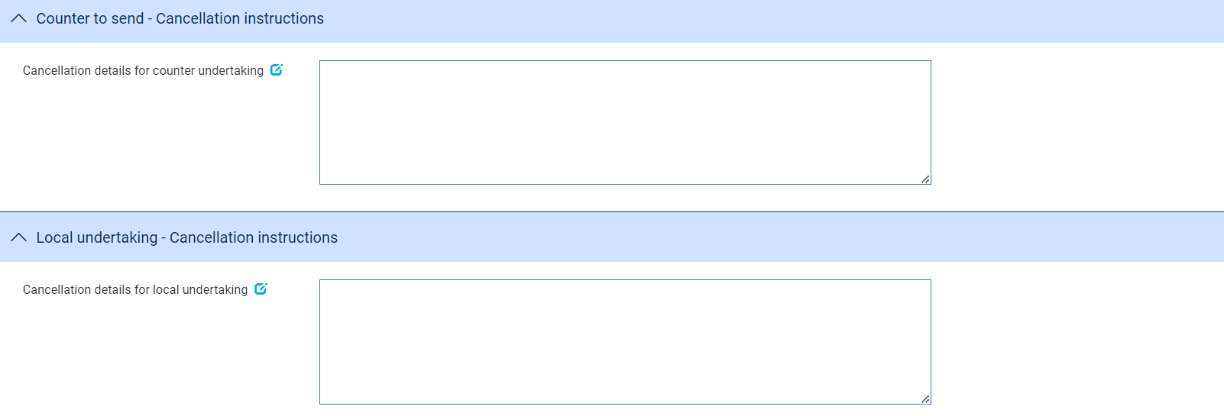

Where a cancellation instruction is received from the counter issuing bank then details of the sender’s cancellation amendment number and any Received cancellation details relating to the counter undertaking can be entered.

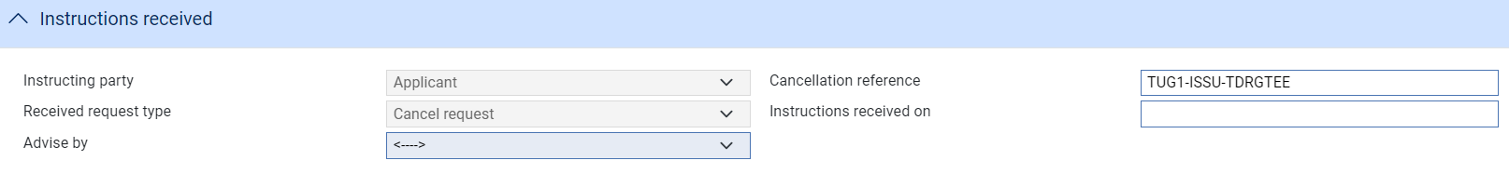

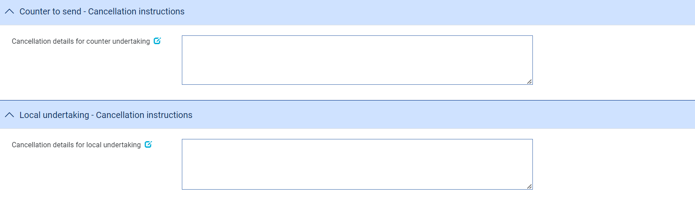

## Recording the Beneficiary's Response to a Cancellation

If, when cancelling an undertaking you check the Seek Beneficiary Approval flag, then the cancellation does not take effect until the beneficiary's approval has been obtained and recorded in the system. The Beneficiary Response to Cancel event allows you to do this.

To enter details of the beneficiary's response, with the appropriate master record open, in the Master Summary window select 'Beneficiary Response to Cancel' from the Create New Event drop-down list and click **Create**. The system opens the event at either a Log step or Input step, depending on how the Workflow orchestration controlling the event is configured. See the *Workflow Tailoring User Guide* – Trade Innovation for details.

### Entering Full Details of the Beneficiary's Response

In the Beneficiary's Response pane, click on the appropriate field to indicate whether the beneficiary has approved or rejected the cancellation.

If Approved, the following details are shown allowing details of the Approval to be entered together with response notes to the instructing party and next advising/issuing bank

Approval

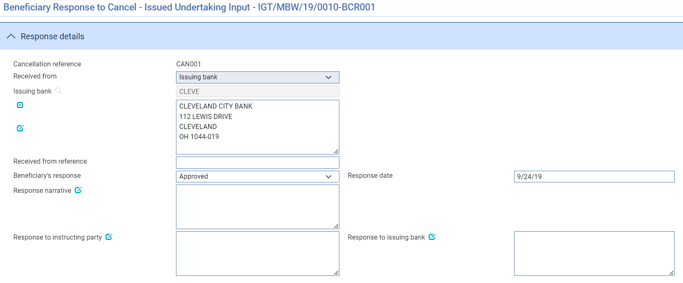

Rejection

If Rejected, then an additional ‘Reasons for rejection’ fields is shown:

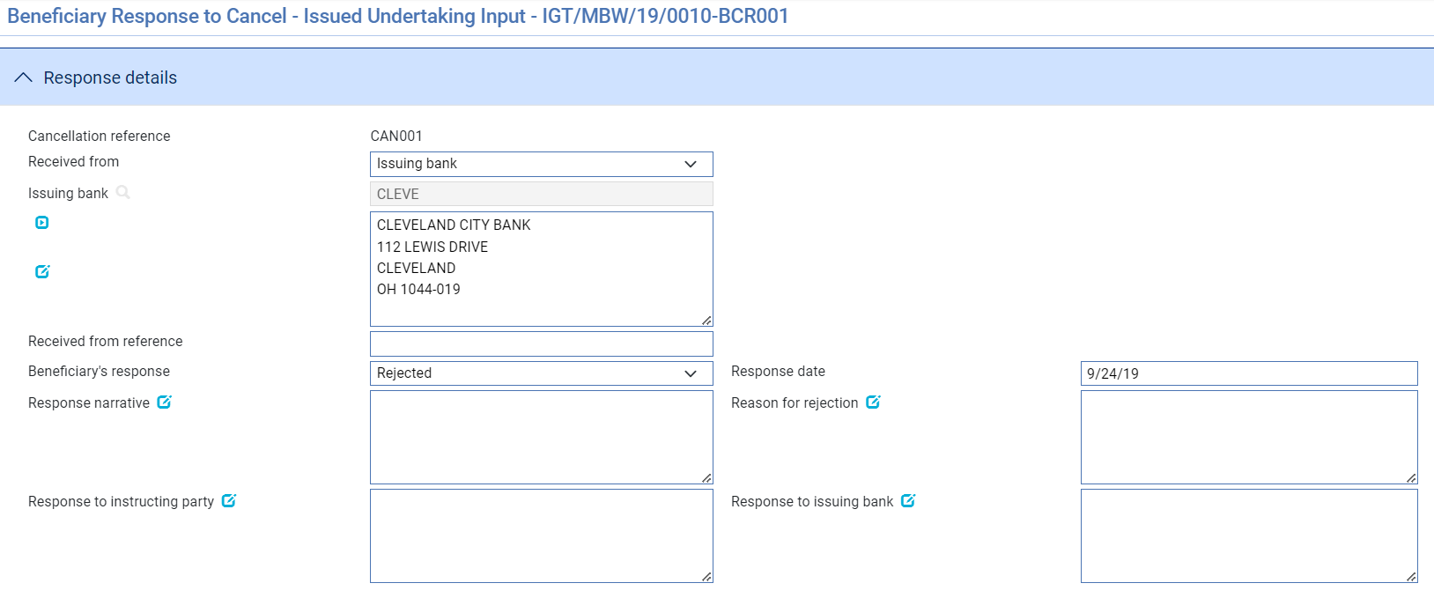

The remaining narrative fields in this window display information taken from the Cancel event.

# Processing Additional Payment Details

This chapter explains how to use the Associated Payment Details pane to apply further processing against the payment or part payments being made.

## Processing Associated Payment Details

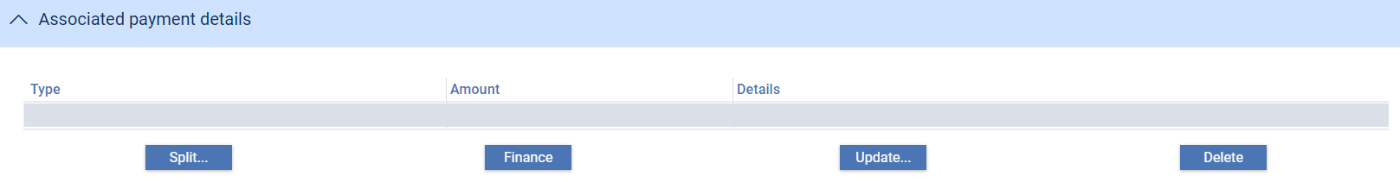

The Associated Payment Details pane allows you to apply further processing against the payment or part payments being made. As payments are defined they are listed in this pane. You can select them individually and enter details of:

* A loan - select the Finance line and click **Update** (see page 84)
* A discount - click **Discount** (see page 87)
* A license - click **Licenses**. See the Licenses User Guide – Trade Innovation for further instructions

### Entering Details of a Loan

1. The functionality described in this section is used to enter loans for systems where the financing module is not implemented. If your system has the financing module implemented see the Financing User Guide – Trade Innovation for information on processing loans.

For payments where you have selected Pay with Financing or Issue Trust Receipt Loan, a Finance line is included as part of the payment details.

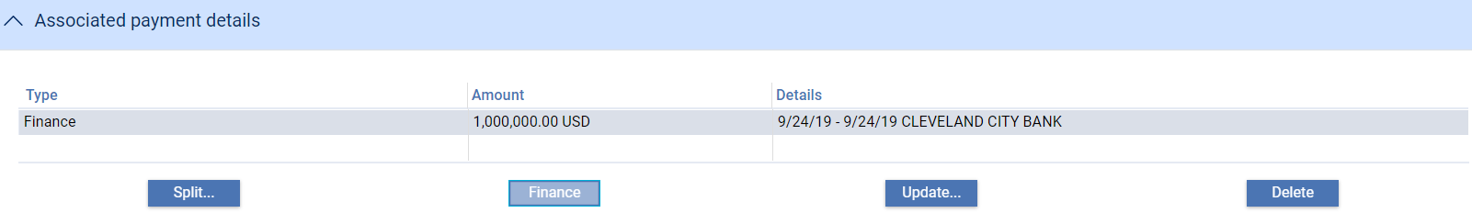

This is used to record information if the applicant needs to borrow funds in order to defer payment to a later date. Typically, a repayment is made from the applicant's own funds at a future date, for example after an onward sale of goods has been arranged. When you double-click on this line or select it and click **Update**, the system displays a window which allows you to enter details of a loan being made against a payment.

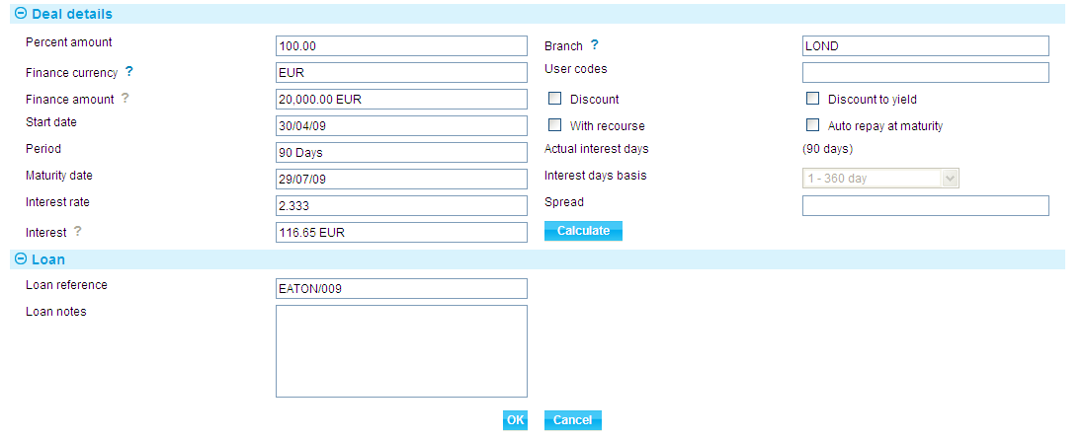

The following table explains what to enter into the fields in this window to record details of any such loan.

When you have completed input and closed this window, the Finance line displays the amount and currency of the loan, its start date and maturity date, the interest rate, and the interest/discount amount.

| Field | What to Enter |
| --- | --- |
| Percent Amount | The amount of the part payment to be financed, as a percentage. |
| Discount/ Discount to Yield | Indicate when interest is to be paid. Check the Discount box if interest is to be paid at inception, or leave the box blank if interest is to be paid at maturity.  Check the Discount to Yield box if the discount to yield formula is to be used to calculate the discount instead of the standard discount formula.  If you click on either the Discount box or the Discount to Yield box and click **Refresh**, the system displays extra fields. |
|  | |
|  | Once you enter a value into the Rate field, click **Refresh**. The system calculates and displays the discount amount and displays it using the Discount Interest field. Alternatively, you can enter the discount amount into the Discount Interest field, and the system will calculate the interest rate and display it using the Rate field. In either case the system calculates and displays the net amount due using the Net Amount field.  Use the Discount Paid By field to define who will pay the discount interest amount on the loan. The debit party is the applicant and the credit party is the presenter. The system uses the credit party as the default. |
| Finance Currency | The currency of the loan, if different from the currency of the transaction.  If you enter a currency here that is different from the transaction currency, the system displays an Exchange Rate field for you to identify the exchange rate to be used to convert the loan amount from the transaction currency.  When you have selected an exchange rate click **Refresh**. The system calculates and displays the converted amount in the Finance Amount field. |
| With Recourse | Use this field to indicate whether or not the loan is with recourse. By default, the box is unchecked and the loan is without recourse. |
| Start Date | The start date of the loan. the system uses the part payment value date as the default. |
| Period/ Maturity Date | The maturity date for the loan. Either enter the maturity date; or use the Period fields to identify the number of days, weeks, months, quarters or years after its start date the loan will mature. If you select the latter option, the system calculates the maturity date and displays it in the Maturity Date field.  The Maturity Date field may be left open for loans with interest payable at maturity. This allows the maturity date to be entered as the loan is repaid. |
| Rate | The overall rate at which interest or discount is to be will be required to record details of the repayment manually.  This field can be checked only if the Maturity Date field is not blank. |
| Spread | The spread rate that has been added to the interest rate. This is used for reporting purposes only. Your bank will have devised its own system for using this field.  The values entered here will appear on the deal generated for the loan. |
| Branch | The branch that owns the loan. |
| Discount Paid By | Select which party is to pay the discount - the credit party or the debit party. |
| Discount Interest | The discount interest amount. |
| Net Amount | The amount to be advanced. The system uses the amount claimed as the default here, and converts it using information entered in the previous fields. |

### Discounting Payments

1. The functionality described in this section is available only if you do not have the financing module implemented.

For payments where you have checked both the Eligible box and the Hold box, the **Discount** button in the Associated Payment Details pane is enabled.

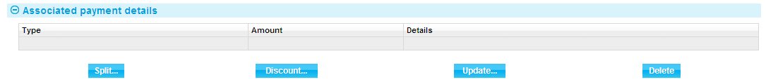

This allows you to record details of a payment to be made to the presenter before the date due under the terms of the master record.

When you click **Discount** the system opens a window for you to enter details of the discount.

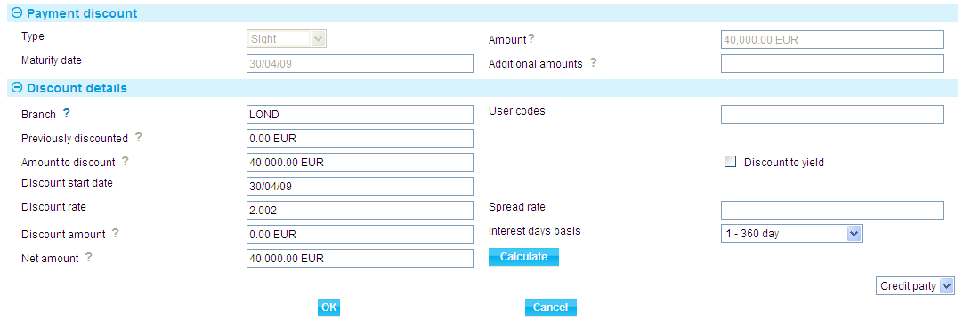

Details of the payment or part payment being discounted are displayed at the top of the window. The table below explains what to enter into the field in this window. Clicking **Calculate** updates the fields, using the values you have entered:

|  | Field | What to Enter |
| --- | --- | --- |
|  | Previously Discounted | If a discount has already been given against the transaction, the amount against which the discount was given. |
|  | Amount to Discount | The amount of the discounted payment for which the early payment is to be made. This may be up to the amount due under the part payment, including additional amounts. |
|  | Discount Date | The date the discounted payment is to be made. The system uses today's date as a default. |
|  | Spread Rate | The spread rate that has been added to the interest rate. This is used for reporting purposes only. |
|  | Days Basis | The days basis to be used to calculate the interest. A list of valid values is given in the Common Facilities User Guide – Trade Innovation. |
|  | Discount to Yield | Click once on the Discount to Yield box so that it is checked if the discount to yield formula is to be used to calculate the discount instead of the standard discount formula. |
|  | Discount Amount | The amount of the discount. If you enter the interest rate into the Discount Rate field, the system calculates the discount and displays it in this field, where you can overwrite it. Alternatively, you can enter the discount value directly into this field and the rate will be automatically recalculated. |
|  | Discount Rate | The interest rate to be used to calculate the discount interest amount. Enter the overall rate at which discount is to be calculated (including the spread).  Alternatively, you can enter the discount as an amount in the Discount Amount field. |
|  | Net Amount | The total value of the early payment, taking into account any discount due. |
|  | Discount Paid By | Indicate which party is to pay the discount on the early payment. |
|  | Branch | The branch that owns the discount deal. |

# Appendix Payment Actions and Charges

This appendix explains how the system handles the processing of charges during a payment event for issued undertakings.

This appendix covers only the special processing for letters of credit. For a full account of how the system handles charges see the Common Facilities User Guide – Trade Innovation.

## Charges

When requesting payment, requesting pay or extend or asking for authorisation to pay, for an undertaking it is sometimes necessary for the bank to advise the counter received from bank of charges that will be due from the applicant. Similarly, when documents are received for an undertaking, the issuing bank may need to advise the applicant of charges due, as a request for payment or approval is sent to the applicant. The system handles this by allowing you to claim the charges.

If you select the Release Items|Charges link during a payment event, then the system will display an additional button - the **Claim All** button.

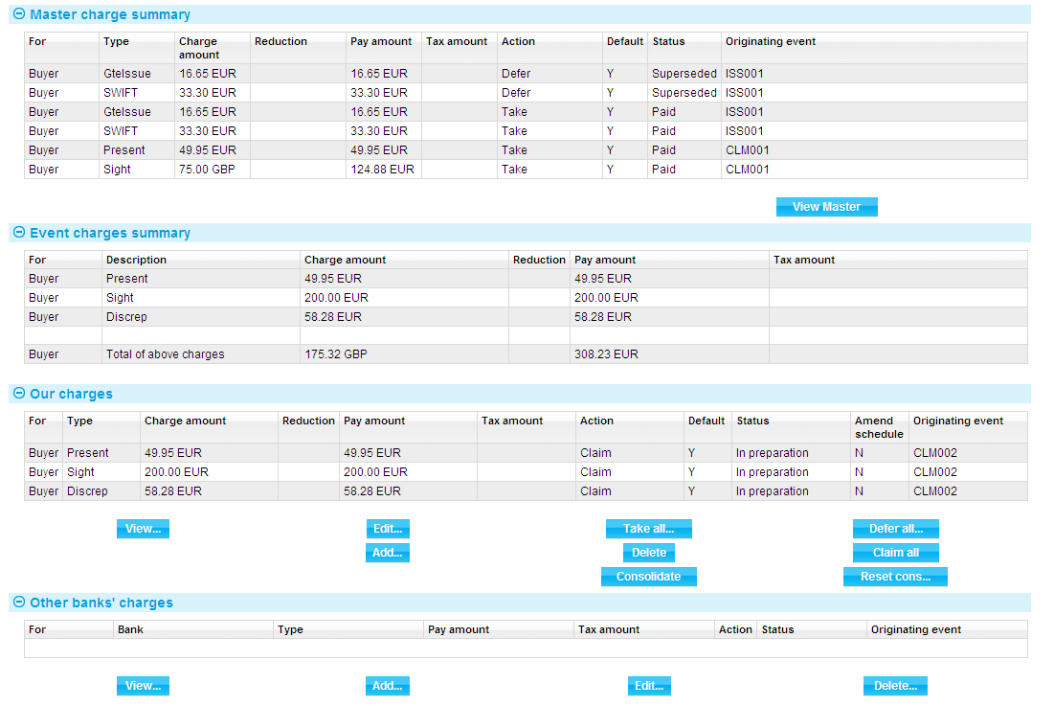

For more on the Charges Summary window, see the Common Facilities User Guide – Trade Innovation.

If you click **Claim All**, the system changes the value in the Action column to 'Claim' for all charges with a status of 'Outstanding' or 'In Preparation'. When the event is completed, the status of these charges changes to 'Claimed'. This indicates that the charges have been claimed by the bank, but payment has not yet been authorised or paid. No postings are generated by the claim as no payment has yet been made.

If the response does not authorise payment of the claim, you will need to manually take all previously-claimed charges. The system will issue a warning that these charges relate to an outstanding payment event and are being superseded. Once taken, these previously-claimed charges can be waived or edited in the usual way.

## Presenter's Actions

The following table lists all the presenter's actions supported by the system and explains when they might be used:

|  |  |
| --- | --- |
| Presenter's Action | What it Signifies |
| Request To Pay or Extend | A request is sent to the applicant to either pay the demand or extend the undertaking expiry date |
| Request Authorisation to Pay | Discrepancies have been advised by the presenter and authorisation to pay is being requested. If this option is selected, an extra field is displayed, allowing you to enter details of discrepancies. |
| Pay and Claim Reimbursement | The sender has paid the beneficiary and has sent a claim to the reimbursing bank. |
| Request Payment | The presenter is requesting payment. |
| Request Acceptance | The presenter is requesting payment and or acceptance of drafts. |
| Sender has Debited our Account | The presenter has paid the beneficiary and has debited the receiver's account. |
| Documents Sent On Approval | Documents with discrepancies have been sent on approval. |
| Other | Used when the payment action involves more complex instructions, for example where discounting of acceptances is being requested. The Notes fields should be used to provide details. |

## Payment Actions

The Payment Action field allows you to select the appropriate action for the claim. Actions are of the following types.

Payment actions that indicate that the bank is paying or will pay the claim in the future. These include:

* Approve Authorisation Request
* Pay
* Pay with Financing
* Pay at Maturity
* Issue Trust Receipt Loan
* Accept
* Forward Documents
* Repay Finance

Payment actions that reject or refuse the claim. These include:

* Refuse Documents
* Reject
* Reject and Claim Refund
* Reject Authorisation Request

Payment actions that leave the claim outstanding. These include:

* Request To Pay Extend
* Await Documents
* Request Approval from Applicant
* Issue Trust Receipt
* Issue a General Request to Applicant or Presenter

Payment actions that complete the claim without paying/rejecting

* Extend – an amend event is automatically created

1. In addition to the standard actions mentioned above, your bank may define other actions (which are based upon the standard actions) in order to satisfy your internal processes. These additional actions will also be available in the drop-down list.

See the *System Tailoring Guide* – Trade Innovationfor instructions on defining additional payment actions.

### The Effect of Different Payment Actions on Charges

The following table indicates the effect of different payment action behaviours on charges for Issued undertakings:

| Payment  Action Behaviour | What it Does | Our Charges for Buyer | Our Charges for Seller | Other Party Charges | Other Bank's Charges for Buyer | Other Bank's Charges for Seller |
| --- | --- | --- | --- | --- | --- | --- |
| Request to Pay or Extend | Used where the Beneficiary request the Applicant either pays the Demand or alternatively extends the term of the undertaking | Take | Take | Take | Take | Take |
| Extend | Used where the Applicant agrees to extend the term of the undertaking | Take | Take | Take | Take | Take |
| Accept | The payment will be made at maturity. The payment advices such as MT756 can be produced immediately and the payment will be automatically picked up as the maturity falls due so that it can be continued and paid.  This is available for acceptance payments only. | Claim | Claim | Claim | Claim | Claim |
| Approve Authorisation Request | This is the same as pay. The response is used to send an MT752 Authorisation to Pay. When this option is taken an additional drop down list can be used to enter further authorisation details.   * See details * Accept * Remitted - note value date field is then shown * Debit sender's account * Negotiate * Claim reimbursement   This is available only if the presenter's action is 'Request Authorisation to Pay'. | Take | Take | Take | Take | Take |
| Await Documents | Typically no accounting will be done. However, where the sender has debited an account in their books or claimed reimbursement then the accounting entries may be generated by using this code in conjunction with the claim details presenter's action. | Defer | Defer | Defer | Defer | Defer |
| Forward Documents | Documents are passed to the applicant when they are received. This is treated as the final action under a claim where the sender has debited the receiver's account. | Take | Take | Take | Take | Take |
| Issue General Request to Applicant or Presenter | This can be used to send correspondence about the claim to the applicant or presenter by entering details into the Notes for Debit Party or Notes For Presenter field, as relevant. | Take | Take | Take | Take | Take |
| Issue Trust Receipt | This allows a trust receipt to be sent to the applicant so that it can be signed and returned. | Take | Take | Take | Take | Take |
| Issue Trust Receipt Loan | This allows the finance button to be made available allowing details of a deal to be entered to fund the receipt of funds from the applicant. | Take | Take | Take | Take | Take |
| Pay | The claim is to be paid and postings generated. The payment advices such as MT756 can be produced immediately. If the payment is a mixed payment each part payment is initially set to have a status of 'Pay' which can be overridden as required to one of the following pay statuses:   * Pay * Pay at maturity * Accept (if acceptance part payment only) | Take | Take | Take | Take | Take |
| Pay at Maturity | The payment will be made at maturity. The payment advices such as MT756 can be produced immediately and the payment will be automatically picked up as the maturity falls due so that it can be continued and paid. | Claim | Claim | Claim | Claim | Claim |
| Pay with Finance | This allows the finance button to be made available allowing details of a deal to be entered to fund the receipt of funds from the applicant. | Take | Take | Take | Take | Take |
| Reject and Claim Refund | Documents are refused. The bank can either return or hold documents. The value date allows the date of refund to be specified where the sender has already debited the receivers account. This is typically used to generate an MT734. | Take | Take | Take | Take | Take |
| Reject Authorisation Request | The payment request (MT750) is refused. The payment is not made. The response is given either as an M796 Answers or an MT734 Advise of Refusal.  This is available only if the presenter's action Is 'Request Authorisation to Pay'. | Take | Take | Take | Take | Take |
| Repay Finance | Allows the user to create a Repay Finance event. | Take | Take | Take | Take | Take |
| Request Approval from Applicant | Your bank does not pay but seeks authorisation to pay from the applicant. | Claim | Defer | Claim | Claim | Defer |
| Reverse Payment | The bank reverses a part payment that has already been paid. | Take | Take | Take | Take | Take |